## Introduction & background

### Forested source water supplies and drinking water treatment

Surface water is the primary source of drinking water for over 85% of the Canadian population and in the province of British Columbia, approximately 80% of drinking water originates from forested headwaters (Pike et al. 2010). Forests offer a variety of ecosystem services (e.g. biodiversity) and also slow and filter runoff which can result in high quality source water supply (Dudley and Stolton 2003). Surface water quality varies over time and space due to climate, weather, and physical characteristics of the watershed (such as topography, land cover and geology), with runoff introducing terrestrial material, sediments, nutrients, and organic matter into surface waters (Pike et al. 2010; Johnson et al. 1997; Delpla and Rodriguez 2016; Health Canada 2019a; Yang et al. 2015; Matilainen, Vepsäläinen, and Sillanpää 2010).

In Canada, all drinking water must meet Health Canada drinking water quality guidelines, which specify allowable levels of biological, physical and chemical parameters that are safe for human use and consumption (British Columbia Ministry of Environment 2017; HealthLinkBC 2018; Health Canada 2019b). To meet guidelines, source water is most commonly treated to remove substances which may pose a health risk. Drinking water treatment processes vary from simple chlorination to combinations of physical filtration, chemically assisted filtration, reverse osmosis, and or advanced oxidative processes (Critten, John C. Trussell, Rhodes. Hand, David. Howe, Kerry. Tchobanoglous 2014; Emelko et al. 2011). Drinking water treatment technologies differ between communities by infrastructure design and operation, which may be guided by source water quality, infrastructure capabilities, budget, regional size and water quality regulations (Emelko et al. 2011). All drinking water treatment processes share the same goal: ensure public health by providing a continuous supply of safe water. While there are guidelines for radiological, chemical and physical parameters (e.g. removal of metals), the highest priority drinking water guidelines focus on the inactivation of potentially harmful microorganisms, therefore disinfection is the most important step in the treatment process (Critten, John C. Trussell, Rhodes. Hand, David. Howe, Kerry. Tchobanoglous 2014; Health Canada 2019b). In BC, chlorination remains the most widely used method of disinfection, whether it is used alone or in combination with other treatment processes (HealthCanada 2006; HealthLinkBC 2018).

Because drinking water treatment requirements vary with source water quality, there are source water quality guidelines in place in addition to treated drinking water quality guidelines (HealthLinkBC 2018; British Columbia Ministry of Environment 2017). Stable source water conditions lead to predictable treatment procedures, while fluctuating source water quality creates treatment challenges (Emelko et al. 2011). Treatment effectiveness is influenced, for example, by turbidity levels (i.e. suspended solids), varying temperature, dissolved oxygen, pH and natural organic matter.

Aqueous natural organic matter (NOM) can lead to issues of objectionable taste, odour and colour (i.e. guideline aesthetic objectives) and while these aesthetic issues may create unpalatable drinking water, they do not directly impact human health (Health Canada 2019a, 2019b). However, source water NOM can interfere with effective drinking water treatment and therefore BC source drinking water quality guidelines include colour as an indicator of aqueous NOM (British Columbia Ministry of Environment 2017; Health Canada 2019a). Depending on infrastructure design and operation of a drinking water treatment plant, elevated levels of NOM in source water can increase coagulant demand which increases the production of sludge (to be disposed of) and promote the formation of disinfection by-products (Matilainen, Vepsäläinen, and Sillanpää 2010; Health Canada 2019a). NOM reduces treatment effectiveness by interfering with ultraviolet (UV) disinfection and/or increasing chlorination demand; NOM can effect coagulation efficiency and oxidative processes; and because NOM promotes biological growth, it can lead to fouling of treatment and distribution infrastructure (British Columbia Ministry of Environment 2017; Matilainen, Vepsäläinen, and Sillanpää 2010; Health Canada 2019a; Jacangelo et al. 1995).

In addition to operational impediments, NOM is partly responsible for unintended chemical contaminants in treated drinking water. When source water is chlorinated, chemical reactions with NOM can form a variety of chlorinated organic compounds which are broadly classified as disinfection by-products (DBPs) (Richardson et al. 2007; Delpla and Rodriguez 2016; Health Canada 2019a; Yang et al. 2015; Hua, Reckhow, and Abusallout 2015; Baird, Eaton, and Rice 2017a). A number of chlorinated carbonaceous DBPs are included in Health Canada’s drinking water quality guidelines, and have maximum allowable concentrations in treated water due to their possible or known health affects (i.e. possible genotoxicity or carcinogenicity) (Richardson et al. 2007; British Columbia Ministry of Environment 2017; Health Canada 2019a).

#### Watershed processes and water quality

Streams are intrinsically linked to their watersheds through dynamic biotic-abiotic interactions and hydroclimatic relationships; as a result, aqueous biogeochemicals like natural organic matter represent an important link between ecosystem processes, land-use, hydrology, and water resources. These water-quality signatures are useful tracers to better understand catchment processes and regional hydrology, as they are indicative of flow paths, sources, chemical origins and transport pathways (Abbott et al. 2018; Meyer and Tate 1983; Vidon, Wagner, and Soyeux 2008; Rautu 2019). The origins, transport and fate of biogeochemicals in source waters is important for drinking water treatment, because the quality of source water (physiochemical composition and concentrations) governs treatment requirements and largely dictates the quality of treated water (Weishaar et al. 2003; Chow et al. 2008). Natural organic matter (NOM) encompasses a suite of biogeochemical compounds that link terrestrial and aquatic environments, with runoff introducing terrestrial compounds into fluvial systems and transporting both allochthonous and autochthonous compounds.

NOM exhibits dynamic variability across watersheds. The river continuum concept (RCC) predicts a temporal shift in NOM character, including seasonal shifts between autotrophic generation of NOM and heterotrophic processing of detritus; a shift from autochthonous to allochthonous NOM (Vannote et al. 1980; Meyer and Tate 1983). The RCC also predicts a spatial reduction in NOM molecular diversity from headwaters (entry point for majority of solutes) to river mouth (i.e. reduced NOM diversity from low to high order streams) (Vannote et al. 1980; Mosher et al. 2015; Abbott et al. 2018; Creed et al. 2015). The longitudinal attenuation of NOM diversity can be explained by a combination of hydrological processes; geomorphic variables and physical impoundments; organic matter inputs and sources; sediment transport; solar inputs; and processing by aquatic invertebrates and microbes (Vannote et al. 1980; Stanley et al. 2012; Aiken, Hsu-Kim, and Ryan 2011; Zarnetske et al. 2018).

On a finer temporal scale, hydrologic pulses can cause temporal variability in NOM characteristics; for example, the character of NOM has been shown to vary during hydrologic response to precipitation, which indicates a change in NOM source over the course of an event (Vidon, Wagner, and Soyeux 2008; Abbott et al. 2018). The Pulse Shunt Concept supplements the temporal aspects of RCC by considering how major hydrologic events drive regional NOM metabolism and the magnitude, timing and spatial extent of NOM flux (Raymond et al. 2016). While the link between mobilization of source material and biogeochemical processes govern the character of aqueous NOM, the Pulse Shunt Concept (PSC) shows that it is hydrologic processes that govern NOM concentrations in streams (Abbott et al. 2018; Creed et al. 2015; Zarnetske et al. 2018). Where the RCC relies on in-stream biogeochemical processing to explain longitudinal alteration of NOM character, intense hydrologic pulses (related to precipitation or melt events) override the rate of biogeochemical processing and force mass transport events. Discharge determines the magnitude of dissolved organic carbon (DOC) flux (i.e. concentration transport) and under pluvial regime, precipitation and discharge are the primary controls on stream DOC concentrations (Zarnetske et al. 2018; Vidon, Wagner, and Soyeux 2008). Indeed, brief flood events are often responsible for most of the fluvial DOC transport in a watershed (Raymond et al. 2010). With respect to drinking water supply, the timing and magnitude of DOC flux is important for water treatment considerations because while treatment infrastructure can be designed and adjusted to handle a range of source water conditions, rapid changes and dramatic variations in source water quality pose major challenges for drinking water treatment {REF}.

Through a large and geographically diverse data study in the United States, Zarnetske *et al* (2018) found that increasing flows systematically increased DOC fluxes in 80% of watersheds (n=1006) across ecoregions. Proportional increases in DOC flux and discharge indicates that the flux is not limited by organic matter supply, but rather by hydrologic connectivity and mobilization (Creed et al. 2015; Zarnetske et al. 2018). Watershed size and stream order were determined to be weak indicators of DOC flux-discharge relationship while watershed slope and mean precipitation were strong predictors of DOC flux (e.g. Zarnetske et al. 2018 ***add more refs***). Zarnetske *et al* (2018) also found that wetland area exerted non-linear control over whether DOC flux was limited by supply or hydrologic transport.

Aspects of both the RCC and PSC were illustrated in a recent nested catchment study by Abbott *et al* (2018) which found greater NOM chemical diversity in headwaters relative to downstream, but not greater temporal variance in headwaters biogeochemistry. Despite longitudinal differences in molecular character, solute concentrations varied synchronously among upstream and downstream sites, leading to temporal stability in relative biogeochemical signatures (Abbott et al. 2018). The temporal extent to which water quality changes echo across nested sub-catchments depends on the synchrony (i.e. mean covariance) of the hydrologic pulse generation among sub-catchments (Abbott et al. 2018).

Changing climatic conditions are likely to lead to increases in hydrologic pulse generation – through increased precipitation, earlier or more intense freshet conditions, or changes in subsurface flow and connectivity [@ ? *refs*]– it follows that drinking water treatment challenges could arise in response to more variable source water conditions. For forested source water supply areas, developing a better understanding of hydrochemical dynamics and their responses to landscape changes (e.g. wildfire, forest management strategies, mass wasting events) could bolster drinking water security by developing source water protection plans to facilitate more predictable treatment requirements. Understanding water supply area source water quality, variability and response patterns is an important part of the multi-barrier approach to safe drinking water (Canadian Council of Ministers of the Environment 2004).

Forest management and landscape disturbances can also affect water quality by altering material inputs, biogeochemical processes and stream ecology, as well as changing preferential flow-paths and the mobilization, transport and dilution of biogeochemcial components (Meyer and Tate 1983). For example, wildfire combined with post-fire salvage logging in the slopes of Alberta’s southern Rockies resulted in higher turbidity and DOC compared to basins that experienced fire without salvage logging, and both disturbed basins had elevated suspended solids and DOC compared to un-burned catchments [Emelko et al. (2011); *more refs*]. In other studies, it was shown that two to three years post-harvest, baseflow DOC concentrations were higher in forested catchments than in clear-cut catchments; however, these studies also showed variable stormflow DOC responses in harvested and forested catchments (Meyer and Tate 1983; Mistick 2019). In the absence of long-term baseline data (i.e. pre- and post-disturbance data sets), the natural variability in fluvial processes complicates land-use studies and anthropogenic climate change can further confound our interpretations. Overall, DOC trends related to land-use are highly dependent on catchment attributes and hydrologic forces. Understanding the hydrochemistry of a water supply area is key to conducting informed preventative forest management applications.

#### Source water considerations for Greater Victoria’s water supply areas

The Capital Regional District (CRD), encompassing the southern tip of Vancouver Island (including Victoria) and the southern Gulf Islands, is committed to the multiple barrier approach to clean drinking water and has taken control of source water protection by purchasing and privatizing the water supply areas for Greater Victoria. Located on southeastern Vancouver Island, British Columbia, Canada, the Greater Victoria Water Supply Area (GVWSA) includes 20,549 hectares (205.49 km2) of protected drinking water catchment lands. Currently, Greater Victoria’s water supply is sourced from five surface water reservoirs in the Sooke and Goldstream watersheds; Sooke Reservoir is the primary drinking water supply.

The provincial Drinking Water Protection Act and Drinking Water Protection Regulation frameworks were developed to implement Health Canada’s drinking water quality guidelines and set out requirements for drinking water operators & suppliers to ensure the provision of safe drinking water (British Columbia Ministry of Environment 2017). Treatment of source water from the Greater Victoria Water Supply Area consists only of disinfection: raw water (unfiltered) is treated with ultraviolet light as primary disinfection, chlorination is secondary, and finally ammonia is added to produce chloramine (NH2Cl, a long-lasting disinfectant that persists throughout the distribution system).

In anticipation of future water demands and uncertainty related to rainfall and climate change, the Capital Regional District (CRD) purchased an additional 96.28 km2 (9,628 hectares) of land in 2007 and 2010. This area includes about 92% of the Leech River watershed (~96 km2) which was designated as the Leech Water Supply Area (LWSA) for future supplemental source water. In the future (possibly by 2050), inter-basin transfer will move water from the LWSA through a diversion tunnel to supplement Sooke Reservoir (Figure 1). Approximately 92% of the Leech River watershed above the point of diversion (Leech Tunnel) is protected as WSA.



Figure 1: *Overview of the Leech and Sooke Water Supply Areas (Greater Victoria, CRD), located on southeastern Vancouver Island, British Columbia, Canada. The overview (bottom) illustrates precipitation and an atmospheric river event common to the west coast. The map (top) was generated in QGIS, and the image of Canada (bottom) and inset of Vancouver Island are screenshots from the Windy app (Windy.com).*

Hydrology and water quality monitoring programs for the Leech began in 2017, thus there is little historical data to describe hydrochemical dynamics in the Leech watershed. The Leech River watershed includes three mainstem rivers (Cragg Creek, Leech River, and West Leech River) as well as several small headwater lakes (Weeks, Jarvis, and Worley) and wetlands (Jordan Meadows surrounding Weeks Lake and Lazar meadows north of Jarvis Lake). Runoff is greatest in the winter under saturated conditions when rivers respond rapidly to precipitation events, rising and falling dramatically. Across the watershed, elevation ranges from approximately 200 m above sea level (asl), near the Leech Tunnel, to 941 m asl in the centre of the watershed, at the top of Survey Mountain.

In the mid-1980’s, some water was transferred from the Leech River into Deception Gulch and Reservoir (adjacent to but physically separated from Sooke Reservoir), and the mixing resulted in biological water quality problems that included odour and raised concerns about the operational usage of the existing tunnel [*personal communication ?refs*]. Before work is done on inter-basin transfers, the hydrology and water quality of the Leech River system need to be better understood.

The LWSA was privately managed forest land which was extensively harvested over the past 70 years (nearly 96% clearcut); as a result, a large portion of the WSA is densely forested with softwood stands less than 35 years of age as of 2020. The second growth forests of the LWSA are no longer managed for timber supply, but rather to improve and maintain drinking source water quality and to reduce the risk of landscape level wildfire. Due to prior harvest, reforestation and active fire suppression, forest fire fuels have accumulated in the LWSA and pose a threat if a fire occurs. In the Sooke WSA, the CRD implements forest treatments designed to foster healthy forest stands capable of reducing fire intensity, such as reducing fuel hazards and creating conditions that are safe for crews to action a fire (e.g. closed-canopy fuel breaks). Similar preventative fire treatments may be applied in the LWSA prior to inter-basin transfers.

Establishing an understanding of baseline water quality dynamics and hydrologic forces in the LWSA will help to inform forest management strategies and evaluate the effects of fire fuel management on water supply. Furthermore, developing relationships between event-based water quality dynamics and establishing hydrochemical ranges across the LWSA will help to anticipate possible treatment challenges that may accompany future inter-basin transfer from the LWSA to the Sooke WSA.

### Research questions and objectives

This Master of Science thesis research was conducted in partnership with the CRD and forWater Network in an effort to help characterize the Leech Water Supply Area while contributing to our understanding of variations in source water quality (primarily with respect to DOC and NOM) across nested catchments in a second growth forested watershed. This thesis tackled four research questions (RQ) and associated objectives (below), each of which is addressed in subsequent chapters.

**RQ.1.** What are the ranges for DOC concentration and NOM character between adjacent drainage basins and among nested sub-catchments in the Greater Victoria water supply area, and what influence does seasonality have on concentration of DOC and character of NOM?

**Objective 1:** Design a sampling strategy to measure the spatial and temporal variation of DOC concentration and NOM character, then describe spatiotemporal patterns that were observed.

**RQ.2.** Are hydrological processes the main driver for DOC transport and variation in the LWSA and is there a mechanistic relationship between river stage and DOC or NOM?

**Objective 2:** Relate water sample results to river stage and report on the relationships between DOC concentrations and NOM character with stage, particularly paying attention to differences between baseflow and storm events.

**RQ.3.** Are some watershed characteristics more important than others for influencing DOC and NOM dynamics?

**Objective 3:** Assess the importance of watershed characteristics and conditions as explanatory variables for DOC and DOM patterns.

**RQ.4.** What are the implications for watershed management and future drinking water supply?

**Objective 4:** Provide context of how results can be used to inform watershed management planning for wildfire reduction strategies and design of continued water quality monitoring for future inter-basin transfers.

Ideally, results of this research will contribute to baseline understanding for further exploration of forest management strategies, such as fire fuel management, and their impacts on source water quality and supply. Understanding source water quality in relation to hydrology is an essential component to multiple barrier approach to ensuring clean drinking water.

## Spatial and temporal patterns in DOC & NOM

### Introduction

Drinking water in Canada is primarily sourced from surface water supplies. Over 85% of Canadians, and approximately 80% of British Columbians depend on drinking water that originates from forested headwaters (Pike et al. 2010). Climate, weather, and physical characteristics of a watershed lead to variations in surface water quality, and runoff links surface water sources to the landscape by introducing terrestrial sediments, nutrients, and organic matter into solution (Pike et al. 2010; Johnson et al. 1997; Delpla and Rodriguez 2016; Health Canada 2019a; Yang et al. 2015; Matilainen, Vepsäläinen, and Sillanpää 2010).

#### Aqueous natural organic matter in source water supply

Natural organic matter (NOM) comprises a dynamic collection of molecules that originate from a variety of sources, and aqueous NOM exists in complex and diverse combinations of particulate, colloidal and dissolved fractions (Peuravuori and Pihlaja 1997 ; Aiken, Hsu-Kim, and Ryan 2011; Matilainen et al. 2011; Ruhala and Zarnetske 2017). NOM can be introduced to a water body from terrestrial sources (i.e. allochthonous NOM) or generated through in-stream processes (i.e. autochthonous NOM) which are often associated with autotrophic organisms like algae and cyanobacteria (Health Canada 2019a; Epps 1994). Terrestrial organic matter (allochthonous NOM) includes humic and fluvic acids, tannins, and a wide variety of other compounds (e.g. phenols and lignin, hydrocarbons, proteins, carbohydrates, etc.), which enter fresh water through runoff (Zarnetske et al. 2018; Health Canada 2019a).

NOM concentration and character vary widely in source water depending on source material, hydrology, and biogeochemical factors (Aiken, Hsu-Kim, and Ryan 2011; Abbott et al. 2018; Zarnetske et al. 2018; Matilainen, Vepsäläinen, and Sillanpää 2010). Molecular composition and physical structure of NOM influence its functionality and reactivity, therefore different types of aqueous NOM in drinking source water have different disinfection by-product formation potentials (DBP-FPs) (Delpla and Rodriguez 2016; Yang et al. 2015; Health Canada 2019a; Chow et al. 2008), and different aquatic ecosystem roles (Cory, Elizabeth W. Boyer, and McKnight 2011). Furthermore, different species of NOM vary in molecular size, structure and charge distribution, which determine requirements for effective treatment and removal (Jacangelo et al. 1995; Matilainen, Vepsäläinen, and Sillanpää 2010).

Molecular structures of NOM can contain nitrogen, silica, oxygen and hydrogen and are composed primarily of carbon; thus, organic carbon (OC) is often quantified as a proxy for NOM concentration (Cory, Elizabeth W. Boyer, and McKnight 2011; Health Canada 2019a; Matilainen, Vepsäläinen, and Sillanpää 2010; Critten, John C. Trussell, Rhodes. Hand, David. Howe, Kerry. Tchobanoglous 2014). Total organic carbon (TOC) is operationally divided into particulate and dissolved fractions (POC and DOC, respectively) which are typically distinguished based on separation by a 0.45-micron filter (Baird, Eaton, and Rice 2017a; Aiken, Hsu-Kim, and Ryan 2011). Generally, DOC is the predominant fraction of TOC in surface water, and the amount of DBPs in treated water is proportional to raw water DOC concentration (Weishaar et al. 2003; Ruhala and Zarnetske 2017; Chow et al. 2008).

In addition to acting as a precursor for DBPs, DOC (thus NOM) has been called a master variable due to it’s terrestrial-aquatic linkages, influence on water chemistry and role in contaminant transport (Zarnetske et al. 2018; Ruhala and Zarnetske 2017). NOM is an energy source for aquatic heterotrophs, it has the ability to bind and transport contaminants in solution (e.g. metals, hydrophobic organic pollutants, nutrients), can influence stream pH and aquatic light and temperature regimes; which, in turn, effect aquatic microbial communities (Matilainen, Vepsäläinen, and Sillanpää 2010; Oni et al. 2013; Aiken, Hsu-Kim, and Ryan 2011; Weishaar et al. 2003; LaZerte 1991; Palleiro et al. 2013; Stanley et al. 2012; Cory, Elizabeth W. Boyer, and McKnight 2011).

 * *

DOC is an important source water quality parameter to monitor and guidelines in British Columbia specify that drinking source water TOC should remain below 4 mg/L, primarily to reduce the production of trihalomethanes (e.g. chloroform, a common DBP) in treated drinking water (British Columbia Ministry of Environment 2017). Aside from DBPs, monitoring source water DOC is important for addressing other operational issues associated with NOM and drinking water treatment challenges. Within a watershed, the characteristics and concentrations of NOM (and therefore DOC) naturally fluctuate over space and through time, creating dynamic conditions and potential treatability concerns (Li et al. 2014; Yang et al. 2015).

#### Surface water sampling strategies

A discrete water sample cannot tell a complete story of a hydrologic system’s water quality dynamics but it can provide information about specific attributes of the water in a given place at a certain time, if it accurately represent the body from which it was collected. Non-representative sampling techniques will lead to non-representative analytical results and ultimately to erroneous conclusions (CCME 2011). Collection of water samples must be done consistently and carefully to avoid sample contamination or sampling errors which would generate unreliable analytical results (CCME 2011). In a carbon-based world, sample contamination must be a crucial and constant consideration when sampling for NOM (CCME 2011; Cory, Elizabeth W. Boyer, and McKnight 2011).

The basis of a water quality monitoring network is the collection of representative quantitative data for physical, chemical or biological parameters that help to characterize a hydrologic system over time (R. O. Strobl and Robillard 2008). A monitoring network, therefore, will involve some form of a sampling program and it’s design should reflect research objectives, account for physical realities (e.g. spatiotemporal heterogeneity, access), while being cost-effective and practical (R. O. Strobl and Robillard 2008; Kirchner 2006). Grab-sampling is a standard method of collecting whole-water samples for laboratory or stream-side analysis (CCME 2011; Ruhala and Zarnetske 2017). Synoptic grab sampling can be completed at a number of sites over a relatively short period of time (e.g. hours to days) to assess spatial variations, however there is often a lack of temporal resolution due to scheduled, convenient or opportunistic sampling at relatively low frequencies (Ruhala and Zarnetske 2017).

It can be difficult to schedule a synoptic sampling campaign for specific weather and flow conditions, especially for short duration of rapid runoff (Harmel, King, and Slade (2003)). Flow changes in response to precipitation or melt events are of interest for NOM studies as the rising limb of the hydrograph has been shown to have higher DOC concentration that non-storm flow (Yang et al. 2015; Raymond et al. 2016, 2010). While high flows present an opportunity to capture the dynamic water quality changes that occur during events, it is logistically challenging and potentially dangerous to manually collect grab samples during events across multiple sites (Graczyk et al. (2000); Mackay and Taylor (2012)). So, pump samplers or passive siphon samplers can be used to collect water samples under difficult or unsafe conditions.

A pump sampler (e.g. ISCO samplers, Teledyne ISCO, Inc., Lincoln, NE, USA; or Global Water Instrumentation, Gold River, California) can be set up in the field and programmed to collect a set of water samples based on time intervals or changes in conditions (e.g. stage or turbidity thresholds). Pump samplers are effective for automatic event-based sampling (Harmel, King, and Slade (2003)) but can be prohibitively expensive ($2K-3K CAD), and also require a reliable power source which can pose logistical challenged for setting up at multiple sites in remote or difficult to access locations (Mackay and Taylor (2012)). A passive siphon sampler is an alternative to a pump sampler that automatically and effectively collects discrete water samples on the rising limb of the hydrograph (e.g.: Mackay and Taylor (2012); Graczyk et al. (2000); Diehl (2007)). Siphon samplers are limited to sampling a single event and (so far) are not suitable for sampling the falling hydrograph limb; they are however very low cost, customizable and require no power (Newham, Croke, and Jakeman 2001).

In this project, a sampling strategy was developed to quantify the ranges of DOC concentration and NOM character between adjacent drainage basins and among nested sub-catchments in the Greater Victoria water supply area.

### Methods

To measure the ranges of dissolved organic carbon (DOC) concentration and natural organic matter (NOM) character over space and time, river sampling was conducted from October 2018 to February 2020. Water samples were collected and analyzed at UBC for DOC concentration and NOM character via high temperature combustion and UV-Vis spectroscopy, respectively (details follow in *‘Analytical Techniques’*). The river sampling program designed for this project included synoptic sampling of 12 sites across the Sooke and Leech water supply areas (WSA), as well as installation of monitoring and sampling stations at 6 sites in the Leech River watershed. Results of synoptic sampling analyses were used to elucidate spatial and temporal patterns in NOM and DOC.

#### Sampling sites

Most of sampling sites were in the Leech WSA and a few key rivers in the Sooke WSA were also included (Figure 2). Rithet Creek is the largest tributary to Sooke Reservoir and Judge Creek is the second largest. Deception (gulch) is a small tributary to Deception Reservoir and the Leech River Tunnel (currently deactivated) terminates at Deception gulch. Thus, Deception Reservoir is a likely balancing reservoir for future inter-basin transfers, and it is separated entirely from the current water supply (Sooke Reservoir) by a dam.

In the LWSA, Weeks and Chris Creek are headwater streams of the Leech River and Lazar and Jarvis Creeks are headwaters of Cragg Creek, a major tributary to the Leech. West Leech River is the other major tributary to the Leech River, and Leech-Beach site was located just downstream from the confluence of West Leech with the mainstem. The Leech Tunnel site was located near the effective mouth of the LWSA, at the Leech River Tunnel.



Figure 2: *River sampling sites across the Leech and Sooke Water Supply Areas (WSA), Greater Victoria, BC.*

##### Synoptic sampling

Synoptic sampling involved collecting grab samples of river water at as many sites as possible over a relatively short time period (e.g. 1 day). River water was collected in triple-rinsed acid-washed 250 mL high-density polyethylene (HDPE) wide-mouth amber bottles. Samples were capped with minimal head-space and transported in coolers with ice to the lab for analysis of dissolved organic carbon (DOC) concentrations and spectroscopic absorbance (an indicator of NOM character).

Samples were collected (via wading) from within 2 meters of the same location at each sampling site, at the safest proximity to channel center, from approximately 10 cm below water surface. All samples were refrigerated while they were held between collection and analysis. Grab samples collected for DOC quantification were filtered and acidified within 48 hours of collection, except for a set of a dozen samples that were collected by CRD staff in January 2020 which were refrigerated for almost two weeks prior to filtration and acidification. Samples for NOM spectroscopy were not acidified, they were confirmed to have zero turbidity and measured unfiltered.

##### Monitoring & sampling stations

Six of the sampling sites in the LWSA were selected for more intensive monitoring (numbered sites in Figure 2). These sites represent the drainage area upstream of the Leech River Tunnel and five sub-basins nested within the Leech Tunnel catchment. Site 6 included the drainage area for the entire LWSA and was located at the Leech River Tunnel. The five sub-basin sites represented important portions of the Leech River system: two headwater streams, Weeks and Chris Creek (sites 1 & 2) and the head of Leech River below their confluence (site 3); and two major tributaries that feed the Leech River, Cragg Creek and West Leech (sites 4 & 5). Monitoring at these sites included river stage, temperatures, and passive siphon sampling schemes.

The Leech watershed system responds quickly to rainfall, and the logistics of grab sampling through events at multiple sites would have been very challenging for one person to accomplish, could have been dangerous to manually sample, and would have required site access beyond safe working hours (i.e. not logistically feasible). It was important to sample across the hydrograph to capture sample-sets that represented the variation in DOC and NOM that occurred during changing flow conditions (i.e. within storm variability). Based on cost, logistical considerations and curiosity, siphon sampling strategies were employed at the monitoring sites across the LWSA. Siphon sampling bottles were used on vertical sampling racks as a cost-effective, logistically practical, reliable and consistent method of passive event-based sampling that enhanced the synoptic sampling program. In addition to passively collecting samples across the Leech watershed during increasing flow conditions, the vertical racks also recorded river stage and air/water temperatures (using HOBO TidbiT v2 Temperature Data Loggers, Onset, USA).

Each vertical sampling rack included a central stilling well (3.81 cm (1.5“) PCV pipe with 1.27 cm (1/2”) holes along the length) with a measuring tape affixed to the front. Inside the stilling well was an Odyssey Capacitance Water Level Logger (Dataflow Systems Ltd., New Zealand); and on either side of the central stilling well was a slotted offset angle bar onto which hose clamps held siphon sampler bottles (Figure 3).

Custom-built siphon sampler bottles used in this research were based on a USGS single stage sediment sampler design (US U-59, 1961, (see Graczyk et al. 2000)). Screw caps for 250 mL amber HDPE wide-mouth bottles were augmented to include a siphon system made of two 1/4" (O.D.) stainless steel tubes, each with a 180 $​^{∘}$ bend at the top end; the longer tube formed an air vent, the shorter acted as a water inlet. The sample bottle filled when river water reached the top of the inlet tube bend (Figure 3). Marine epoxy was applied to the outside of siphon caps to ensure a water-tight seal around the inlet and exhaust tubes, and inert silicone sealant was added to the inside of lids to ensure watertightness and clean sample containment. The siphon samplers collected river water from approximately 5 cm below the surface (the distance between bend at top of intake tube to inlet orifice). Sampled water filled each siphon bottle with approximately 1 cm of head space between the water level and sealed lid, such that a sample was not in direct contact with the siphon lid.



Figure 3: Vertical sampling rack and siphon sampler bottle, illustrative of installations at six sites across the LWSA (shown here is Chris Creek (site 2).

Each time a monitoring site was visited, empty acid-washed sample bottles with siphon lids were set out on vertical racks. Sampling bottles could be placed at any height and were generally staggered at 10-20 cm intervals. The stage at which each siphon bottle filled was recorded – this was the observed height on the stilling-well measuring tape that corresponded to the top of each siphon intake tube bend (filling-stage). Samples were passively collected in my absence as rivers responded to precipitation, and I retrieved them on subsequent field trips (at which point the filling-stage was double checked).

During data analysis, each siphon bottle’s filling-stage was references to level-logger data to determine the date and time of collection for each rising-stage sample. To the best of my knowledge, this project was the first to combine vertically staggered passive siphon samplers with observed and continuously recorded stage to obtain timestamps of sample collection. The timestamps were used to asses temporal variability in DOC & NOM (details in Chapter 3) and to inform quality management of samples (below).

###### Siphon sampler assumptions

The representativeness of vertical rack samples relied on two key assumptions: (1) the water column was well mixed (no stratification) therefore the sample collected was representative of river water quality at each sampling stage; and (2) the sample was discrete, such that there was no infiltration or mixing between surrounding river water and the sample in the bottle once the sample was collected.

Based on turbulence associated with flows upstream of the vertical racks (step-pool formations), the assumption of fully mixed and unstratified water seemed justified. Sample discretion was validated in lab using food colouring and a flow-through bucket system. In this test, a siphon sampler bottle was submerged in a container filled with circulating tap water; following siphon sample collection, food colouring was added to the system and circulated for 15 minutes, then the sample bottle was removed from this dye chamber and the colour of the sample inside the siphon bottle was compared to the dyed water that had circulated around it. This test was repeated five times with different siphon-lid bottles. There was no dye present in any of the siphon sample bottles following the tests. This affirmed the assumption of discrete siphon sample collection.

###### Sampling rack hold-time experiments

Every effort was made to retrieve rack samples as quickly as possible from the racks following rain events. None the less, some samples remained on a rack for more than a few days due to logistical, access and safety considerations. So, hold-time experiments were performed to assess river sample stability over periods between rack sample collection and retrieval. The hold-time experiments included replicate sample collection (n = 10) where half the samples were capped with siphon lids and placed out of water on a vertical rack in the field and the other half of samples were immediately returned to the lab for analysis. Three sets of hold-time experiments were completed such that the simulated-rack samples were left in the field for 11, 20 and 34 days before being retrieved for analysis and comparison to their counterpart replicates (details in results section). The temperature sensors installed at each vertical rack were used as part of the hold-time assessment for sample stability and results were used to flag data as suspect or acceptable for inclusion in results.

#### Laboratory analyses of water samples

Each water sample was transported from the field to the lab in a cooler with ice for quantification of dissolved organic carbon (DOC) and qualitative assessment of natural organic matter (NOM) molecular character. Aqueous forms of NOM in freshwater play important ecological roles but can be problematic for drinking water treatment because they increase oxidant demand (e.g. chlorination), contribute to the formation of disinfection by-products, and cause other disruptions (e.g. short filter run times, microbial bio-fouling, coagulant demand). Because the backbone of NOM is carbon, DOC is a measure of the dissolved forms of NOM in a sample. While quantifying a sample’s DOC is important in describing the amount of NOM, it tells us nothing about the structure (and therefore the function) of that material. Characterizing molecular attributes in addition to quantifying NOM provides greater insight than quantification alone; therefore, both quantification of DOC and characterization of NOM were tackled for this project. Samples were also measured for phosphate concentration using a colourimetric (ascorbic acid) orthophosphate test kit (HACH PO-19); each water sample had phosphate concentration below detectable limits (0.1 mg/L).

##### Quantifying DOC (dissolved organic carbon)

To quantify dissolved organic carbon (DOC), the major constituent of natural organic matter, samples were analyzed for non-purgeable organic carbon (NPOC) via High-Temperature Combustion (Method 5310-B) on a Shimadzu TOC-V (Baird, Eaton, and Rice 2017a).

###### Sample preparation

Water samples were brought to room temperature, inverted to mix, then filtered and acidified by hand. A clean 60 mL luer-lock syringe was pre-rinsed with sample water three times, then used to triple-rinse a vial (acid-washed 40 mL borosilicate amber glass vial) with filtered sample water. Samples were filtered using pre-rinsed (filter to waste) 0.45 μm polyethersulfone syringe filters (Karanfil, Erdogan, and Schlautman 2003; Baird, Eaton, and Rice 2017a). Each sample was syringe-filtered into its pre-rinsed vial and acidified to bring pH below 2 (by adding 200 μL of 4 M hydrochloric acid, reagent grade, into 35 mL filtered sample). Filtered and acidified samples were sealed with Parafilm and place on the autosampler tray (Shimadzu ASI) for instrumental analysis. On a few occasions with extended time in the field (greater than 48hrs), samples were filtered and acidified (as above) at the field house, then capped with Teflon-lined caps and refrigerated until return to the lab for analysis.

###### Instrumental analysis

The first five vials of each analytic run contained only lab grade water; these blanks were analyzed to (1) flush the system and (2) assess instrumental stability (i.e. precision). In series, the Shimadzu autosampler sparged each sample vial with high purity hydrocarbon-free air (1 minute) to drive off dissolved inorganic carbon (upon acidification, inorganic species were converted to aqueous CO2), leaving only dissolved organic carbon in the sample. Aliquots of sparged sample (80 μL) were then drawn into the TOC-V and catalytically combusted (Shimadzu standard catalyst with quartz wool) to convert all organic carbon into carbon dioxide which was measured by non-dispersive infrared gas detection to quantify sample NPOC (i.e. DOC). The instrument measured three to five aliquots from each vial to ensure the replicate measurements coefficient of variation (CV) was below 2% and standard deviation (SD) was below 0.1 mg/L. This method represents a direct quantitative measure of DOC; although small volatile organic compounds could be removed in the sparging process, most NOM compounds are of higher molecular weight (e.g. humic substances) and it is unlikely that DOC analytes would be lost (Baird, Eaton, and Rice 2017a; Matilainen et al. 2011; Aiken and Cotsaris 1995).

Files output by the TOC-V software included sample identification information, details of analytical processes and results including detected intensities and calculated NPOC concentrations. Concentration results were calculated from a selected calibration file. Calibration was completed each time the zero-air gas cylinder was replaced, and in one instance when the gas flow rate was adjusted. A five- or six-point calibration curve (0-30 mg/L organic carbon) was created with series made from stock solution of anhydrous primary-standard grade potassium hydrogen phthalate. Calibration was verified regularly by including a ‘cal-ver’ in most sample trays (standard solution (labchecm.com, catalog No.LC129107) diluted to approximately 5 mg/L); these cal-vers resulted in an average accuracy of 10.8% (n=20).

##### Characterization of NOM (natural organic matter)

To assess the molecular character of NOM, samples were analyzed by UV-Vis spectroscopy (ultraviolet-visible light) using a spectro::lyser (s::can, Vienna, Austria). The spectro::lyser is a self-contained spectrophotometer and data-logger (with external power source) that measures turbidity and UV-Vis absorbance (i.e. light attenuation) across the wavelength range of 200 nm to 750 nm (recorded at 2.5 nm intervals). While the spectro::lyser is a field-deployable instrument, it was used in-lab for this project.

For NOM to be detected by UV-Vis spectroscopy the molecules must absorb ultraviolet (UV) or visible (Vis) light, which is a physiochemical ability determined by the electronic structure of a molecule. UV-Vis absorption requires the presence of a conjugated pi-bond system (i.e. a chromophore) in the molecule, which is common in aromatic molecules. In a forested watershed, the suite of molecules that comprise NOM generally have more aromatic than aliphatic character (Weishaar et al. 2003). Increasing aromaticity will lead to greater absorbance at shorter wavelengths (shorter wavelength, higher energy), and a more concentrated sample will lead to greater absorption intensity; therefore, the UV-Vis spectrum of a sample can provide valuable information about relative weights, aromaticity and relative concentrations of aqueous NOM (Helms et al. 2008; Cory, Elizabeth W. Boyer, and McKnight 2011; Ågren et al. 2008; Karanfil, Schlautman, and Erdogan 2002; Karanfil, Erdogan, and Schlautman 2003). DOC concentration estimated from UV-Vis absorbance is a proxy measure that represents the chromophoric component of NOM, which is proportional to the samples’ average aromatic carbon component (Helms et al. 2008).

###### Sample analysis

Water samples were removed from refrigeration, brought to room temperature, and inverted to mix prior to spectral analysis. The spectro::lyser comes with a sleeve to contain approximately 100 mL of sample around the spectral path. The analytical sample space (path and sleeve) was triple-rinsed with room-temperature sample water prior to analysis, then the sample sleeve was filled, and the sample was analyzed.

The spectro::lyser has been shown to effectively determine DOC content and character on unfiltered samples (Avagyan, Runkle, and Kutzbach 2014). However, suspended matter interferes with UV-Vis absorbance due primarily to light scattering (Baird, Eaton, and Rice 2017b). While unfiltered water samples were analyzed in the spectrolyser for NOM, samples that had detectable turbidity (greater than 0.0000 FTU) were removed from data analysis.

###### Instrument and data handling

Files output by the spectro::lyser software (ana::pro, Version 5.9h (1.0.z)) include results of estimated concentrations (details follow) and specific absorbance coefficients (m-1) at 254 nm and 436 nm (A254 and A436, respectively), as well as another “fingerprint” file of specific absorbance coefficients for the entire wavelength range. Within the instrument software, full scan absorbance data (unitless absorbance values) were converted to specific absorbance coefficient (SAC). SAC represents absorbance at a given wavelength (absλ) normalized to the spectrophotometer pathlength (SACλ); the spectro::lyser used in these analyses had a fixed pathlength of 35.0 mm.

The spectro::lyser is pre-calibrated with an internal Global calibration file (Global Calib.: “RIVER000V120”) to calculate estimates of total organic carbon (TOC), dissolved organic carbon (DOC), and nitrate-nitrogen (NO3--N) concentrations. Details of the Global calibration algorithm were not provided by the manufacturer, but the local representative (Aquatic Life, Ltd.) suggested a paper that reported the Global Calibration as “multi-wavelength algorithms of a turbidity-compensated absorbance fingerprint” (Avagyan, Runkle, and Kutzbach 2014). Spectro::lyser DOC estimates were evaluated in comparison to NPOC as an indicator of molecular changes, otherwise specific absorbance coefficients were used to calculate SUVA254 and E2:E3 (SAC254:SAC365), which are spectral indices used to describe NOM character.

###### SUVA254 (specific ultraviolet absorbance)

Specific ultraviolet absorbance at 254 nm (SUVA254) is a widely adopted indicator of NOM character that measures the aromatic content of a sample per unit concentration of organic carbon (e.g. Weishaar et al. (2003); Chow et al. (2008)), it is the ratio of SAC254 normalized to the samples DOC concentration. SUVA254 was calculated by dividing SAC254 by DOC concentration (mgL-1 as NPOC) and is reported in units of liter per milligram carbon per meter (Lmg-C-1m-1, i.e. L/mg-m) (Weishaar et al. 2003; Karanfil, Erdogan, and Schlautman 2003). SUVA254 has been shown to correlate strongly with aromaticity and also with chemical reactivity (Weishaar et al. 2003; Helms et al. 2008; Chow et al. 2008).

With respect to SUVA254 and drinking water treatability, it’s important to consider the diversity of DOM and DBP species and the heterogeneous character contained in a water sample. While SUVA254 may indicate reactivity, it is not necessarily a strong indicator of disinfection by-product formation potentials (DBP-FPs) (Weishaar et al. 2003; Chow et al. 2008). This is because some DBP precursor NOM components which have negligible absorptivity in the UV-Vis range (e.g. aliphatic components) may contribute to DBPs but not SUVA254 (Owen et al. 1995); additionally, not all NOM with measurable SUVA254 will create DBPs (Weishaar et al. 2003). Therefore, SUVA254 should be interpreted primarily as an indicator of molecular aromaticity and size. Aside from DBPs, aromaticity and size are important when considering other treatability factors such as biofouling, filter clogging and interference with UV disinfection.

A sample with high SUVA (relatively great UV absorption at 254 nm for the amount of DOC in the sample) indicates more aromatic, larger (higher molecular weight) NOM components, and a lower SUVA value (e.g. below 3 L/mg-m) corresponds to a sample with lower molecular weight, more aliphatic and hydrophilic, less humic NOM (Karanfil, Schlautman, and Erdogan 2002). Because allochthonous NOM (i.e. humic substances) are more aromatic than aliphatic, SUVA254 is a good indicator of terrestrial sources of NOM (Weishaar et al. 2003; Vidon, Wagner, and Soyeux 2008; Abbott et al. 2018).

###### E2:E3 (spectral ratio)

In the absence of fluorescence excitation-emission matrices, or high-resolution spectrometric methods, UV-Vis absorbance data provides a simple tool for elucidating the molecular characteristics of aromaticity and weight. Two indices used for molecular characterization are spectral slopes and absorbance quotients.

A spectral slope (S) is the change in absorbance intensity over a range of wavelengths. The ratio of S over the range 275-295 nm (S275-295) to S over 350-400 nm (S350-400) is a semi-quantitative indicator called slope ratio (SR) which is inversely proportional to molecular weight and aromaticity of chromophoric organic matter (Helms et al. 2008). S275-295 and S350-400 are calculated from linear regression of log-transformed spectral absorbance coefficients (m-1), or from fitting absorption spectra to an exponential decay function by non linear regression (see Helms et al. (2008) p 958, or Fichot and Benner (2012) eqn.1, p 1455).

Alternatively, the quotient E2:E3 provides information analogous to that of SR and is a much simpler calculation (Helms et al. 2008). E2:E3 is the ratio of absorbance coefficients at wavelengths 250 nm and 365 nm (calculated by dividing A250 by A365) and, like SR, is inversely related to the aromaticity and molecular weight of aquatic humic solutes (Peuravuori and Pihlaja 1997; Helms et al. 2008). E2:E3 values were calculated to elucidate molecular character of NOM in samples.

##### Weather in the Leech watershed

The Capital Regional District (CRD) provided data from two fire-weather (“FWx”) stations located in the Leech water supply area (LWSA). Chris Creek weather station was near the headwaters of the Leech watershed and Martin’s Gulch was located near the future point of diversion, the Leech River Tunnel (Table 2 & Figure 1, Chapter 1). Data from January 2018 to March 2020 were provided and were used in defining sampling seasons and in quality control assessments of vertical rack samples.

Table 2: *CRD fire weather station (FWx) summary of features*

|  |  |  |  |  |  |  |  |
| --- | --- | --- | --- | --- | --- | --- | --- |
| Station name (FWx) | Latitude | Longitude | Elevation (m a.s.l) | Installation | Rain gauge | Snow depth | Air temp |
| Chris Creek | 48.58028 | -123.8406 | 560 | Jan. 2015 | RG-T tipping bucket (FTS) | SR50A sensor (Campbell Sci) | THS-3-R (FTS) |
| Martin’s Gulch | 48.51611 | -123.7617 | 512 | Nov. 2009 | RG-T tipping bucket (FTS) | SR50A sensor (Campbell Sci) | THS-3-1 (FTS) |

Average LWSA weather data was calculated as arithmetic means from Chris Creek and Martin’s Gulch FWx stations data (Figure 4, Table 3, see Appendix for summary of each FWx station). It was assumed that the arithmetic means of rainfall from Chris Creek and Martin’s Gulch stations were representative of rain conditions across the Leech watershed (LWSA rain) and were used to define storm events that corresponded to vertical rack sample collection. Mean LWSA air temperature data were used in linear regression to estimate temperatures at each of the six monitoring sites for the period before temperature loggers were deployed. While snow melt contributed to runoff and river responses at the six LWSA monitoring sites, the CRD FWx stations are situated at elevation and therefore snow depth records were not assumed to be representative of snow cover across the LWSA and snow depth data were not included in event calculations, but were taken into consideration when defining seasons.

Table 3: *Average weather data from CRD stations in Leech water supply area in 2018, 2019, and the period of 2020 included in this project*

|  |  |  |  |  |  |  |  |
| --- | --- | --- | --- | --- | --- | --- | --- |
| year | mean annual rain (mm) | stdev rain. (±mm) | max. snow depth (m) | mean air temp. (°C) | stdev air temp. (±°C) | min. temp., mean (°C) | max. temp., mean (°C) |
| 2018 | 2005.1 | 52.7 | 0.53 | 8.5 | 0.6 | -10.7 | 33.8 |
| 2019 | 1457.5 | 41.2 | 0.48 | 7.9 | 0.6 | -13.2 | 31.2 |
| Jan-Feb 2018 | 573.6 | 4.5 | 0.24 | 1.9 | 0.5 | -10.7 | 12.3 |
| Jan-Feb 2019 | 468.8 | 28.7 | 0.41 | 0.8 | 0.7 | -13.2 | 12.9 |
| Jan-Feb 2020 | 883.6 | 65.8 | 0.56 | 1.9 | 0.4 | -9.4 | 10.8 |

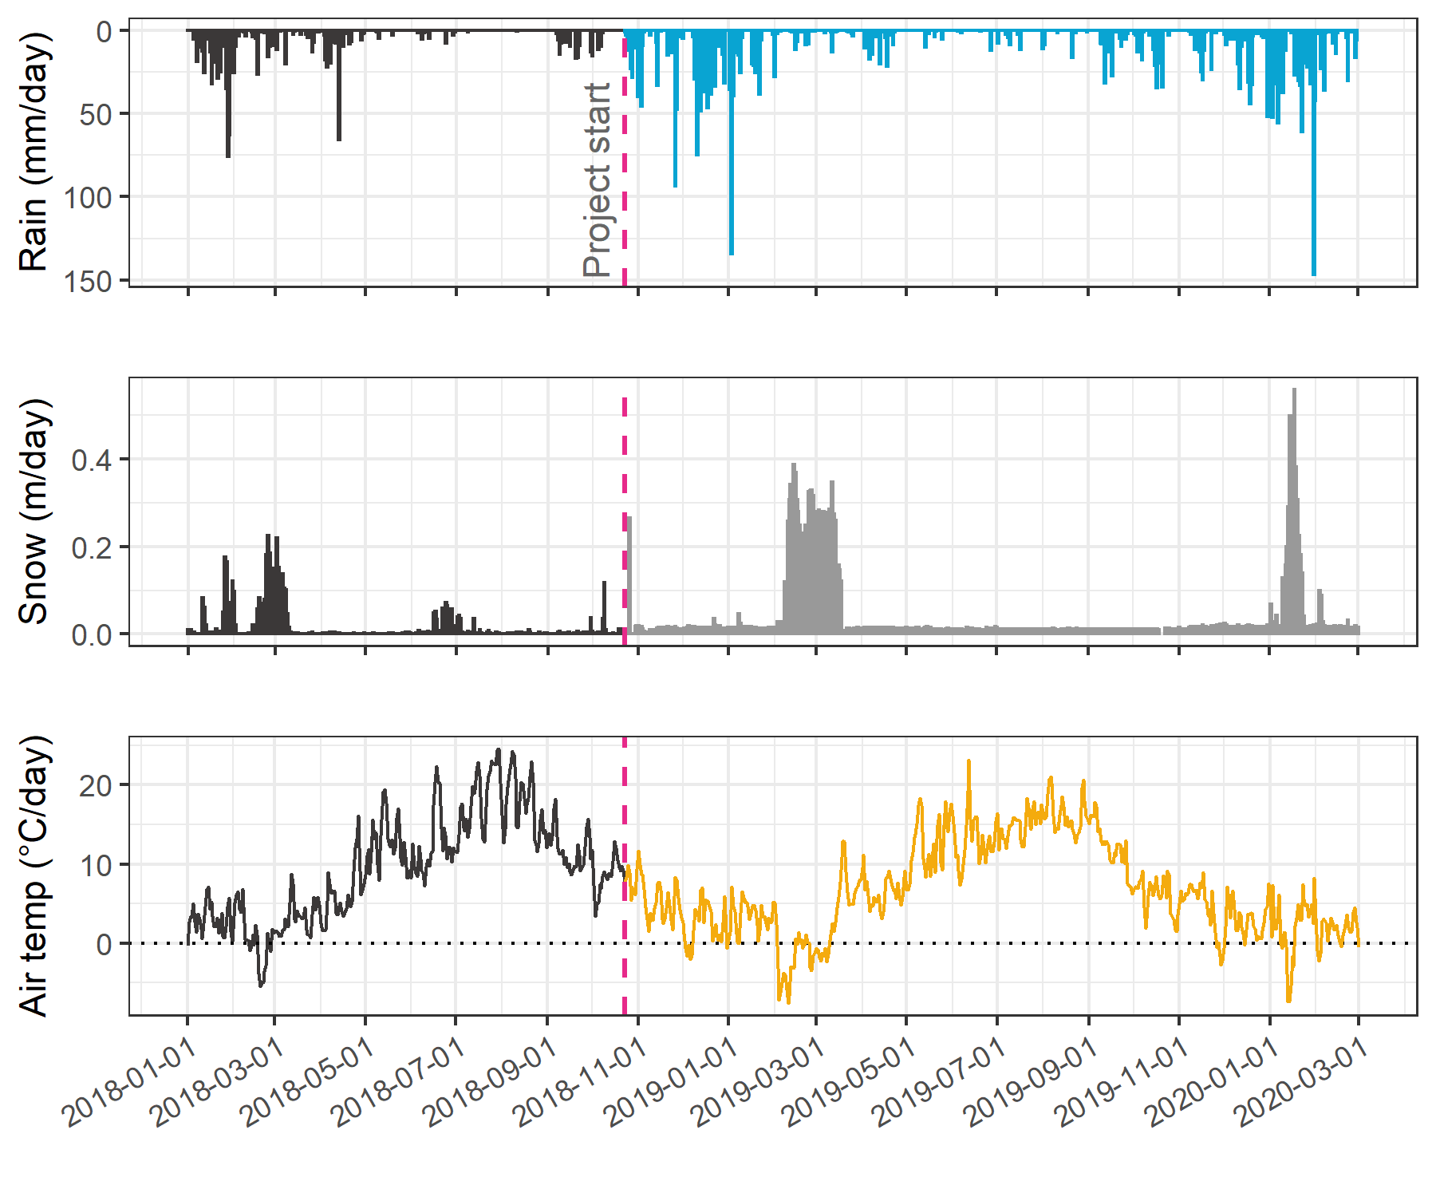

Figure 4: *Average weather from two stations in the Leech water supply area, where the highlighted section indicates the study period.*

###### Defining seasons

Coastal BC climate is characterized by a predominantly wet season and dry season and while the dry season often includes periods of drought there is generally some rainfall throughout the entire year (Figure 4). For this research, seasons were operationally defined by sampling method restrictions such that the “wet” season was defined as the period when rainfall generated stream response significant enough for Vertical Racks to collect rising limb samples, and the “dry” season was defined by the absence of rainfall response substantial enough for Rack sampler collection. The R package *Rainmaker* (github.com/USGS-R/Rainmaker) was used with LWSA rain data (average of Chris Creek and Martin’s Gulch FWx stations) to define events that corresponded to Rack sampling, which helped to distinguish between seasons. Snow was qualitatively considered when defining seasons, as it did not contribute to event definitions but did contribute to stream levels at each monitoring site.

### Results

Over the sixteen-month field study, 426 river samples were collected and analyzed for DOC, and 318 of those samples were analyzed for NOM by UV-Vis (Table 4). Fewer samples were analyzed for UV-Vis properties than for DOC concentration due to method evolution at the start of the project and instrument-sharing limitations. Of the samples collected and analyzed, DOC data were filtered and reduced by 9.2% (to 387 samples) during quality control checks (described below) and UV-Vis data were reduced by 19.5% (to 256 samples). Quality control resulted in a 9% reduction in UV-Vis data and an additional 10.5% data loss was unfortunately caused during instrument maintenance.

Table 4: *Summary of samples collected*

|  |  |  |  |  |
| --- | --- | --- | --- | --- |
| type of sample collected | total collected & analyzed for DOC | data included in DOC results | total collected & analyzed for NOM | data included in NOM results |
| synoptic Grabs outside of monitoring sites | 48 | 48 | 42 | 42 |
| opportunistic Grabs | 22 | 21 | 12 | 11 |
| monitoring sites synoptic Grabs | 153 | 148 | 114 | 103 |
| monitoring sites vertical Rack | 203 | 170 | 150 | 100 |
| total | 426 | 387 | 318 | 256 |

#### Vertical Rack sampling quality control

Hold-time experiments were conducted at the Tunnel site to assess stability of river water samples held in siphon bottles on the vertical rack. Three sets of samples were used in hold-time experiments, each set included samples held on the rack for different periods and the timing and air temperatures for each set were assessed (Figure 5).



Figure 5: *Plot of air temperature during vertical rack hold-time experiments. Red horizontal lines indicate the 0-7°C range of a typical laboratory refrigerator and dashed vertical lines separate the three sets of hold-time samples from collection of grab samples to retrieval of held samples.*

Each hold-time set included ten replicate samples, each collected at the same time in the same way from the same location. For each hold-time set, five samples were returned to the lab for immediate quantification of DOC and measurement of UV-Vis absorbance (“fresh” samples) and five were placed on the vertical rack, capped with siphon lids to simulate rack samples, and collected at a later date for analysis (“held” samples).

All samples were analyzed to quantify DOC and characterized NOM properties (Figure 6), and the fresh and held samples of hold-time set were compared using two-sided paired Wilcoxon signed rank tests (a.k.a ‘Mann-Whitney’ test, non-parametric paired difference test that does not assume normally distributed data). To err on the side of caution, a 90% confidence level was used to evaluate the comparisons between fresh and held samples. Results of hold-time comparisons considered the timing of sample collection, the number of days the rack samples were held, the mean air temperature over that period, and the percent change in analytical results (Table 5).

 the order of plot and words was rearranged here a bit, same content



Figure 6: *Sample DOC concentrations and UV absorbance at 254nm contrasting hold-time samples from collection of grab samples to retrieval of held samples.*

Table 5: *Results comparing three vertical-rack hold-time sets*

|  |  |  |  |  |  |  |  |  |  |  |
| --- | --- | --- | --- | --- | --- | --- | --- | --- | --- | --- |
| Set | Days held | Air temp. | DOC change (%) | p-value (DOC) | SAC254 change (%) | p-value (SAC254) | SUVA254 change (%) | p-value (SUVA254) | E2:E3 change (%) | p-value (E2:E3) |
| A | 11 | 7.1 ± 2.2 | -45* | 0.0625 | 0 | 0.1250 | 80* | 0.0625 | -1 | 0.1250 |
| B | 20 | 6.0 ± 2.7 | 1 | 0.4375 | -8* | 0.0625 | -10* | 0.0625 | 0 | 0.8125 |
| C | 34 | 4.3 ± 3.2 | -23 | 0.1875 | -34* | 0.0625 | -9 | 0.6250 | -14* | 0.0625 |

*Note:* one star (*) indicates significant difference at 90% confidence (p < 0.1), two stars (**) indicates significant difference at 95% confidence (p < 0.05)

There was a significant change in DOC concentration (at 90% confidence, p-value = 0.063) for hold-time set-A, where mean DOC concentration was 45% lower in the held samples compared to the fresh grab samples. While there was no change in UV absorbance (i.e. SAC254 and E2:E3) for samples from hold-time set-A, the change in DOC generated a significant difference in SUVA254. Samples collected for hold-time set-A were DOC-rich “first flush” samples, and the Rack samples were held for 11 days at average temperature of 7° C (slightly above laboratory refrigerator temperatures).

Set-B had a hold-time of 20 days with average air temperature of 6° C. There were no significant changes to DOC concentrations or E2:E3 values between fresh and rack-held samples for this set. Wilcoxon tests for set-B showed that the 8% change in SAC254 was statistically significant (at 90% confidence). However, the SAC254 difference in set-B was determined to be caused by an outlier which could be rejected with 99% confidence by Dixon’s Q-test (Qexp = 0.941 > Qcrit = 0.821). Therefore, it was concluded that, despite the measured difference (Figure 6, Table 5) there was not truly a reliable change in SAC254 (or SUVA254, which relies on SAC254) for hold-time set-B.

Hold-time set-C included samples held for 34 days at an average of 4.4° C, including a period of sub-zero temperatures. While set-C did not yield statistically significant changes in DOC concentration (23% DOC reduction from fresh to held), there were significant changes to SAC254 (34% decrease in absorbance), and E2:E3 (14% decrease). In addition to the change in absorbance, rack-held set-C samples had greater variability for both all variables compared to the fresh sample counterparts.

Results of these hold-time experiments suggest that early-season (“first flush”) samples may contain more labile and aliphatic DOC which is unstable and should be analyzed immediately after collection, whereas later season samples contain DOC which is relatively more stable for up to and including 20 days when held at temperatures that approximate a refrigerator. A hold-time of 34 days with periods of freezing resulted in significant changes to sample NOM molecular character; and while DOC concentrations were not statistically altered, there was a notable increase in held sample DOC standard deviation. Additional tests would be required to determine if the change in NOM character was caused by the length of time the sample was held, or perhaps due only to freezing and thawing, or a combination of both time and temperature. Based on these results, sample analyses data were updated to include quality-assurance/quality-control (QA/QC) flags which were used to filter sample data, reducing the effective number of samples included in results by less than 10% (Table 4).

Hold-times were calculated for each sample as the time between sample collection and analysis. Any sample that remained held for fewer than 20 days at temperatures between 0-7° C were flagged as acceptable for further data analysis; Rack samples that were held for 20 days or longer were flagged for exceeding a reliable hold-time; and samples identified as early-wet-season (“first-flush”) that had a hold-time of 7 days or longer were flagged as unacceptable and not included in further data analysis. Because of possible freeze-thaw changes to DOC and NOM, any sample that underwent suspected or confirmed freezing was also flagged for temperature effects. Hold-time temperatures (daily means) at each monitoring site were measured and recorded with Hobo TidbiT loggers from 2019-08-24 to 2020-02-18 (field study end), and temperatures prior to TidbiT deployment were estimated by linear regression (Appendix ###).

#### Seasonal delineation

Wet seasons were defined by conditions that generated significant stream responses and Vertical Rack sample collection, and the dry season was defined by baseflow conditions with no detectable stream responses at the Vertical Racks. LWSA rain data were used to define rain events using the USGS *Rainmaker* package in R (‘RMevents’ function), which determined there were 18 major events that corresponded to Vertical Rack sample collection. The conditions that defined major rain events were precipitation accumulating to 50 mm or more, with a period of at least 14 hours passing between 50 mm events. As major rain events were defined based on Rack sampling responses, they were the primary method of delineating seasons, where the wet season was defined by the presence of major rain events and the dry season was defined by their absence. However, there was a period of surprising snowfall in the winter of 2018/2019, during which time rainfall runoff subsided but the eventual melt generated streamflow response across the monitoring sites. Therefore, that period of snow accumulation and melt was included when defining wet seasons, despite the lack of major rain events (Figure 7).



Figure 7: *Plot of LWSA weather, stream response and sample collection at the six monitoring sites across the LWSA. Seasons were separated by stream responses and conditions that initiated or ceased rack sample collection.*

#### Spatial patterns in DOC & NOM

Several comparisons can be made among the twelve synoptically sampled river sites (refer to Figure 2); presented here are comparisons of cross-basin (from LWSA to SWSA) and upstream to downstream, and sampling methods evaluated with respect to nested catchments and DOC range.

##### Cross-basin & upstream/downstream DOC comparison

Mean DOC concentrations were similar when comparing across basins from the current source water tributaries, Rithet and Judge Creeks, to the future supplemental supply, Leech River at the Tunnel (Table 6). From upstream to downstream sites there was an overall decreasing trend for DOC concentrations and NOM aromaticity and/or molecular size (Figure 8).

Table 6: *Dissolved organic carbon concentrations across twelve synoptically sampled river sites*

|  |  |  |  |  |  |  |  |  |
| --- | --- | --- | --- | --- | --- | --- | --- | --- |
| site | description | count | DOCmean | DOCsd | RSD | DOCmin | DOCmedian | DOCmax |
| Weeks | headwater of Leech Rv., LWSA | 49 | 9.9 | 3.4 | 34 | 3.78 | 9.7 | 19.1 |
| ChrisCrk | headwater of Leech Rv., LWSA | 42 | 4.9 | 2.1 | 42 | 1.84 | 4.7 | 9.2 |
| LeechHead | mainstem river, LWSA | 44 | 7.2 | 1.7 | 24 | 3.95 | 6.9 | 11.6 |
| Jarvis-crk | headwater of Cragg Crk., LWSA | 12 | 9.7 | 2.9 | 30 | 5.92 | 9.7 | 16.7 |
| Lazar-crk | headwater of Cragg Crk., LWSA | 9 | 6.3 | 1.7 | 27 | 3.69 | 6.5 | 8.6 |
| CraggCrk | mainstem river, LWSA | 62 | 4.7 | 1.5 | 33 | 1.79 | 4.4 | 8.2 |
| WestLeech | mainstem river, LWSA | 57 | 5.8 | 2.4 | 41 | 2.00 | 5.5 | 10.9 |
| Leech-Beach | below confluence of WestLeech with Leech Rv. | 3 | 4.7 | 1.2 | 26 | 3.27 | 5.1 | 5.6 |
| Tunnel | inlet of Leech Tunnel, LWSA outlet | 64 | 4.8 | 1.8 | 39 | 1.65 | 5.0 | 9.0 |
| Rithet-crk | key tributary to Sooke Reservoir, SWSA | 13 | 5.4 | 3.9 | 71 | 1.64 | 3.5 | 12.7 |
| Judge-crk | key tributary to Sooke Reservoir, SWSA | 6 | 5.7 | 1.1 | 20 | 4.42 | 5.3 | 7.6 |
| Deception | outlet of Leech Tunnel, SWSA | 5 | 4.2 | 1.8 | 43 | 2.16 | 4.1 | 7.0 |
| all sites | summary | 366 | 6.1 | 2.9 | 48 | 1.64 | 5.7 | 19.1 |

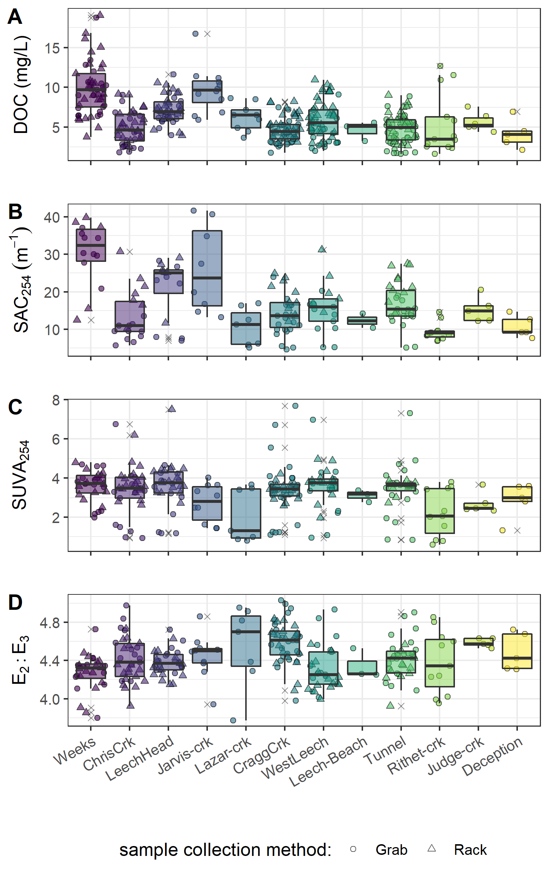

Figure 8: *Synoptic sampling results of dissolved organic carbon concentrations from 12 sites over 16 months.*

Table 7: *Spectral properties of natural organic matter (NOM) character across twelve synoptically sampled river sites*

|  |  |  |  |  |  |  |  |  |  |  |
| --- | --- | --- | --- | --- | --- | --- | --- | --- | --- | --- |
| Site | Description | Count | Mean SAC254 (m-1) | sd (±) | SAC254 Min. (m-1) | SAC254 Max. (m-1) | Mean E2E3 | sd (±) | E2E3 Min. | E2E3 Max. |
| Weeks | headwater of Leech Rv., LWSA | 28 | 30.3 | 8.5 | 12.49 | 39.82 | 4.3 | 0.2 | 3.80 | 4.73 |
| ChrisCrk | headwater of Leech Rv., LWSA | 33 | 13.5 | 6.7 | 5.68 | 30.72 | 4.4 | 0.2 | 3.92 | 4.98 |
| LeechHead | mainstem river, LWSA | 31 | 21.3 | 7.9 | 7.04 | 29.03 | 4.4 | 0.1 | 4.15 | 4.72 |
| Jarvis-crk | headwater of Cragg Crk., LWSA | 10 | 26.1 | 11.7 | 13.26 | 41.66 | 4.4 | 0.2 | 3.94 | 4.86 |
| Lazar-crk | headwater of Cragg Crk., LWSA | 7 | 10.6 | 5.0 | 5.18 | 16.98 | 4.5 | 0.4 | 3.77 | 4.95 |
| CraggCrk | mainstem river, LWSA | 44 | 14.4 | 5.5 | 4.69 | 24.87 | 4.6 | 0.2 | 3.98 | 5.03 |
| WestLeech | mainstem river, LWSA | 29 | 15.7 | 6.4 | 5.20 | 31.18 | 4.3 | 0.2 | 3.99 | 4.94 |
| Leech-Beach | below confluence of WestLeech with Leech Rv. | 3 | 12.3 | 2.7 | 10.39 | 14.17 | 4.3 | 0.2 | 4.25 | 4.53 |
| Tunnel | inlet of Leech Tunnel, LWSA outlet | 34 | 16.9 | 5.6 | 5.18 | 27.49 | 4.4 | 0.2 | 3.92 | 4.91 |
| Rithet-crk | key tributary to Sooke Reservoir, SWSA | 11 | 9.4 | 2.4 | 6.85 | 14.62 | 4.4 | 0.3 | 3.95 | 4.85 |
| Judge-crk | key tributary to Sooke Reservoir, SWSA | 5 | 15.3 | 3.4 | 12.30 | 20.59 | 4.6 | 0.0 | 4.53 | 4.63 |
| Deception | outlet of Leech Tunnel, SWSA | 5 | 10.7 | 2.9 | 7.70 | 14.69 | 4.5 | 0.2 | 4.31 | 4.72 |
| all sites | summary | 240 | 16.9 | 8.4 | 4.69 | 41.66 | 4.4 | 0.2 | 3.77 | 5.03 |

##### Nested catchments, DOC and sample-type comparison

As the Leech River Tunnel will be the point of diversion for future inter-basin transfers from Leech water supply area (LWSA) to the Sooke Reservoir basin, the Tunnel (site 6) is the effective outlet of the LWSA where runoff from each nested catchment is integrated.

From a headwaters perspective, Weeks and ChrisCrk (sites 1 & 2) are integrated at LeechHead (site 3), which is just below the headwaters’ confluence. And Jarvis and Lazar creeks are ultimately integrated at CraggCrk site; however, there was a greater distance between CraggCrk and its headwaters’ sampling sites compared to LeechHead and its headwaters’ locations (see Figure 2).

Within these nested catchments, sampling methods were evaluated through three comparison sets to assess whether a Rack sampler combined with Grab sampling downstream of a confluence captured the same range in DOC concentrations as synoptic Grab sampling alone at upstream sites (Figure 9). Synoptic Grab samples from the headwater sites of Weeks and ChrisCrk were compared to Rack and Grab samples from below their confluence at LeechHead site (Figure 9, plot A). Similarly, Grab samples collected at the headwaters of Cragg Creek, Jarvis and Lazar creeks, were compared to all samples at the CraggCrk monitoring site (Figure 9, plot B). Higher order rivers were also examined in a similar way, comparing Rack and Grab samples at the Tunnel to Grab samples collected upstream at LeechHead, CraggCrk and WestLeech sites (Figure 9, plot C).

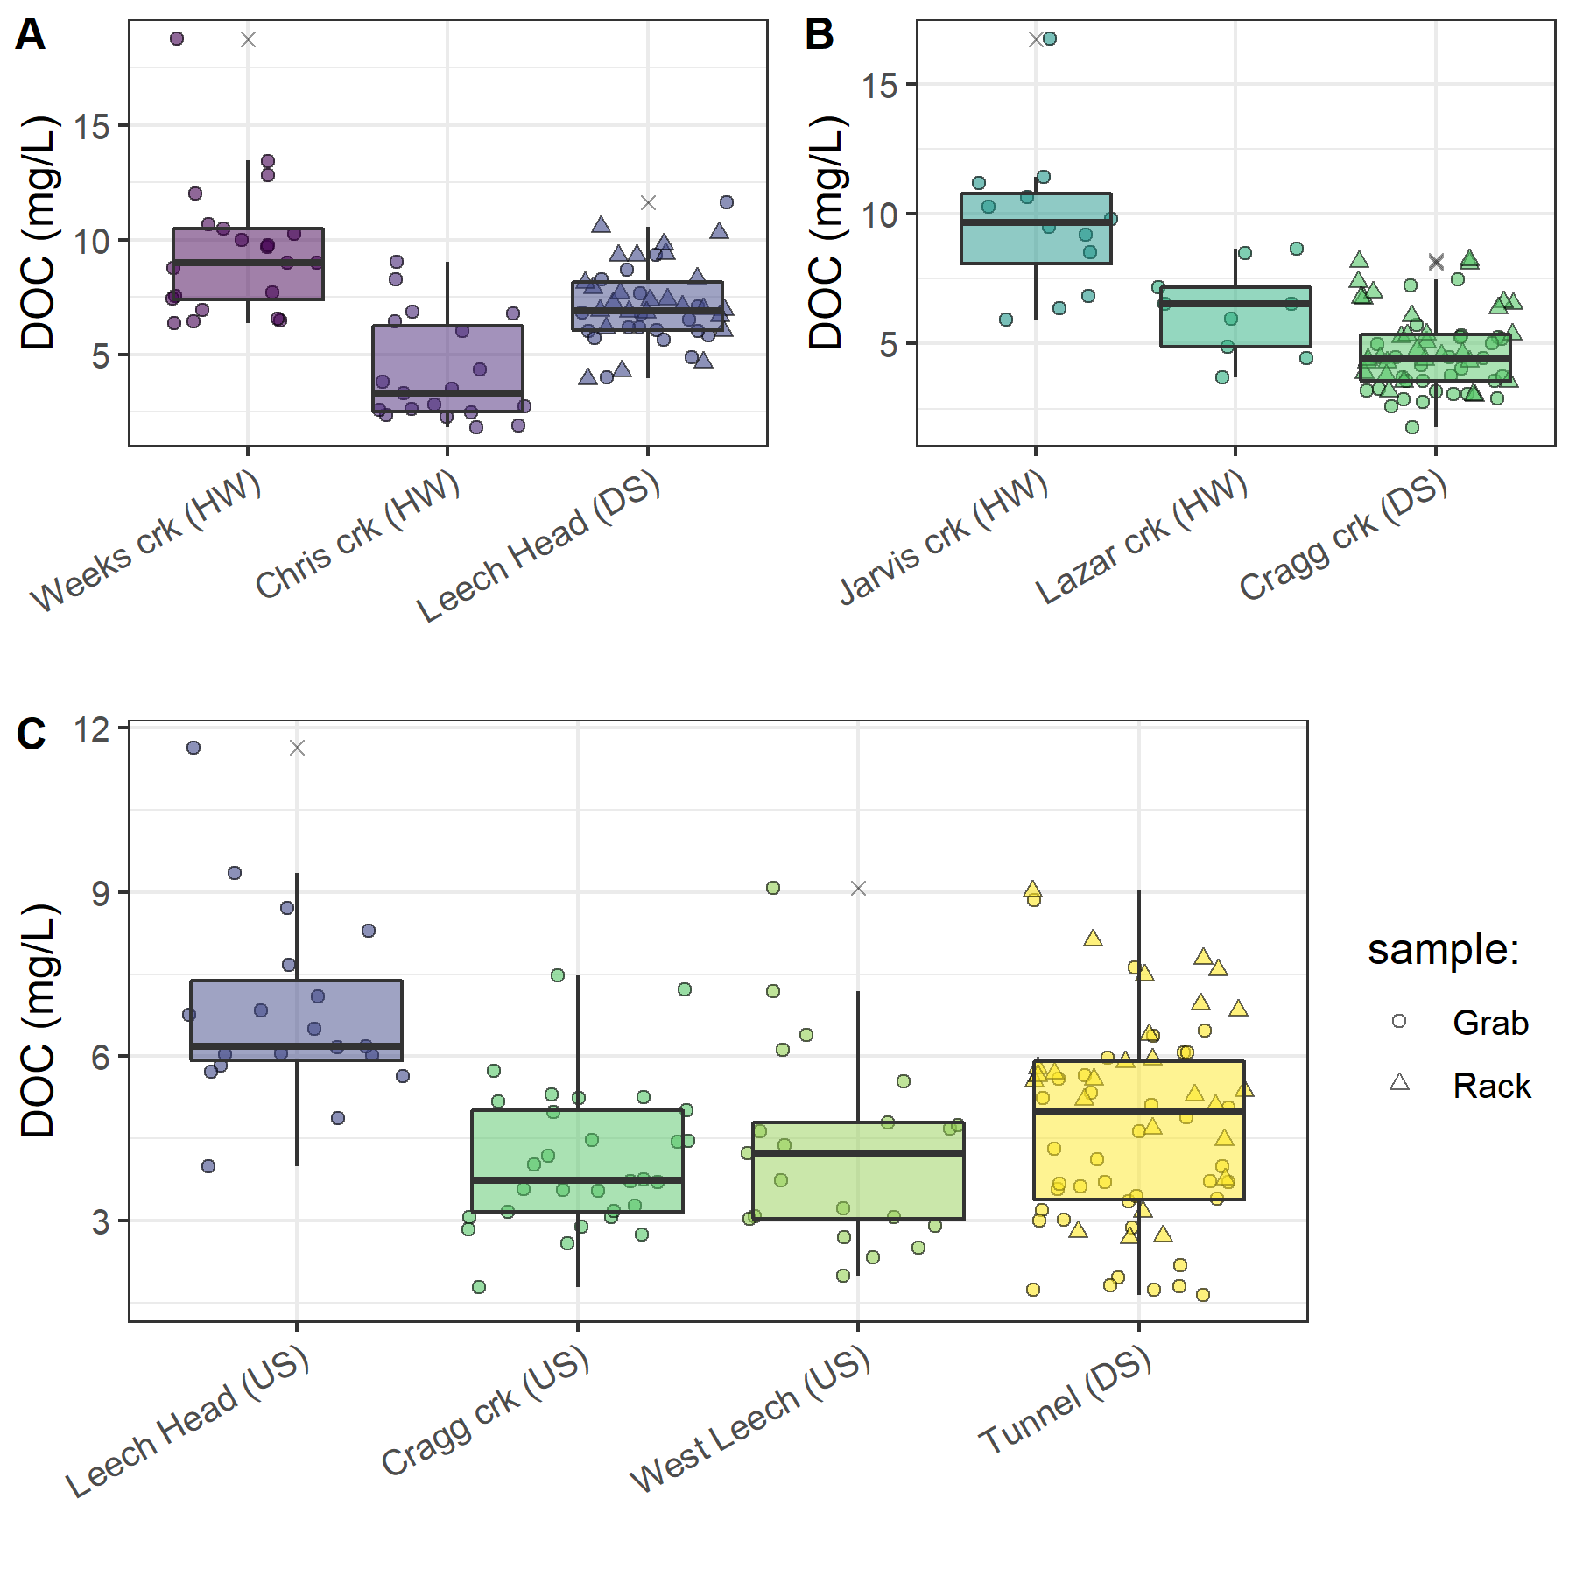

Figure 9: *Grab sample DOC at upstream locations compared to Rack and Grab sample DOC below their confluence(s). A and B show grab samples from headwaters (HW) compared to downstream (DS) monitoring sites; C shows upstream river sites (US) compared to mainstem monitoring.*

Below the confluences of headwaters sites, the combination of Rack and Grab sampling did not capture the ranges of DOC observed in upstream Grab samples alone. LeechHead, below the confluence of Weeks and ChrisCrk, collected DOC concentrations that were close to the average of the two headwaters. The variance obtained by combining Rack and Grab samples downstream was not the same as upstream Grab sampling variance (Levene’s test for homoscedasticity p-value = 3.8 x 10-5). Similarly, Rack and Grab samples collected at CraggCrk did not cover the same DOC variance as Grab sampling at the headwaters (Levene’s p-value 0.0011). Unlike LeechHead, which had moderate DOC concentrations relative to it’s two headwaters, samples collected at CraggCrk had DOC that was lower than concentrations in either of it’s headwater sites. The differences in DOC attenuation between these two sets can be attributed to different reach lengths between headwaters’ confluence and the downstream monitoring sites; where LeechHead was very close to the headwaters’ confluence and CraggCrk was considerably further from it’s headwaters’ sampling locations.

When higher order rivers were examined in a similar upstream-Grab/downstream-Rack’n’Grab comparison, the combination of Rack and Grab samples at the Leech Tunnel site did capture the DOC ranges observed in Grab samples at three upstream river sites (Figure 9, plot C). Levene’s test for homogeneity of variance (homoscedasticity) confirmed that there was no difference in DOC variance in the downstream Rack/Grab combination results compared to Grab-only from upstream (p-value 0.165). Similar trends were seen for SAC254 but not E2:E3 (Appendix ####).

#### Temporal patterns in DOC & NOM

Over sixteen months, DOC concentrations followed similar trends across the synoptic sampling sites (Figure 10). DOC was highest early in the wet season and progressively decreased through the fall and winter, reaching minimum concentrations in the spring, and progressively increasing over the summer.

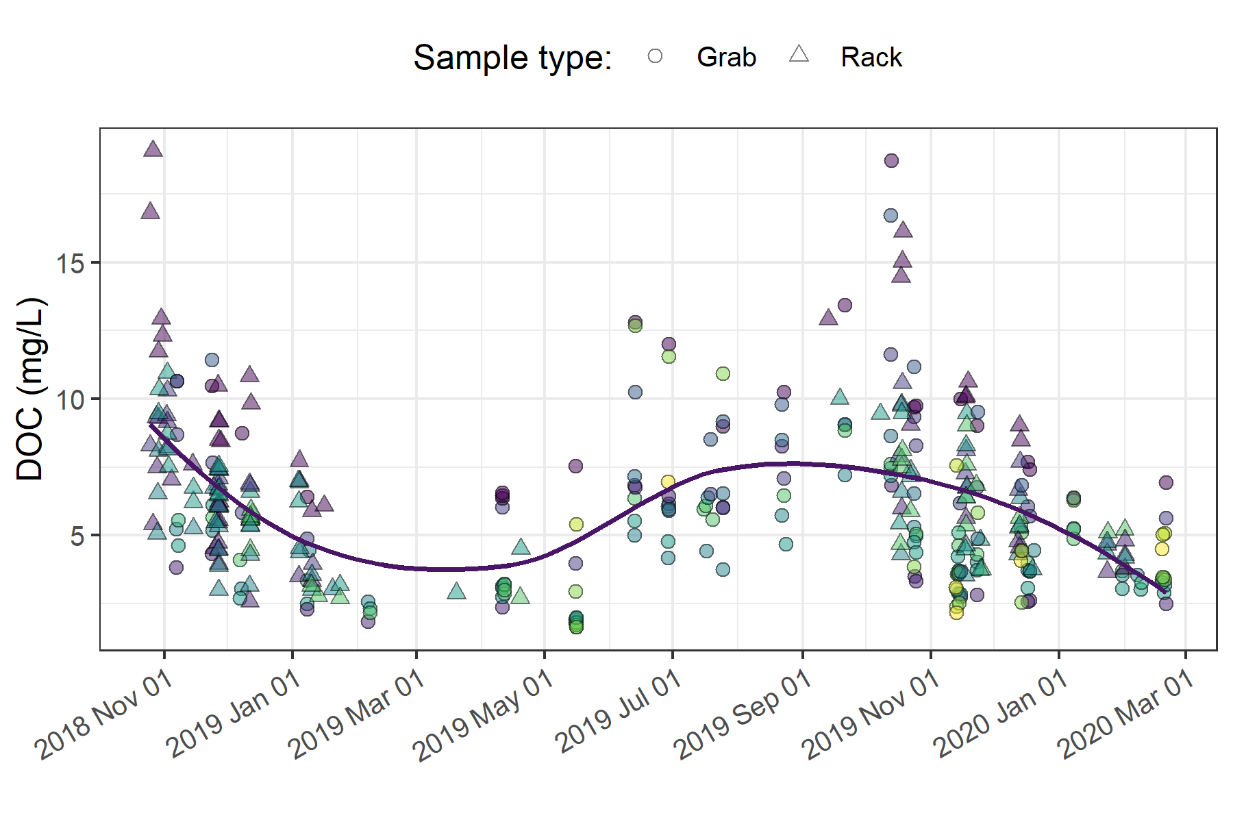

Figure 10: *Trends in dissolved organic carbon concentrations over sixteen months at twelve sites across the Greater Victoria Water Supply Area. Trend line shows locally weighted smoothing (loess, local polynomial regression).*

While there was an apparent sinusoidal trend in DOC over the seasons sampled (Figure 10), there was almost no difference between the mean DOC concentration between the wet and dry seasons (Table 8). However, there were far fewer samples collected in the dry season than during the wet season.

Table 8: *Seasonal sample collection and DOC summary from twelve synoptic sampling sites*

|  |  |  |  |  |  |  |  |
| --- | --- | --- | --- | --- | --- | --- | --- |
| Season | Sample count | Mean DOC (mg/L) | sd (± mg/L DOC) | RSD (± %) | Min. (mg/L) | Median (mg/L) | Max. (mg/L) |
| dry | 55 | 6.13 | 2.99 | 49 | 1.6 | 6.1 | 12.8 |
| wet | 311 | 6.14 | 2.91 | 47 | 1.8 | 5.6 | 19.1 |
| all | 366 | 6.14 | 2.92 | 48 | 1.6 | 5.7 | 19.1 |

The wet season was most heavily sampled at the six monitoring sites, where Rack samplers more than doubled the number of samples that would have been collected through Grab sampling alone. Isolating DOC results to the six monitoring sites during only the wet season allows for comparison of Vertical Rack sampling methods to standard synoptic Grab sampling (Figure 11, Table 9).

Table 9: *Wet season DOC by sample collection method at the six monitoring sites*

|  |  |  |  |  |  |  |  |
| --- | --- | --- | --- | --- | --- | --- | --- |
| sample_type | count | DOCmean | DOCsd | RSD | DOCmin | DOCmedian | DOCmax |
| Grab | 109 | 5.22 | 2.74 | 53 | 1.8 | 4.4 | 18.7 |
| Rack | 170 | 6.79 | 2.80 | 41 | 2.6 | 6.4 | 19.1 |
| all | 366 | 6.14 | 2.92 | 48 | 1.6 | 5.7 | 19.1 |



Figure 11: *DOC from each monitoring site grouped by collection method (synoptic Grab vs. Vertical Rack samples).*

Vertical Racks captured higher DOC concentrations than synoptic Grab sampling alone and the two methods collected samples with comparable variance (Table 9). These results are in agreement with other studies that found higher DOC concentration on the rising limb of the hydrograph compared to non-event samples (e.g. (Yang et al. 2015; Raymond et al. 2016, 2010)).

##### Seasonal changes in NOM character

Molecular aromaticity is associated with chromophores which are responsible for UV-Vis absorbance in aqueous NOM, therefore more aromatic NOM molecules (i.e. humic substances) will absorb more energy at 254 nm wavelength than less-aromatic molecules. To evaluate if (and when) molecular character of river samples shifted, DOC concentrations (NPOC) were compared to absorbance-based DOC estimates from the spectro::lyser (Figure 12).

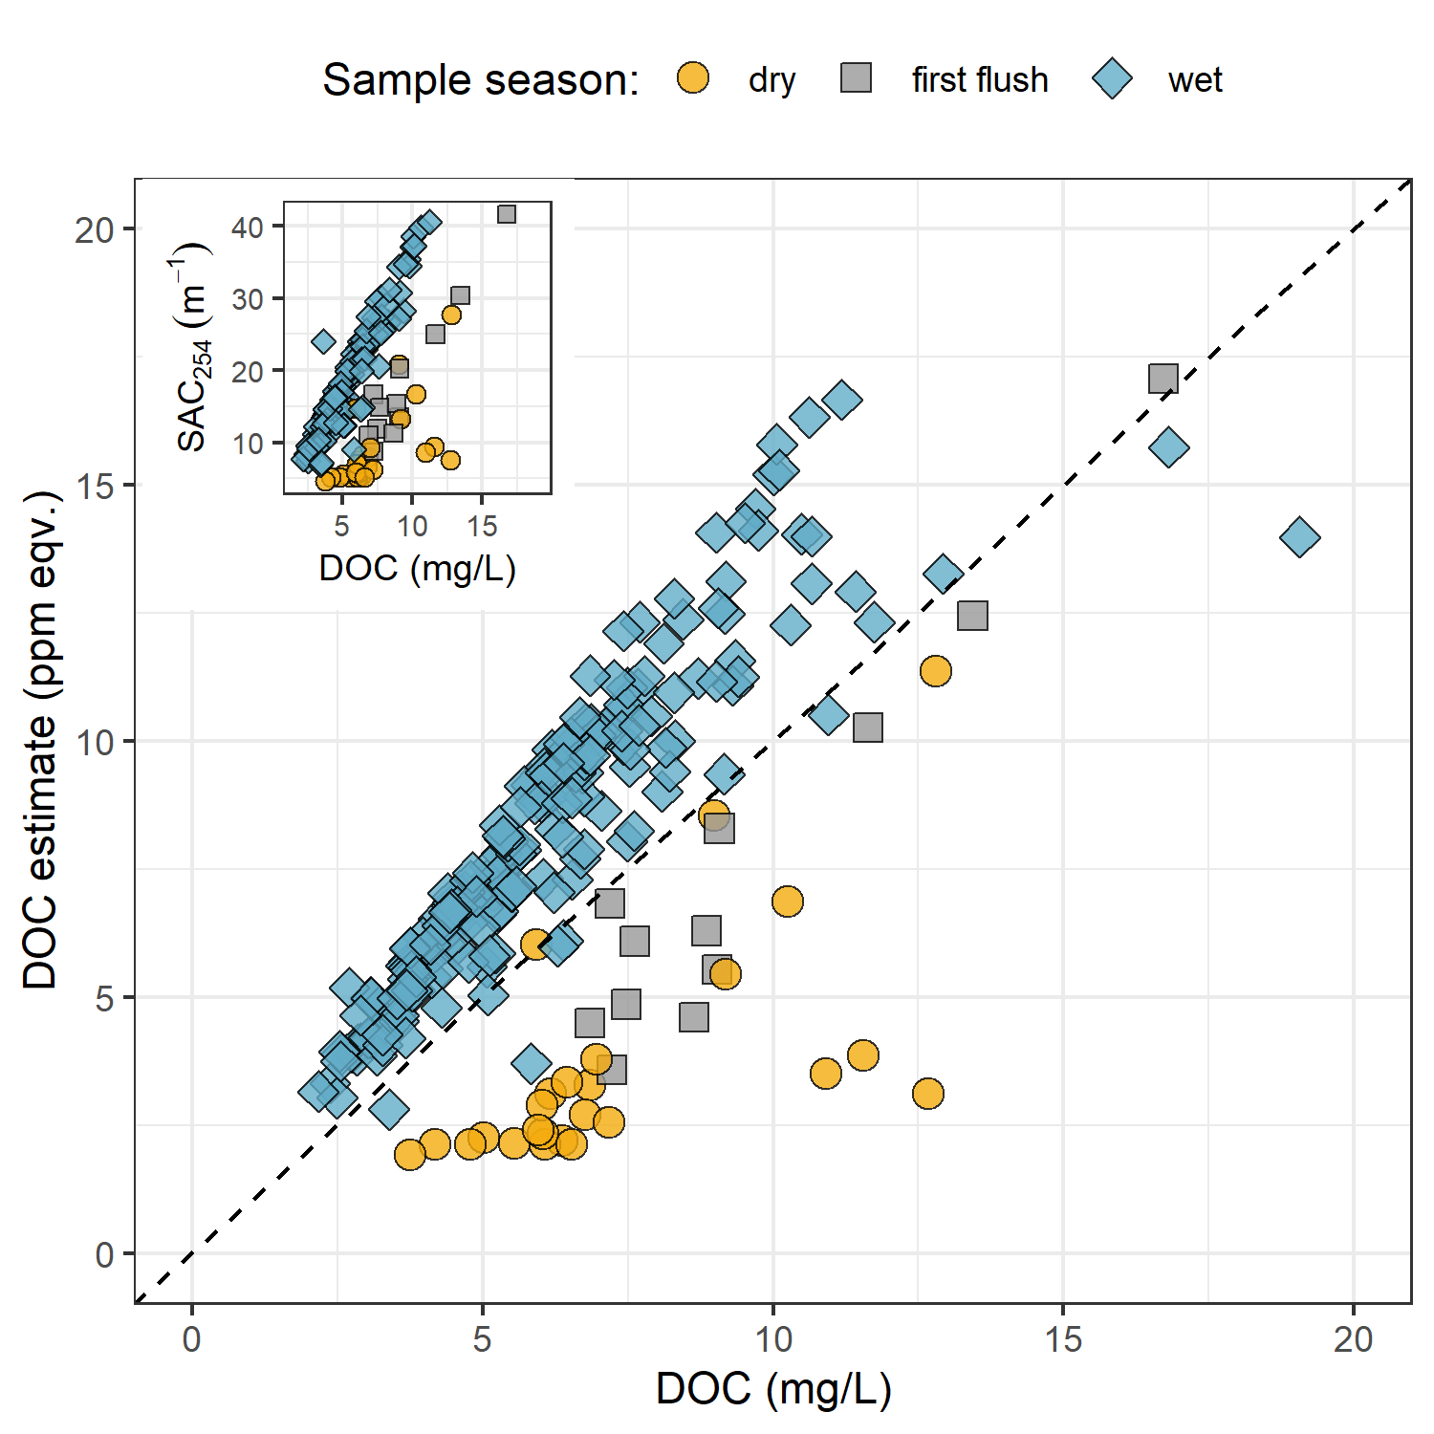

Figure 12: *Dissolved organic carbon measured directly (as NPOC) plotted against concentration estimated via UV-Vis spectroscopy, grouped by sampling season. The dashed lined indicates best fit (1:1), and the inset shows the relationship between NPOC and SAC at 254 nm, a key absorbance that informs the UV-estimated DOC concentration.*

Characteristics of wet-season samples caused positive bias in absorbance-based DOC estimates, while dry-season sample characteristics lead to negative bias in UV-based DOC estimates. The separation of wet and dry season samples suggests that river NOM had more aromatic character (more humic-like, allochthonous NOM) during the wet-season than during the dry-season.

The concentration of NOM in a sample is proportional to the intensity of absorbance (based on the Beer-Lambert law) which is why SUVA254 (specific UV absorbance at 254 nm) is widely used as indicator of sample aromaticity (concentration-relative character). Seasonally grouped DOC and SUVA254 (Figure 13), also indicated a greater aromatic character in river water samples during the wet season compared to the dry season.

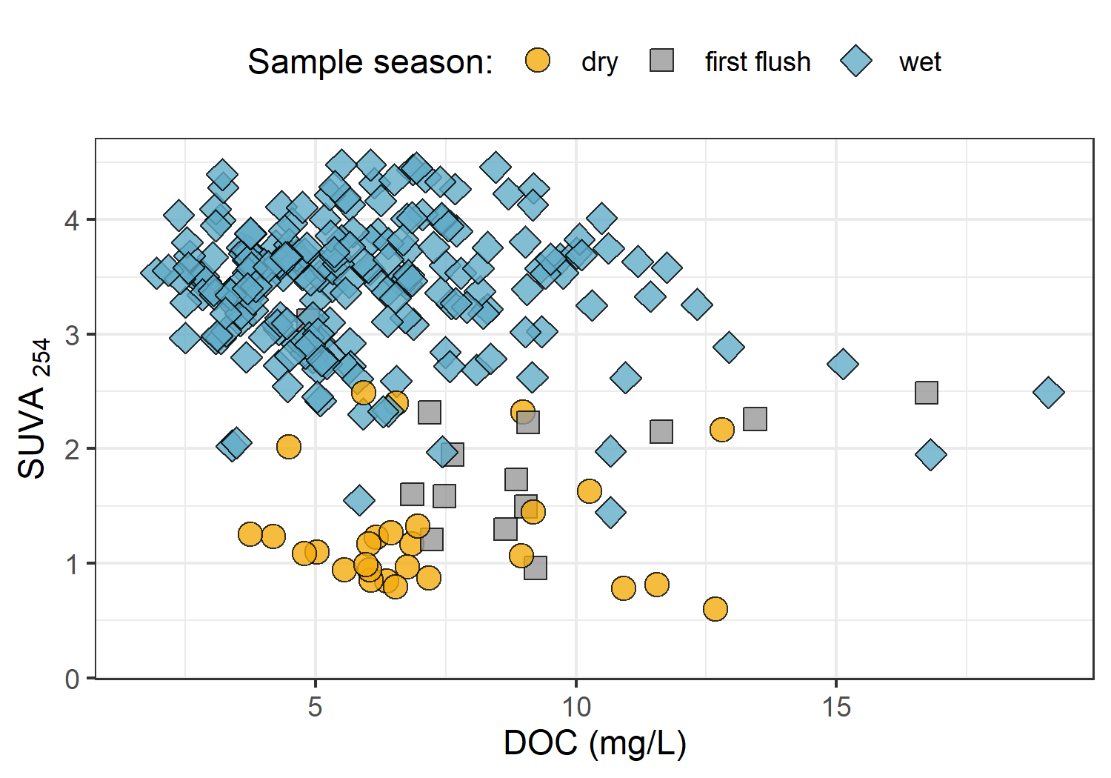

Figure 13: *Dissolved organic carbon plotted against specific UV absorbance at 254 nm, showing greater aromaticity (more humic-like organic matter) in wet season samples.*

### Discussion

The objective of this work was to design a sampling strategy to measure the ranges of DOC concentration and NOM character between adjacent drainage basins and among nested sub-catchments and to evaluate the influence of seasonality on concentration of DOC and character of NOM. The sampling strategy was a combination of synoptic Grab sampling across twelve sites in the Greater Victoria water supply area in tandem with Vertical Rack sampling at six of those sites in the Leech water supply area (LWSA).

Vertical Racks were a consistent and comparable method of reproducible sample collection that proved important for passively capturing higher DOC concentrations which were not observed through Grab sampling alone. These results are in agreement with other studies that found higher DOC concentration on the rising limb of the hydrograph compared to non-event samples (e.g. (Yang et al. 2015; Raymond et al. 2016, 2010)). Rack sampling more than doubled the number of samples that would have been collected through Grab sampling alone. Therefore, the Vertical Rack method was a useful tool for collection of event-based samples with increased sampling frequency. Questionable sample hold-times resulted in a few occasions when logistics or high water limited safe immediate retrieval of Vertical Rack samples. However, the Vertical Rack method employed in this project allowed for calculation of sample hold-times, quality-control evaluation or data for processing of acceptable samples only.

From 366 quality controlled river water samples collected over 16 months, DOC ranged from 1.6 to 19.1 mg/L (5.7 mg/L median) with mean DOC of 6.1 ± 2.9 mg/L. The relative standard deviation for DOC in each of the synoptically sampled sites was at least 24% and at most 71%, indicating a wide range of variance among the sites. Overall, DOC decreased in concentration from upstream to downstream and followed a sinusoidal trend over time.

Seasonality was evaluated by operationally separating time into wet and dry seasons, where the wet season corresponded with weather events that generated streamflow response sufficient enough for Vertical Racks to collect samples and the dry season was confined to Grab sampling only (no river responses). While the absolute magnitude of DOC varied between sites, the general temporal trends were similar across the study area. DOC was highest in the early wet season, then progressively decreased through the wet season. DOC was lowest during the coldest periods, and concentrations of DOC increased over the summer. Spectroscopic analyses indicated that the wet season NOM was predominantly humic (i.e., aromatic) content and the summer carbon was derived from more aliphatic NOM sources. These observations support a shift in NOM source pools from autochthonous in the dry (summer) period to allochthonous in the wet season when the landscape was more connected to the river systems. The seasonal shifts observed in this project agree with the shift from autochthonous to allochthonous NOM that is predicted by the river continuum concept (Vannote et al. 1980; Meyer and Tate 1983).

At the future point of diversion (5th order river), it was found that the combination of Vertical Rack and Grab samples collected the same variance in DOC that was observed in Grab samples upstream across three 4th order river sites (LeechHead, CraggCrk, WestLeech). This indicates that well-represented water quality monitoring for the LWSA could achieved by combining event-based (i.e. Vertical Rack) sampling with standard Grab sampling at the future point of diversions. In the headwaters, however, Racks combined with Grab samples at 4th order streams did not capture the variance in DOC observed upstream in Grab samples from 3rd order (headwater) stream samples. The longitudinal attenuation of DOC observed in the LWSA is promising for experimental forest fuel treatments (e.g. prescribed burning) in the headwaters, and is a positive indication for future inter-basin transfers and drinking water treatability.

* DOC scaling from upstream to down stream – comparable to JimButtle Turkey Lakes studies

### Conclusions and future directions

Longitudinal attenuation in DOC (decreasing concentrations from upstream to downstream) and SAC254 were observed across the sampling sites as was a seasonal shift from autochthonous NOM sources in the dry season to allochthonous NOM sources in the wet season. The structural changes to NOM that occurred seasonally are a strong indicator that site-specific calibrations should be performed at least a few times a year if DOC/NOM is monitoried by UV-Vis *in-situ*. DOC concentrations were typically higher than BC source water Guidelines suggest, however it should be noted that if Leech River water is transferred to a reservoir prior to treatment that NOM is likely to be photodegraded or diminished through microbial processing.

Expanded comparisons between the Leech Tunnel site, Rithet Creek and Judge Creek would be interesting from a source water perspective, particularly if conducted in conjunction with Sooke Reservoir water balance and residence time studies.

:)

## Leech monitoring sites and hydrodynamics

### Introduction

Natural organic matter (NOM) is a complex assembly of carbon-based molecules that exhibit dynamic variability across watersheds due to interconnected biotic and abiotic processes. NOM is a complicated medley of molecules so it can be challenging to quantify, but measuring organic carbon (the backbone of NOM) is standard and thus organic carbon is quantified as a surrogate for NOM. The molecular character of NOM can vary from large, highly aromatic compounds to smaller more aliphatic molecules and the differences in molecular makeup can be attributed to the source of NOM (e.g. terrestrial humic substances or in-stream algae, i.e. allochthonous or autochthonous NOM). Concentrations and character of NOM vary over space and time. The river continuum concept predicts a temporal shift in NOM character from autochthonous (e.g. algal) to allochthonous (e.g. humic material) sources, and a spatial reduction in NOM molecular diversity from headwaters to river mouth. The river continuum concept (RCC) explains temporal changes in NOM character through variable mobilization of source material and biogeochemical processing. Spatial-scaling of NOM diversity is attributed to hydrological processes and most watershed characteristics, including: geomorphic variables; physical impoundments; organic matter inputs and sources; sediment transport; solar inputs; and processing by aquatic invertebrates and microbes (Vannote et al. 1980; Stanley et al. 2012; Aiken, Hsu-Kim, and Ryan 2011; Zarnetske et al. 2018).

The Pulse Shunt Concept (PSC) supplements temporal aspects of the RCC by describing how hydrologic events drive the magnitude, timing and spatial extent of NOM fluxes and therefore are ultimately responsible for NOM concentrations in streams over time (Abbott et al. 2018; Creed et al. 2015; Zarnetske et al. 2018; Raymond et al. 2016). The RCC relies on in-stream biogeochemical processing to explain longitudinal attenuation of NOM character, and the PSC shows that intense hydrologic pulses (related to precipitation or melt events) override the rate of biogeochemical processing and force mass transport events.

##### Event based sampling

Given that brief flood events are often responsible for most of the DOC transport in a river system (Raymond et al. 2016), event-based water sampling is an important part of a water quality monitoring program. The rising limb of the hydrograph has been shown to have higher DOC concentration than low flows between storm pulses (Yang et al. 2015; Raymond et al. 2016, 2010; Zarnetske et al. 2018). The change in DOC concentration across the rising limb is indicative of source pools of NOM, where increasing rising limb DOC indicates that source material is unlimited and flux is driven by hydrologic connectivity; whereas NOM is likely source-limited if DOC concentration decreases on the rising limb (Zarnetske et al. 2018). Therefore, the collection of event-based river samples is important for clarifying the magnitude and direction of water quality changes in response to precipitation, and providing information about solute supply and hydrologic connectivity to the landscape (Vidon, Wagner, and Soyeux 2008; Abbott et al. 2018; Creed et al. 2015; Zarnetske et al. 2018).

Pump samplers are effective for automatic event-based sampling that can be set up in the field and programmed to collect a set of water samples based on time intervals or changes in conditions (Harmel, King, and Slade (2003)). However, pump samplers can be prohibitively expensive ($2K-3K CAD), and also require a reliable power source which can pose logistical challenged for setting up at multiple sites in remote or difficult to access locations (Mackay and Taylor (2012)).

A low-cost, customizable alternative to a pump sampler is a passive siphon sampler that automatically and effectively collects discrete water samples on the rising limb of the hydrograph (e.g.: Mackay and Taylor (2012); Graczyk et al. (2000); Diehl (2007)). Siphon samplers are limited to sampling a single event and cannot yet collect water samples on the falling hydrograph limb (Newham, Croke, and Jakeman 2001).

#### Random Forests

The pulse shunt concept (PSC) explains DOC transport with major hydrologic events and the river continuum concept (RCC) explains NOM character changes through a combination of watershed processes and characteristics, but how can the relative importance of these attributes be determined? Random Forests are a statistical tool for non-parametric regression, prediction, classification and assessment of variable importance (Strobl, Malley, and Tutz 2009).

A collection of decision trees is a Random Forest, which play an important role for both predictive modeling and inference purposes. The Breiman’s Random Forests (RF) is a machine learning algorithm for practical applications, which is popular for its accuracy in real-world systems (Tyralis, Papacharalampous, and Langousis 2019; Biau and Scornet 2016). In RF, a set of predictor variables (features) are used to predict the outcome of another variable (the predictant) through supervised learning algorithms, grouped as either regression or classification, depending on whether the variables are quantitative (i.e. numeric) or qualitative (Breiman 2001; Tyralis, Papacharalampous, and Langousis 2019). RF is useful for solving practical statistical problems with real-world data and has been widely published in hydrologic and water resource research in recent years (Tyralis, Papacharalampous, and Langousis 2019).

The RF algorithm learns from many independent Classification And Regression Trees (CARTs) which undergo bootstrap-aggregating (“bagging”) with randomization; meaning that no single tree includes all the data, which reduces over-fitting and improves prediction performance (Breiman 2001; Tyralis, Papacharalampous, and Langousis 2019; Biau and Scornet 2016). In RF, many decision trees are created, each one generated by randomly sampling from the full data set (with replacement) and each tree is trained until only one possible solution remains (i.e. leaf nodes contain one deciding variable). For problems of regression (i.e. quantitative numeric variables, such as the data in this thesis), the forest prediction is the average of the individual trees predictions (Tyralis, Papacharalampous, and Langousis 2019; Biau and Scornet 2016). The relative importance of each feature is determined by assessing the accuracy of how well the predictant variable is anticipated in the absence or presence of that feature.

The capability to evaluate variable importance metrics sets RF apart from other data-driven models that focus on prediction (Tyralis, Papacharalampous, and Langousis 2019). Variable importance measure is a powerful part of Random Forests that evaluates the impact of each predictor variable on predicting a response variable; however, the variable importance measure shows bias towards correlated predictor variables (C. Strobl et al. 2008).

This chapter sets out to determine whether hydrological processes were the main driver for DOC and NOM dynamics and variation in the LWSA or if other watershed characteristics were more important for predicting DOC and NOM dynamics. The objective was to identify a mechanistic relationship between river stage and DOC or NOM by relating DOC concentrations and NOM character with stage (with attention to differences between baseflow and storm events). An additional objective was to assess the importance of watershed characteristics and conditions as explanatory variables for DOC and DOM patterns.

### Methods

Six river locations in the Leech water supply area (Greater Victoria, BC) were set up as monitoring sites. Water samples were collected synoptically (standard grab sampling) and passively on the rising limb of the hydrograph via siphon samplers. Concentrations of dissolved organic carbon (DOC) were quantified and molecular characteristics of natural organic matter (NOM) were evaluated with UV-Vis spectroscopy. Samples were related to river stage at each site, and relationships between stage and DOC/NOM were evaluated. Random Forests (Breiman 2001) were used to determine the relative importance of watershed characteristics and conditions in determining DOC concentrations and NOM character across the six sites of the LWSA.

#### Leech River Watershed

The Leech River watershed is in the Coastal Western Hemlock biogeoclimatic zone (CWH), with forests dominated by Douglas-fir (Pseudotsuga menziesii), western hemlock (Tsuga heterophylla) and western red cedar (Thuja plicata); subspecies include white pine (Pinus monticola), amabalis fir (Abies amabilis), alder (Alnus rubra), broad-leaf maple (Acer macrophyllum) and arbutus (Arbutus menziesii). The Leech watershed also includes the moist and dry maritime sub-zones of the CWH (Montane moist 43%, submontane moist 38%, xeric 19%) (Ussery and AECOM 2015). While some precipitation occurs as snow at higher elevations, the predominant hydroclimatic regime is pluvial and most of the ~2000 mm per year falls as rain (CRD 2020). Like much of the south coast of BC, the water year can be broadly divided into wet and dry seasons, where approximately October through April are wet while May through September are relatively dry.

#### Monitoring sites and sub-basin characteristics

At each site, Vertical Racks were installed to measure continuous stage and collect water samples as the rivers rose in response to precipitation events. Nested catchments of the Leech River system included two headwater streams (Weeks and Chris Creek, sites 1 & 2), the head of Leech River below the confluence of the two headwater streams (site 3), two mainstem rivers that feed the Leech (Cragg Creek and West Leech, sites 4 & 5), and Leech Tunnel (site 6) encompassed the entire LWSA drainage area above the point of diversion (Figure 14).



Figure 14: *Research sites in the Leech Water Supply Area. Sites are named and numbered, where the number indicates both the sequence of vertical rack installations as well as the relative progression from headwaters to mouth. Each research basin boundary (defined using each sampling site as the drainage outlet) is outlined in black, and the water supply area boundary is delineated in red.*

Weeks Creek (site 1), had the greatest proportion of wetland and open water compared to the other sub-basins (Table 10). Chris Creek (site 2) and Cragg Creek (site 4) had no metasedimentary parent material (Argillite-Metagraywacke or Metagraywacke). Cragg Creek, draining from the east, was the only sub-basin with predominantly metamorphic parent material (Wark-Gneiss, 78%). West Leech (site 5) was the only sub-basin that did not have Wark-Gneiss nor Chert-Argillite-Volcanic groups as parent materials and was the only sub-basin of the Metchosin igneous complex (16% Methchosin-volcanics). Like Weeks basin (site 1), which also drains from the West, WestLeech is predominantly underlain by Argillite-Metagreywacke (metasedimentary parent material).

Table 10: *Watershed characteristics summary for study sites*

|  |  |  |  |  |  |  |
| --- | --- | --- | --- | --- | --- | --- |
| Site number | 1 | 2 | 3 | 4 | 5 | 6 |
| Full Site name | Weeks Main Creek | Chris Creek | Leech River Head | Cragg Creek | West Leech River | Leech River Tunnel |
| Short-hand name (used throughout report) | Weeks | ChrisCrk | LeechHead | CraggCrk | WestLeech | Tunnel |
| Latitude | 48.5757 | 48.5774 | 48.5665 | 48.5478 | 48.5069 | 48.507 |
| Longitude | -123.8456 | -123.8403 | -123.8257 | -123.7711 | -123.7847 | -123.7674 |
| Elevation (m a.s.l) at installation | 521 | 522 | 476 | 509 | 248 | 207 |
| Sub-basin Class | Headwater | Headwater | Mainstem (headwater) | Mainstem | Mainstem | Outlet (mainstem) |
| Strahler order | 3 | 3 | 4 | 4 | 4 | 5 |
| Drainage area (km2) | 11.5 | 5.9 | 20.6 | 28.1 | 20.9 | 95.3 |
| Forest cover (%) | 94.5 | 99 | 96.6 | 97.8 | 98.5 | 97.6 |
| Wetland cover (%) | 4.2 | 0.8 | 2.6 | 1.6 | 0.4 | 1.1 |
| Open water coverage (%) | 2.9 | 0.6 | 1.8 | 0.9 | 0.3 | 0.7 |
| Average slope (degrees) | 9.1 | 10.5 | 10.2 | 9.5 | 11.3 | 11.8 |
| Standard dev. of mean slope (degrees) | 7 | 6.2 | 7.1 | 6.1 | 7.9 | 8.5 |
| Median slope (degrees) | 8 | 10 | 9 | 9 | 9 | 10 |
| Maximum slope (degrees) | 44 | 38 | 50 | 40 | 56 | 61 |
| Parent Material |  |  |  |  |  |  |
| Wark-Gneiss (%) | 13.6 | 44.9 | 20.5 | 77.6 | 0 | 30.6 |
| Argillite-Metagreywacke (%) | 64.2 | 0 | 42.1 | 0 | 76.8 | 45.1 |
| Metagreywacke (%) | 0 | 0 | 0 | 0 | 7.2 | 1.6 |
| Chert-Argillite-Volcanic (%) | 22.2 | 55.1 | 37.4 | 22.4 | 0 | 17.9 |
| Metchosin Volcanics (%) | 0 | 0 | 0 | 0 | 16 | 4.2 |
| Gabbro Stocks (Sooke-Gabbro, %) | 0 | 0 | 0 | 0 | 0 | 0.7 |
| Forest Harvest History |  |  |  |  |  |  |
| 1980s forest harvest (%) | 11.2 | 56.3 | 28.6 | 30.8 | 21.6 | 24.2 |
| 1990s forest harvest (%) | 11.7 | 3 | 9.6 | 8.7 | 3 | 5.9 |
| 2000s forest harvest (%) | 4.5 | 3.4 | 4.1 | 1.1 | 1.1 | 2.9 |
| 2010 & 2011 forest harvest (%) | 0.6 | 0 | 0.4 | 0.7 | 0.1 | 0.9 |

***this is essentially the same method section as in chapter 2***

Each Vertical Rack collected discrete water samples during the rising limb of stormflow and included a water level logger that recorded continuous stage at ten-minute intervals. Vertical Racks achieved advanced synoptic sampling within stormflow by providing synchronized spatial sampling resolution that would otherwise be difficult to achieve (i.e. sampling multiple sites across the watershed at approximately the same time). Simultaneous stormflow sample collection can provide insights about relative hydrologic pulse responses across nested catchments (Abbott et al. 2018). Standard Grab samples were collected manually between storm events and during dry season baseflow.



Figure 15: Vertical sampling rack and siphon sampler bottle, illustrative of installations at six sites across the LWSA (shown here is Chris Creek (site 2).

The passive sampling bottles employed principles of a siphon design to collect river water as it reaches pre-determined levels the Rack. Siphon sampler bottles were based on a USGS single stage sediment sampler design (US U-59, 1961) which passively collect discrete water samples at a fixed stage on the rising limb of the hydrograph (Graczyk et al. 2000). The siphon samplers built for this research were 250 mL amber HDPE wide-mouth bottles with augmented screw caps. The caps were fit with two 1/4" (OD) stainless steel tubes, one longer than the other, both with a 180 $​^{∘}$ bend at the top end.

Each rack included a central stilling well (3.81 cm (1.5“)) PCV pipe with 1.27 cm (1/2”) holes along the length) with a measuring tape affixed to the front. Inside the stilling well was an Odyssey Capacitance Water Level Logger (Dataflow Systems Ltd., New Zealand); and on either side of the central stilling well was a slotted offset angle bar onto which hose clamps held sample bottles fit with custom siphon lids. Each rack also included temperature sensors (HOBO TidbiT v2 Temperature Data Logger, Onset, USA) that recorded air and water temperatures (Figure 3). By combining the height at which each siphon bottle filled with observed stage (stilling-well measuring tape) and level-logger data, the date and time for collection of each rising-stage sample was determined.

The timestamps of event-based river samples collected near-simultaneously at sites across a watershed were used to inform stage-concentration relationships, and to tease out insights about relative hydrologic pulse responses across nested catchments.

#### Sample analysis

Water samples were collected in acid-washed 250 mL HDPE wide-mouth amber bottles and transported in coolers with ice to the lab for analysis of dissolved organic carbon (DOC) concentrations and spectroscopic absorbance (indicator of NOM character). DOC samples were filtered (0.45-micron PES filters) and acidified (pH < 2), spectroscopy samples were not filtered nor acidified but were ensured to have zero turbidity. Descriptions of sample preparation and quality control are detailed in Chapter 2. DOC was quantified via Method 5310-B on a Shimadzu TOC-V (Baird, Eaton, and Rice 2017a), and UV-Vis measurements were completed on a spectro::lyser spectrophotometer (S::can, Vienna, Austria)

Molecular character of NOM in water samples was assessed through specific ultraviolet absorbance at 254nm (SUVA254) and the spectral quotient E2:E3. SUVA254 is UV absorption (spectral absorbance coefficient, SAC, m-1) at 254 nm wavelength, normalized to the samples DOC concentration (Weishaar et al. 2003), it correlates with NOM aromaticity (Weishaar et al. 2003; Helms et al. 2008; Chow et al. 2008). E2:E3 is the ratio of absorbance at wavelengths 250 nm and 365 nm, and is inversely related to aquatic humic solute aromaticity and molecular size (Peuravuori and Pihlaja 1997; Helms et al. 2008). Additional details can be found in Chapter 2.

#### Defining rain events and seasons

***this is similar to Chapter 2***

The R package *Rainmaker* (USGS, github.com/USGS-R/Rainmaker) was used with LWSA rain data (average of Chris Creek and Martin’s Gulch FWx stations) to define events that corresponded to sampling campaigns and to distinguish between seasons. The pluvial hydroclimatic regime on the coast of BC is characterized by a predominantly wet season and dry season and while the dry season often includes periods of drought there is generally some rainfall throughout the entire year (Chapter 2, Figure 4). For this research, seasons were operationally defined by sampling method restrictions such that the “wet” season was defined as the period when rainfall generated stream response significant enough for vertical racks to collect rising limb samples, and the “dry” season was defined by the absence of rainfall response substantial enough for rack sampler collection.

#### Random Forests for variable importance

The R package RandomForest was built on Breiman’s Random Forests (RF) algorithm. RandomForest was used to determine the relative importance of watershed characteristics and conditions in determining DOC concentrations and DOM character in across the six sites of the LWSA (Breiman 2001).

***EXPLAIN WHICH VARIBLES YOU USED AND WHY***

included:

* antecedent 7 day (+14 day / 21 day / 28 day / 35 day?) temperature & rain

* what are key fire risk parameters – is there a link between fire weather risk and inceased NOM or DOC?

* include event data (rain intensity, amount, duration)

* include antecedent rain amounts *

include antecedent snow also

### Results

#### Rain events and sampling

LWSA mean FWx precipitation data were used to define rain events using the USGS *Rainmaker* package in R (‘RMevents’ function). During the study period there were 18 major rain events which corresponded to sample collection by the Vertical Racks (i.e. events large enough to trigger substantial river responses). The 18 Rack sampling rain events were defined by precipitation accumulating to 50 mm or more, where the events were separated from each other by a period of 14 hours or longer (Table 11).

Table 11: *Rain events defined by a threshold of 50mm with 14-hour inter-event period*

|  |  |  |  |  |  |  |  |  |  |
| --- | --- | --- | --- | --- | --- | --- | --- | --- | --- |
| Major event no. | Start Date | Duration (days) | Rain (mm) | Intensity (mm/hr) | Samples collected | mean DOC (mg/L) | mean SAC254 | mean SUVA254 | mean E2:E3 |
| 1 | 2018-10-27 | 6.1 | 124.4 | 0.8 | 19 | 9.09 | 29.13 | 3.24 | 4.34 |
| 2 | 2018-11-03 | 0.9 | 54.8 | 2.5 | 18 | 6.40 | 25.15 | 4.30 | 4.20 |
| 3 | 2018-11-25 | 3.6 | 156.1 | 1.8 | 34 | 6.23 | 27.93 | 4.68 | 4.18 |
| 4 | 2018-12-09 | 4.9 | 205.1 | 1.7 | 18 | 5.88 |  |  |  |
| 7 | 2019-01-02 | 4.2 | 227.6 | 2.3 | 22 | 4.68 |  |  |  |
| 8 | 2019-01-17 | 3.0 | 68.7 | 1.0 | 3 | 2.97 |  |  |  |
| 9 | 2019-09-12 | 3.1 | 58.4 | 0.8 | 14 | 9.97 | 16.75 | 1.85 | 4.82 |
| 10 | 2019-10-15 | 6.4 | 136.2 | 0.9 | 44 | 6.73 | 19.74 | 3.57 | 4.53 |
| 11 | 2019-11-15 | 2.3 | 67.6 | 1.2 | 28 | 6.44 | 22.84 | 3.64 | 4.51 |
| 12 | 2019-12-10 | 3.1 | 70.4 | 1.0 | 25 | 5.30 | 18.90 | 3.69 | 4.51 |
| 13 | 2019-12-18 | 4.1 | 112.1 | 1.2 | 1 | 4.46 | 16.55 | 3.71 | 4.61 |
| 15 | 2020-01-02 | 5.7 | 180.0 | 1.3 | 3 | 5.13 | 15.78 | 3.11 | 4.40 |
| 16 | 2020-01-18 | 9.9 | 238.3 | 1.0 | 8 | 4.11 | 11.42 | 3.06 | 4.43 |
| 17 | 2020-01-30 | 1.9 | 208.8 | 4.6 | 5 | 4.46 | 12.82 | 2.92 | 4.15 |
| 18 | 2020-02-05 | 3.4 | 75.9 | 0.9 | 10 | 3.79 | 9.61 | 3.09 | 4.48 |

* *

The study period was separated into “wet” and “dry” seasons based on detectable river response at each monitoring site, which was primarily based on the presence or absence of major rain events and included a period of snowmelt late in the 2018/2019 wet season (Figure 16). The 2018/2019 wet season extended from the start of the project (October 2018) to mid-May 2019, where the period from late January (event 8, Table 11) to mid-May had streamflow changes governed by snowmelt rather than rainfall. The 2019 dry sampling season spanned from mid-May to late-September, and the 2019/2020 wet season began mid-September (event 9, Table 11) and extended to the end of the field study period (Feb 20, 2020). Stream levels at each monitoring site were matched to the stage that Vertical Rack samples were collected to obtain date-time of sample collection, and the date-time of each Grab sample collection was matched to recorded stage (Figure 16).

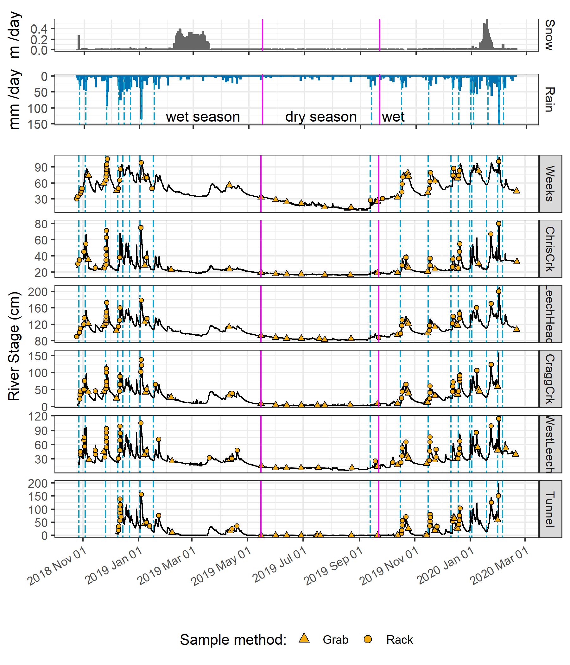

Figure 16: *Rain events, stream response, sample collection and seasons across the Leech Water Supply Area. Dashed vertical lines indicate the start of rain events, points indicate the timing and stage of river samples collected, and pink vertical lines delineate seasons.*

Eight of the 18 rain events were captured in the 2019 water year (2018-2019 wet season), the other ten in the 2020 water year. For each calender year in the study period, major rain events’ minimum and maximum values of depth, duration and intensity were identified (Table 12).

Table 12: *Minimum and maximum rain event values*

|  |  |  |  |  |  |  |
| --- | --- | --- | --- | --- | --- | --- |
| year | min. duration (days) | max. duration (days) | min rain (mm) | max rain (mm) | min intensity (mm/hr) | max intensity (mm/hr) |
| 2018 | 0.9 | 6.2 | 54.5 | 205.1 | 0.84 | 2.5 |
| 2019 | 2.0 | 6.4 | 57.1 | 227.6 | 0.78 | 2.3 |
| 2020 | 1.9 | 9.9 | 75.9 | 238.3 | 0.93 | 4.6 |

An intense atmospheric river event hit the LWSA January 29-31 (event 17, Table 11) and generated incredible flows across the Leech watershed (and across Vancouver Island and most of the south coast of BC). Streamflow at CraggCrk (site 4) and the Tunnel (site 6) over-topped the 2 m vertical racks and ripped the level-loggers out of their stilling wells. Luckily, the level-loggers were found downstream in February and (after drying the circuit boards) the data were successfully retrieved from both Odyssey loggers. Following event 17, changes to the stream-bed morphology were evident at LeechHead (site 3) in the form of gravel and cobble deposition, there was evidence of substantial coarse woody debris transport at ChrisCrk (site 2), and destruction to hydrologic monitoring equipment at the Leech Tunnel.

#### Spatial patterns in DOC & NOM

Samples with maximum DOC concentrations were captured by vertical racks at five of the six sites, except for the head of Leech River (LeechHead, site 3) where peak DOC happened to be collected as a Grab sample (Table 13).

Table 13: *Summary of DOC across the six LWSA installation sites including breakdown of sample type collected.*

|  |  |  |  |  |  |  |  |  |
| --- | --- | --- | --- | --- | --- | --- | --- | --- |
| Site | Sample type | Sample count | Mean DOC (mg/L) | sd  (± mg/L) | RSD (± %) | Min. (mg/L) | Median (mg/L) | Max. (mg/L) |
| Weeks | Grab | 21 | 9.5 | 3.0 | 31 | 6.38 | 9.02 | 18.74 |
| Weeks | Rack | 28 | 10.2 | 3.7 | 36 | 3.78 | 9.94 | 19.07 |
| ChrisCrk | Grab | 19 | 4.2 | 2.3 | 54 | 1.84 | 3.33 | 9.04 |
| ChrisCrk | Rack | 23 | 5.5 | 1.7 | 32 | 2.59 | 5.41 | 9.16 |
| LeechHead | Grab | 19 | 6.8 | 1.7 | 25 | 3.99 | 6.19 | 11.64 |
| LeechHead | Rack | 25 | 7.4 | 1.7 | 23 | 3.95 | 7.26 | 10.57 |
| CraggCrk | Grab | 30 | 4.1 | 1.3 | 32 | 1.79 | 3.74 | 7.47 |
| CraggCrk | Rack | 32 | 5.3 | 1.5 | 29 | 3.00 | 4.91 | 8.22 |
| WestLeech | Grab | 21 | 4.3 | 1.8 | 42 | 2.00 | 4.23 | 9.08 |
| WestLeech | Rack | 36 | 6.7 | 2.2 | 33 | 2.89 | 6.49 | 10.95 |
| Tunnel | Grab | 38 | 4.2 | 1.7 | 41 | 1.65 | 3.71 | 8.85 |
| Tunnel | Rack | 26 | 5.6 | 1.7 | 30 | 2.69 | 5.61 | 9.02 |
| All sites | Grab | 148 | 5.3 | 2.7 | 52 | 1.65 | 4.77 | 18.74 |
| All sites | Rack | 170 | 6.8 | 2.8 | 41 | 2.59 | 6.39 | 19.07 |
| ALL SITES | SUMMARY | 318 | 6.1 | 2.9 | 47 | 1.65 | 5.65 | 19.07 |

Highest concentrations and variance in DOC occurred at the Weeks Main creek headwater site (Weeks, site 1), a sub-basin in the northwest of the Leech watershed which includes Weeks Lake and surrounding wetlands. Lowest average concentration and variance in DOC was recorded at Cragg Creek (CraggCrk, site 4), a mainstem river that drains the east sub-basin of the Leech watershed including Jarvis Lake and the western slopes of Survey Mountain. DOC concentration and variance at Leech River Tunnel (Tunnel, site 6) was somewhat between that at WestLeech and CraggCrk (Figure 17).

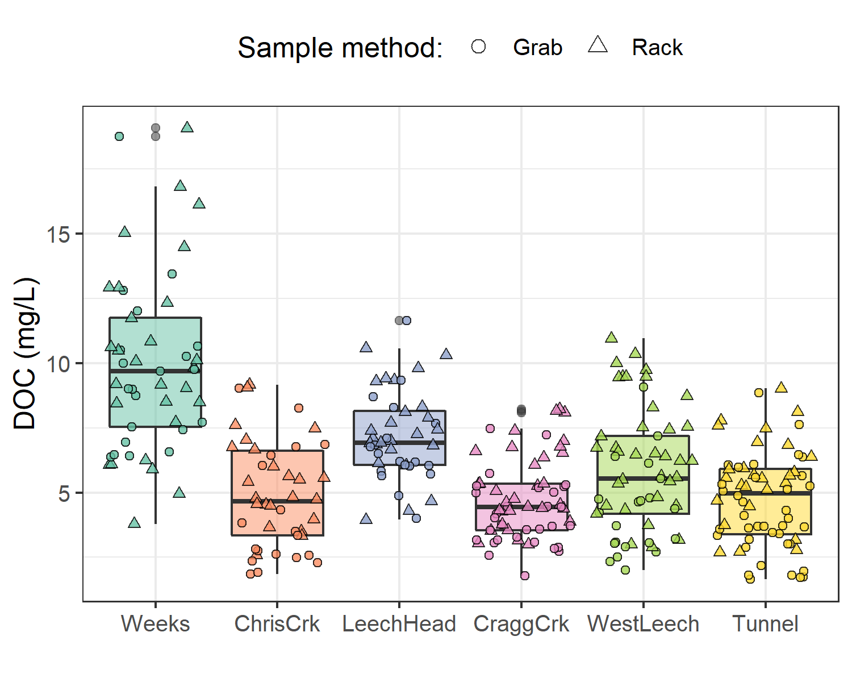

Figure 17: *Dissolved organic carbon (DOC) concentrations across the Leech watershed over sixteen months, collected by standard grab sampling and on vertical racks (318 samples total).*

##### Seasonal patterns in DOC & NOM

DOC concentrations followed similar sinusoidal trends over time at each site, with amplitude of variation decreasing from upstream to downstream sites (Figure 18).

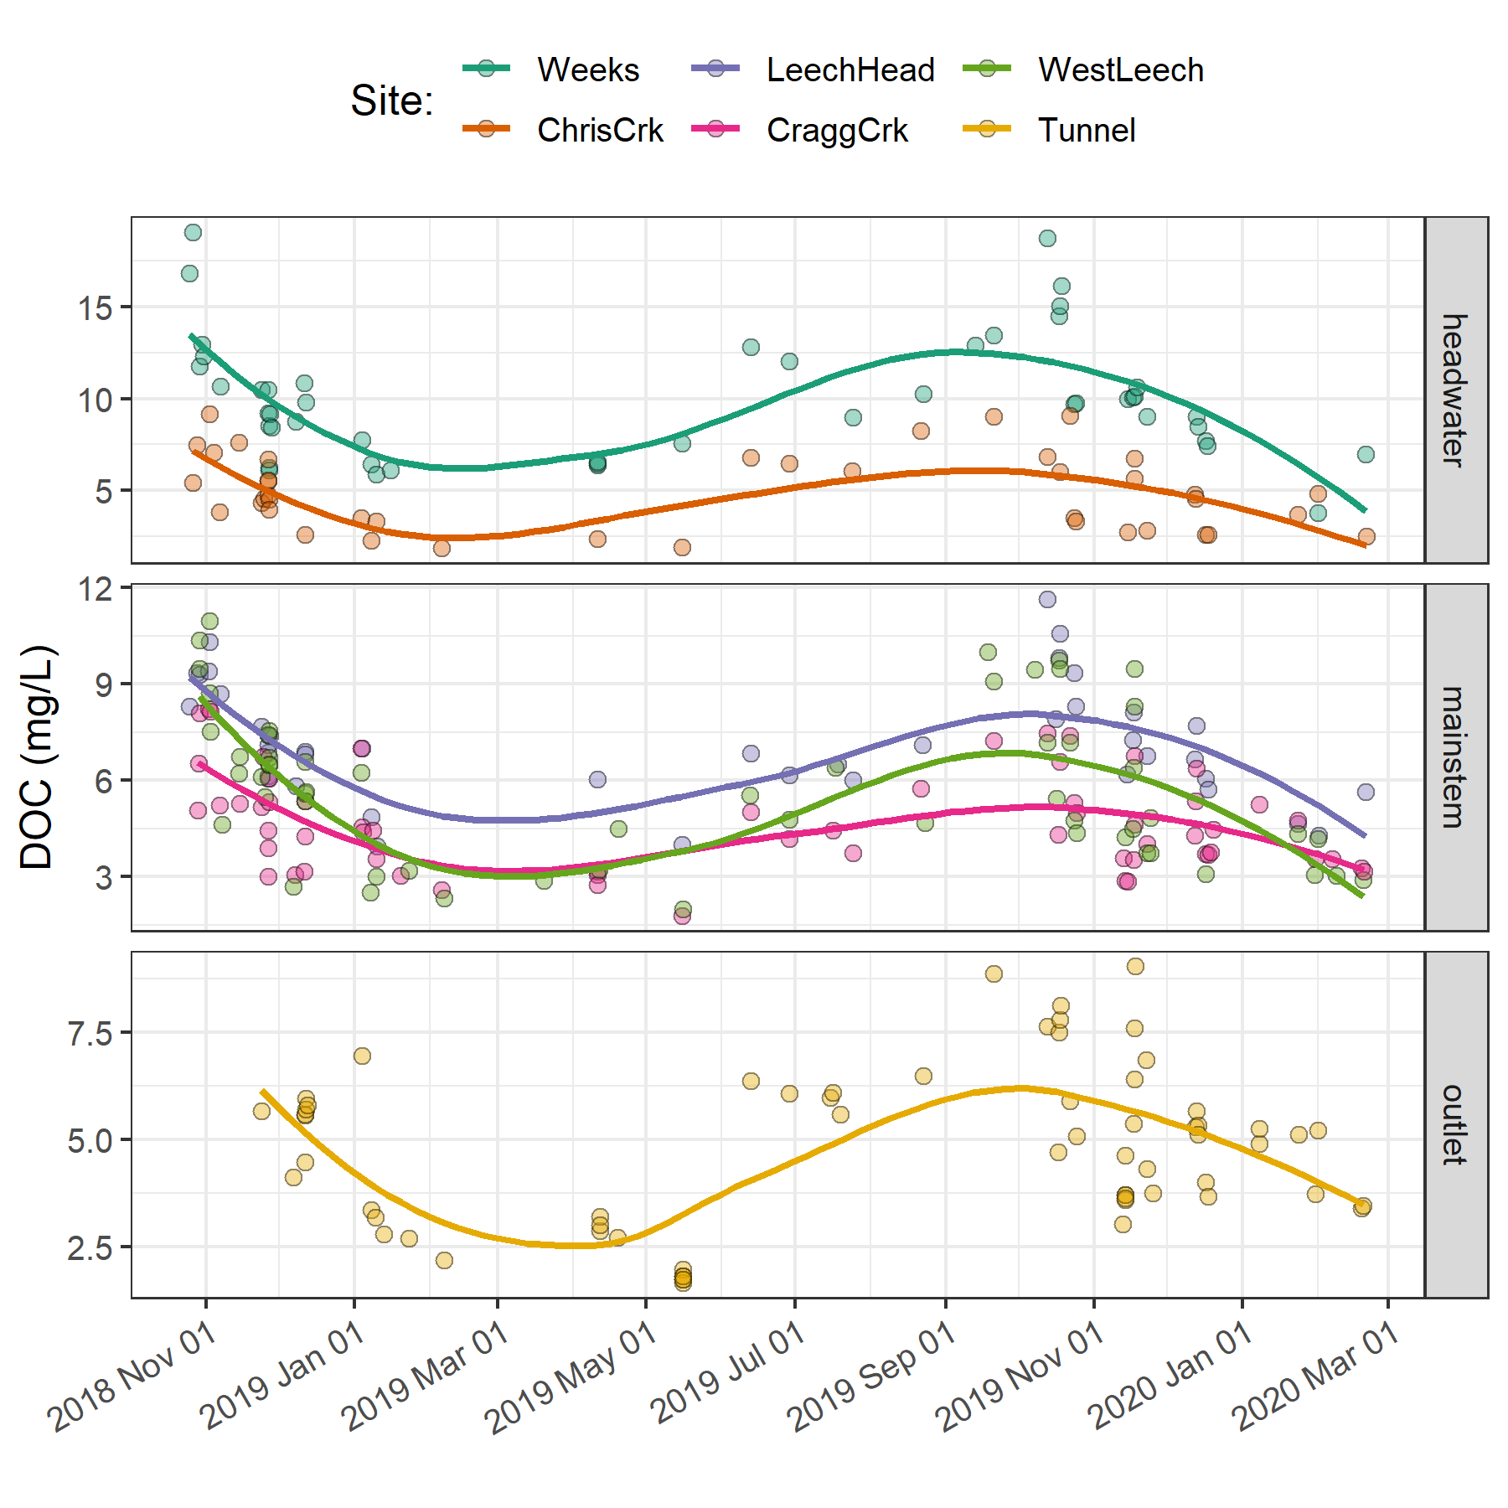

Figure 18: *Trends in dissolved organic carbon concentrations over sixteen months (Oct 2018 to Feb 2020) at six sites across the Leech water supply area. Trend lines represents locally weighted smoothing (‘loess’ method of local polynomial regression).*

The wet season was better represented than the dry by sample number and was therefore more interesting in terms of DOC concentration patterns. Additionally, the wet season water quality is most relevant with respect to water supply because that is when flows are great enough to allow diversion for inter-basin transfer. High flows during the wet season also showed increased DOC concentrations relative to low flows; stormflow samples collected on vertical Racks showed higher DOC than Grab samples manually collected across wet seasons (Figure 19.

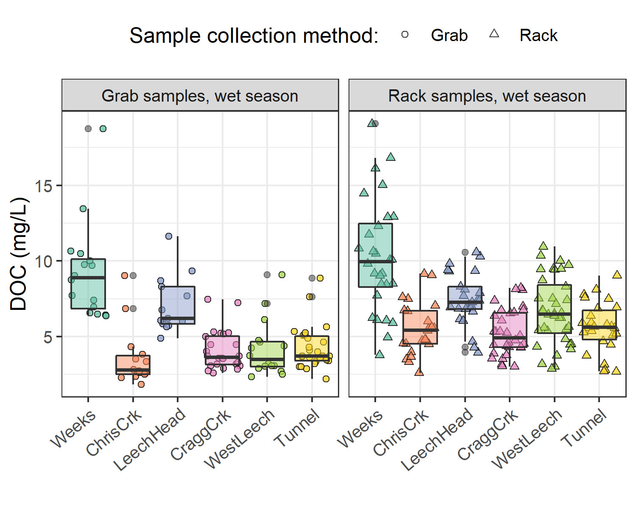

Figure 19: *Wet-season dissolved organic carbon concentrations grouped by site and sample collection method, where Grab samples were manually obtained (n = 109) and Rack samples were collected passively on vertical racks fit with siphon sampler bottles (n = 170).*

Table 14: *Wet-season dissolved organic carbon concentrations by sample collection method across six monitoring sites in the LWSA.*

|  |  |  |  |  |  |  |  |
| --- | --- | --- | --- | --- | --- | --- | --- |
| Site | Sample type | Sample count | Mean DOC (mg/L) | sd (± mg/L DOC) | RSD (± %) | Min. (mg/L) | Max. (mg/L) |
| Weeks | Grab | 17 | 9.1 | 3 | 35 | 6.38 | 18.74 |
| Weeks | Rack | 32 | 10.1 | 4 | 40 | 3.78 | 19.07 |
| ChrisCrk | Grab | 15 | 3.6 | 2 | 54 | 1.84 | 9.04 |
| ChrisCrk | Rack | 27 | 5.3 | 2 | 33 | 1.94 | 9.16 |
| LeechHead | Grab | 13 | 7.1 | 2 | 27 | 4.87 | 11.64 |
| LeechHead | Rack | 30 | 7.3 | 2 | 24 | 3.95 | 10.57 |
| CraggCrk | Grab | 26 | 4.1 | 1 | 31 | 2.58 | 7.47 |
| CraggCrk | Rack | 37 | 5.2 | 1 | 28 | 3.00 | 8.22 |
| WestLeech | Grab | 17 | 4.1 | 2 | 44 | 2.33 | 9.08 |
| WestLeech | Rack | 43 | 6.3 | 2 | 36 | 2.66 | 10.95 |
| Tunnel | Grab | 26 | 4.3 | 1 | 34 | 2.19 | 8.85 |
| Tunnel | Rack | 34 | 5.4 | 2 | 29 | 2.69 | 9.02 |
| All | Grab | 114 | 5.2 | 3 | 52 | 1.84 | 18.74 |
| All | Rack | 203 | 6.6 | 3 | 43 | 1.94 | 19.07 |

More samples were collected over the wet seasons than during the dry season due to event-based sampling and the relatively longer wet season period compared to dry (Table 15). Despite seasonal sample count differences, interesting spatial differences emerged when sample results were grouped by season (Figure 20). NOM molecular character was judged through a combination of specific UV-absorbance at 254 nm (SAC254, an indicator of chromophoric NOM) and SUVA254 (L mg-1 m-1) which indicates aromaticity relative to DOC concentrations. The quotient E2:E3 (unitless) is inversely proportional to aromaticity and/or molecular weight of aqueous NOM.

Table 15: *Seasonal comparison of sample results by monitoring site*

|  |  |  |  |  |  |  |  |  |  |  |
| --- | --- | --- | --- | --- | --- | --- | --- | --- | --- | --- |
| Site | season | count | mean DOC (mg/L) | sd (±) | mean SAC254 (m-1) | sd (±) | mean SUVA254  (L mg-1 m-1) | sd (±) | mean E2E3 | sd (±) |
| Weeks | dry | 5 | 10.3 | 2.2 | 24.3 | 4.9 | 2.2 | 0.1 | 4.01 | 0.30 |
| Weeks | wet | 44 | 9.9 | 3.5 | 31.2 | 8.7 | 3.6 | 0.8 | 4.18 | 0.61 |
| ChrisCrk | dry | 5 | 5.9 | 2.4 | 6.8 | 1.3 | 1.1 | 0.2 | 4.52 | 0.06 |
| ChrisCrk | wet | 37 | 4.8 | 2.0 | 14.8 | 6.6 | 3.7 | 1.1 | 4.41 | 0.25 |
| LeechHead | dry | 6 | 6.1 | 1.1 | 7.5 | 0.5 | 1.2 | 0.0 | 4.41 | 0.04 |
| LeechHead | wet | 38 | 7.3 | 1.8 | 24.5 | 4.3 | 3.9 | 0.9 | 4.38 | 0.14 |
| CraggCrk | dry | 6 | 4.2 | 1.3 | 5.1 | 0.4 | 1.2 | 0.1 | 4.42 | 0.05 |
| CraggCrk | wet | 55 | 4.8 | 1.6 | 15.0 | 4.5 | 3.5 | 1.0 | 4.60 | 0.23 |
| WestLeech | dry | 5 | 4.7 | 1.7 | 5.2 | 0.0 | 1.0 | 0.1 | 4.31 | 0.05 |
| WestLeech | wet | 52 | 5.9 | 2.4 | 17.1 | 5.4 | 4.1 | 1.7 | 4.26 | 0.31 |
| Tunnel | dry | 12 | 3.9 | 2.3 | 5.3 | 0.1 | 0.8 | 0.0 | 4.20 | 0.16 |
| Tunnel | wet | 52 | 4.9 | 1.7 | 17.7 | 4.8 | 3.7 | 0.9 | 4.42 | 0.20 |
| all sites | dry | 39 | 5.5 | 2.7 | 8.5 | 6.6 | 1.2 | 0.4 | 4.34 | 0.19 |
| all sites | wet | 279 | 6.2 | 2.9 | 18.9 | 7.6 | 3.7 | 1.1 | 4.39 | 0.34 |

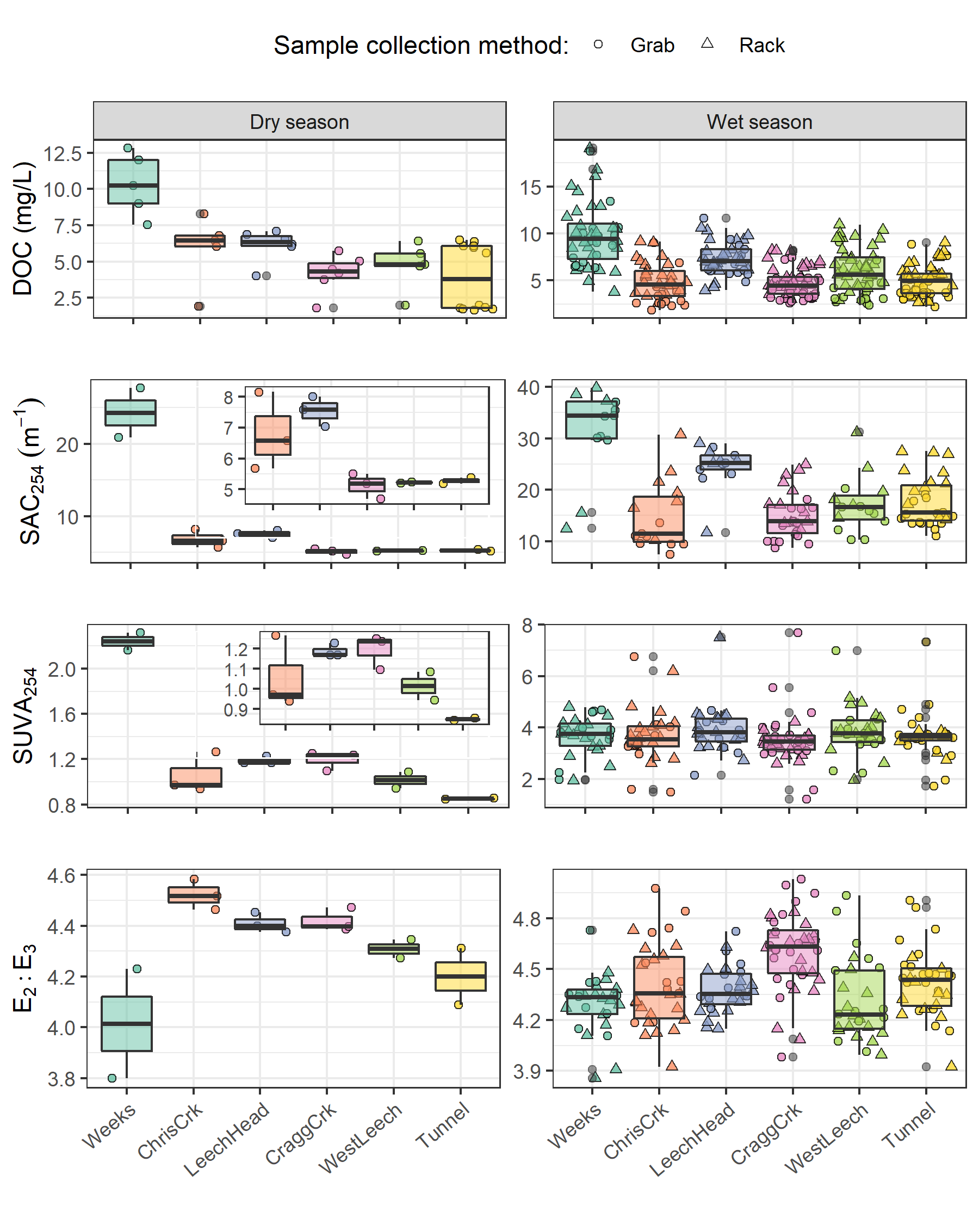

Figure 20: *Sample results over the dry and wet seasons for DOC (as NPOC, mg/L) concentrations and indicators of NOM aromaticity and molecular size: SAC254(m-1), SUVA (L mg-1 m-1), E2:E3.*

The spectral indices indicated that, during the dry-season, Weeks (site 1) had much greater aromaticity compared to the other sites – this may have been due to inputs from Weeks Lake and its surrounding wetlands. Aside from the highly aromatic character of NOM observed at Weeks in the dry months, E2:E3 suggests that aqueous NOM increased in aromaticity from upstream to downstream; while this quotient can also be indicative of molecular size (by an inverse relationship), the simultaneous decrease in DOC concentration indicates that molecular weight was not increasing downstream (Figure 20). SAC254 showed a similar increase in aromatic character from headwaters to mouth during the dry season, albeit the trend was less pronounced and there was a larger difference between ChrisCrk and LeechHead in SAC254 than in E2:E3. SUVA254, as could be expected, displayed a combination of DOC and SAC254 trends. DOC concentrations decreased from headwaters to mouth in both the wet and dry seasons, with the greatest variance at the head (Weeks) and mouth (Tunnel).

In the wet season, there was a spatial decrease in NOM aromaticity from headwaters to the Tunnel. In the headwater streams (sites 1 & 2), wet season NOM character was more aromatic at Weeks but had a broader range in spectral indices values at ChrisCrk. The River continuum concept predicts greater NOM diversity in headwaters than in higher order streams; these results only partially agree with that RCC concept and it appears that the wetland-dominated sub-basin (Weeks) had much more consistent NOM character than the ChrisCrk headwater stream. The longitudinal decrease in aromatic NOM character could have been an affect of dilution during the wet season. Of the main tributaries to the Leech River mainstem, CraggCrk had less aromatic character than WestLeech.

#### Rising stage and NOM dynamics

Across the LWSA, fluctuations in river stage were temporally synchronized over the sixteen-month study period. Overall river responses among the six sites were confirmed to be congruent with high confidence (p-value < 0.001, based on 1050 randomizations) via Kendall’s coefficient of concordance (Kendall’s W = 0.9721) and Spearman’s ranked correlation (ρ = 0.9666).

Table 16: *Summary of stream response to precipitation events across the LWSA.*

|  |  |  |  |  |  |  |
| --- | --- | --- | --- | --- | --- | --- |
| site | shortest time to peak stage (hr) | longest time to peak stage (hr) | smallest change in stage (cm) | largest change in stage (cm) | minimum rate of stage change (cm/hr) | maximum rate of stage change (cm/hr) |
| Weeks | 16.5 | 159.8 | 9.9 | 47.9 | 0.17 | 0.6 |
| ChrisCrk | 15.0 | 192.3 | 5.3 | 44.6 | 0.03 | 2.7 |
| LeechHead | 33.0 | 167.7 | 22.1 | 57.1 | 0.29 | 1.3 |
| CraggCrk | 18.2 | 125.2 | 32.7 | 97.3 | 0.26 | 5.4 |
| WestLeech | 25.8 | 122.8 | 36.7 | 70.2 | 0.33 | 1.4 |
| Tunnel | 18.2 | 123.8 | 29.0 | 135.3 | 0.45 | 7.4 |

Rates of change in stream response were calculated for each site to evaluate the fastest and slowest times to peak stage and relative magnitudes of change (Table 16). As expected, rate of change in stage was greatest at the Tunnel (site 6) and smallest at the Weeks headwater creek (site 1) which drains Weeks Lake and surrounding wetlands.

#### Spatiotemporal synchrony in local extrema: river stage and DOC

A trend in DOC concentration during rising stage can provide information about NOM source and flux dynamics. Increasing DOC with rising stage suggests NOM transport dynamics were driven by hydrologic connectivity to an unlimited supply of source NOM. Alternatively, if DOC concentrations decrease with rising stage it’s likely that the NOM source pool was limited (i.e. depletion of terrestrial allochthonous NOM supply) (Zarnetske et al. 2018).

Streams responded harmoniously to precipitation across the LWSA, with synchronous changes in stage, but was a similar harmony present for fluctuations in DOC or spectral properties? Aqueous DOC was quantified from discrete river samples, and therefore the temporal synchrony of peaks could not be evaluated in the same manner as stage, which was continuously recorded. However, each river sample was matched to stage and had a corresponding time-stamp, therefore temporal synchrony in DOC could be inferred based on relationships between peak DOC and stage. To determine if local DOC extrema (maxima and minima concentrations) were captured in conjunction with the local extrema of sampled flows (minima and maxima of sampled stage), synchrony tests were run on sample results. For each site, results of samples were grouped by collection period and rain event to identify samples with extreme DOC concentrations as well as samples collected at extreme stage (max/min). Samples corresponding to maxima and minima DOC and stage were compared to determine how often they overlapped (i.e. was the sample with max DOC also the sample collected at the highest stage?). Table 17 summarizes proportions of common DOC and stage extrema samples, where 1 indicates perfect agreement between samples of extreme DOC and sample-stage, and zero indicates complete asynchrony between DOC and stage highs and lows.

Table 17: *Proportion of samples for which peak DOC was found in the highest sample stage.*

|  |  |  |
| --- | --- | --- |
| Site | Proportion of common maxima | Proportion of common minima |
| Weeks | 0.588 | 0.647 |
| ChrisCrk | 0.800 | 0.800 |
| LeechHead | 0.889 | 0.889 |
| CraggCrk | 0.800 | 0.900 |
| WestLeech | 0.864 | 0.773 |
| Tunnel | 0.765 | 0.941 |
| all sites | 0.789 | 0.825 |

Most samples showed congruence between highs and lows of DOC with stage. West Leech was the only site which had a greater proportion of common maxima compared to minima, all other sites had more frequent occurrence of low DOC occurring at low stage that they did of high DOC occurring at high stage. Overall, each site’s samples showed majority, but not absolute, agreement in extremes of DOC-stage relationships (Figure 21).



Figure 21: *Stage and samples collected, highlighting samples with maximum and minimum DOC concentrations for each rain event and collection period. Black vertical lines indicate a subset of samples that were assessed more closely.*

Changes in DOC during events varied from a little more than 1% DOC change to nearly 100% change during event response (Table 18).

Table 18: *Summary of DOC changes within stormflow response to precipitation events across the LWSA (samples from wet season only).*

|  |  |  |  |  |  |  |
| --- | --- | --- | --- | --- | --- | --- |
| site | lowest DOC in stormflow (mg/L) | highest DOC in stormflow (mg/L) | smallest change in DOC (mg/L) | largest change in DOC (mg/L) | smallest difference in DOC during stormflow (%) | largest difference in DOC during stormflow (%) |
| Weeks | 6.1 | 16.1 | 1.0 | 6.4 | 9.6 | 53.2 |
| ChrisCrk | 2.3 | 9.2 | 1.2 | 3.9 | 26.1 | 82.0 |
| LeechHead | 5.7 | 10.3 | 0.1 | 2.0 | 1.2 | 29.5 |
| CraggCrk | 3.0 | 8.2 | 1.2 | 3.2 | 28.8 | 67.5 |
| WestLeech | 2.5 | 10.9 | 0.1 | 5.8 | 4.5 | 94.6 |
| Tunnel | 3.4 | 5.9 | 0.0 | 2.0 | 1.4 | 42.5 |

#### River stage, DOC & NOM

In general, DOC concentrations increases with increasing stage across the LWSA, thought the trends were not necessarily linear and not always consistent. The relationships between spectral indicators of NOM character and stage showed tighter patterns than DOC concentration with stage at all sites, but again the relationships were not linear (Figure 22).

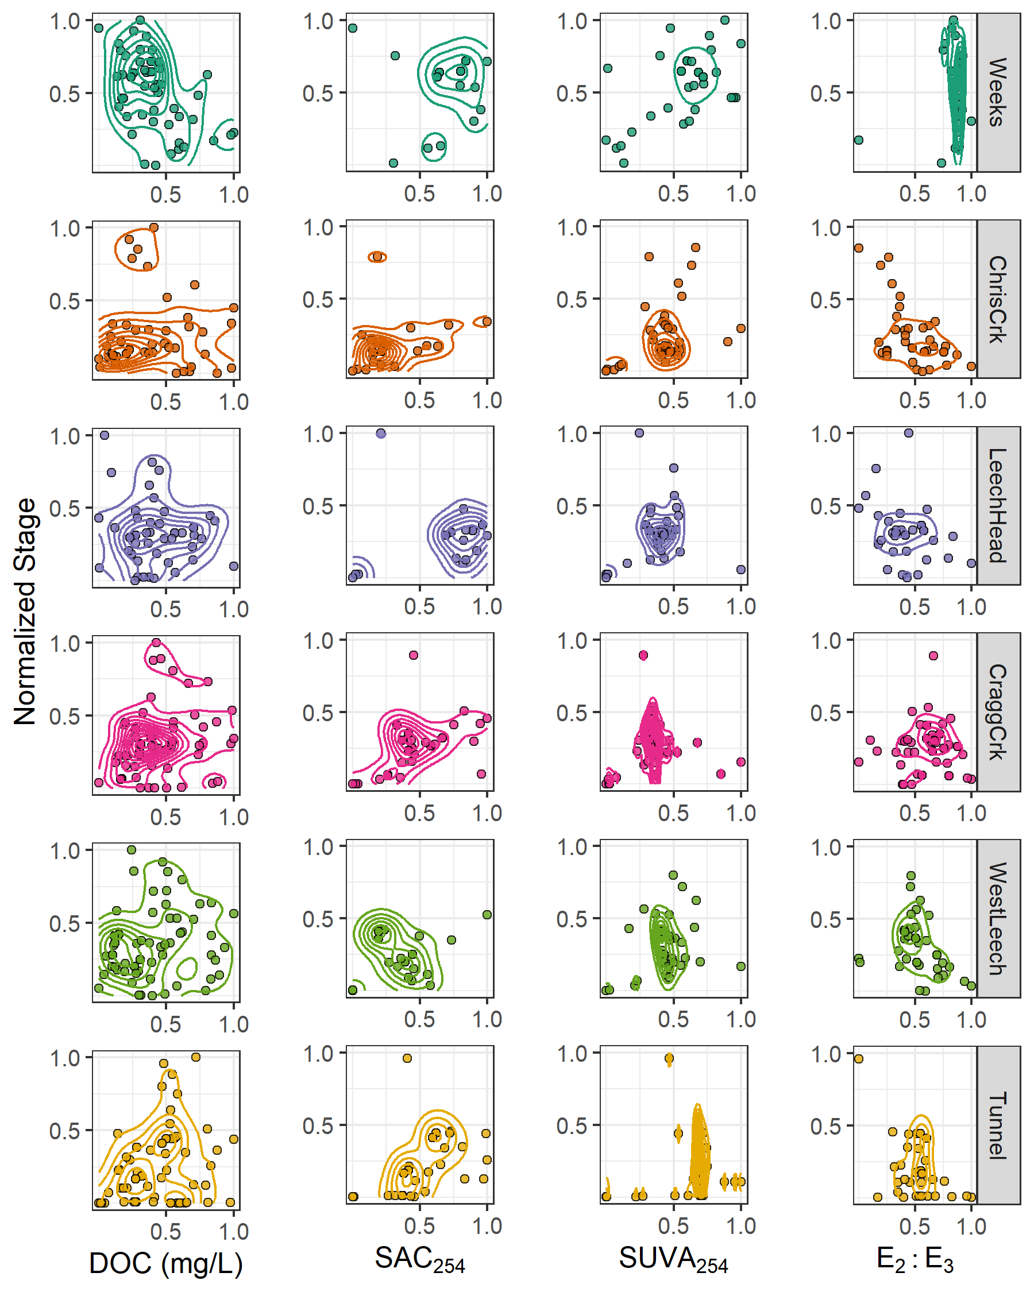

Figure 22: *Relationships between river stage and sample content and character. Data for each variable were normalized (min-max normalization) to clarify relative scales in each relationship*

#### Random Forests for variable importance

Watershed characteristics for each of the six monitoring sites (Figure 14, Table 10) were included with antecedent 7 day temperatures and antecedent 7 day rain, river stage and sampling season as possible predictor variables for DOC concentrations. The variable importance was assessed using the R package randomForest, the backbone of which is Breiman’s Random Forests (RF) algorithm (Breiman 2001). parameters were filtered as much as possible to remove those that could cause spurious correlations (i.e. cross-correlated variables) and the RF variable importance measure (VIM) was evauated for the entire study period (Figure 23), dry season (Figure 25) and wet season (Figure 24).

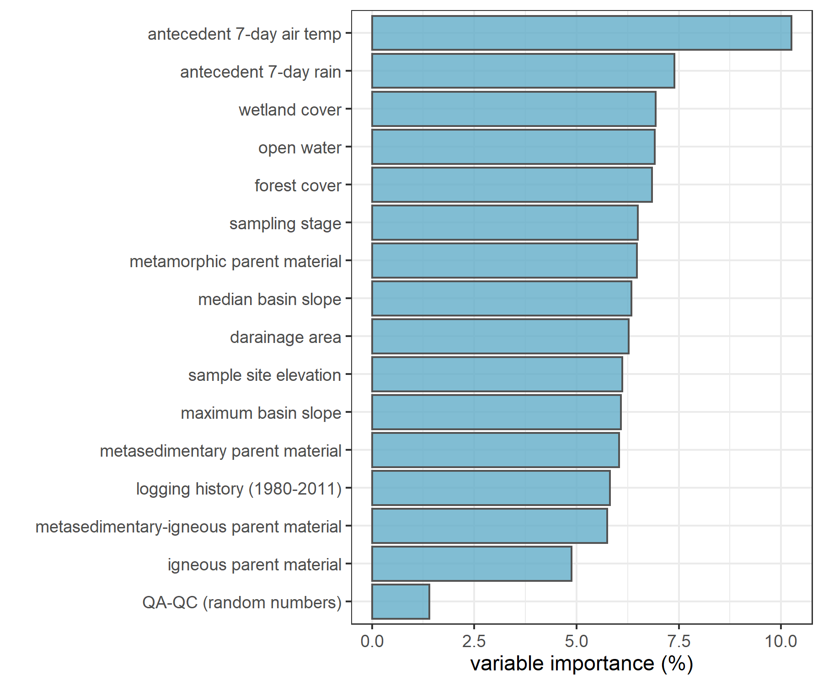

Figure 23: *Variable importance for predicting DOC over the full study period, with importance measured by type 1: mean square errors (i.e. mean decrease in accuracy when variable was omitted).*

When the entire sixteen month study period was evaluated, the greatest relative importance in predicting DOC concentration was determined to be antecedent 7-day air temperature and antecedent 7-day rain, followed by land cover: wetland, open-water and forest percent cover. Sampling stage was almost as important as metamorphic parent material (i.e. Wark-Gneiss), which was slightly more important than median basin slope and drainage area (Figure 23). Logging history (area clear-cut between 1980 and 2011), was found to be a relatively poor predictor for DOC, along with other parent materials (e.g. meta-sedimentary, igneous, and combinations thereof).

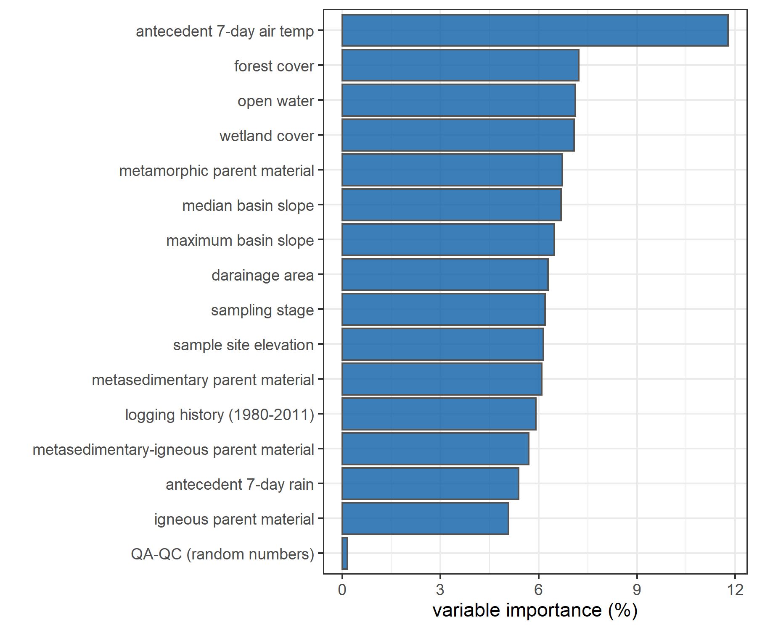

Figure 24: *Variable importance for predicting DOC during wet season (only), measured by type 1: mean square errors (i.e. mean decrease in accuracy when variable was omitted)*

Oddly, in the wet season antecedent 7-day rain was not found to be an important predictor for DOC but antecedent 7-day air temperature was still the most important predictor variable, followed by forest, open-water and wetland cover before metamorphic parent material again (Figure 24). Maybe in the wet season, antecedent rain matters less than year-round because the watershed is near saturation and though rain generates stream response the variable NOM source areas are already highly connected to the streams.

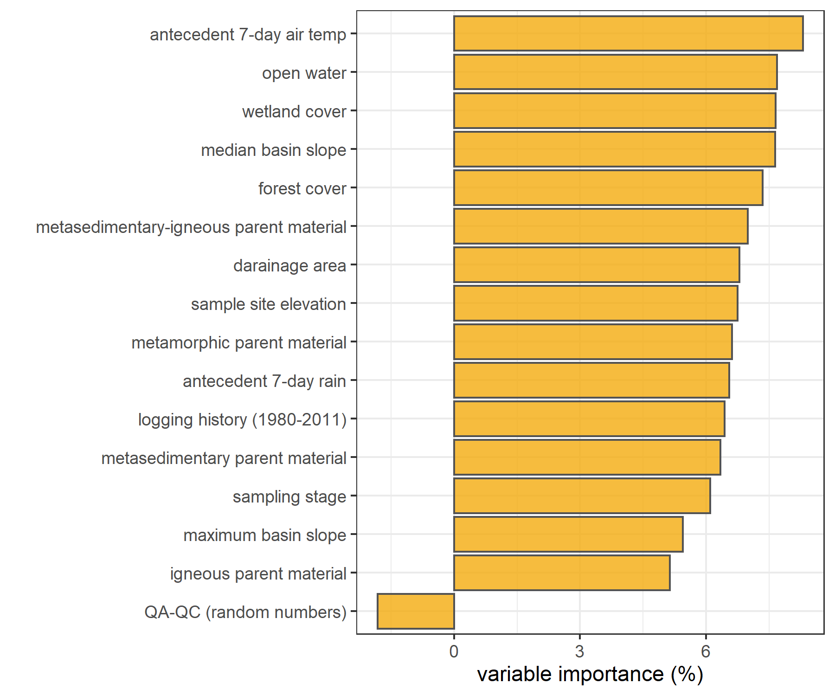

Figure 25: *Variable importance for predicting DOC during dry season (only), measured by type 1: mean square errors (i.e. mean decrease in accuracy when variable was omitted).*

Looking only at the dry season, antecedent 7-day air temperature was once again the primary predictor for DOC concentrations, followed by land-cover (open-water, wetland cover) and basin slope was found to be more important than forest cover for dry season DOC.

***Do this for SAC254 and E2:E3 also***

### Discussion

Increasing DOC on the rising limb indicates that source material is not limited and flux is driven by hydrologic connectivity; whereas source limited conditions likely drive NOM dynamics if DOC concentration decreases on the rising limb (Zarnetske et al. 2018). Analysis of rack samples clarifies the magnitude and direction of water quality changes in response to precipitation relative, which provides information about solute supply and hydrologic connectivity (Vidon, Wagner, and Soyeux 2008; Abbott et al. 2018; Creed et al. 2015; Zarnetske et al. 2018).

* variability among sub-basins versus variability within each sub-basin over time
* timing of peaks and valleys of stage – at 10 min resolution was there a lag from upstream to downstream?
* source versus transport limitations – DOC in rising limb
* any hysteretic behaviour? (DOC over time by event)
* was there a relationship between rain event intensity/duration and DOC?
* use RF to determine relative importance of watershed characteristics as DOC predictors
* use RF to in-fill missing NOM absorbance data based on relationship with DOC??? Like Yeonuk did for CH4 flux

### Conculsions

* establishing connectivity among nested catchments as a baseline for experimental treatments (future)

Combining methods of vertical sampling racks with standard synoptic grab sampling provided useful time-stamped discrete river samples data that could be adapted and correlated to local rating curves to calculate loads of river material (e.g. nutrients, metals, organics, etc.) exported from monitored catchments. Material transport loads are important for management decisions and comprehensive system understanding.

future:

* matched sample filling-stage with continuous logger stage could be combined with rating curve to determine mass transport or loading (future)

## Summary & Conclusions

### Discussion of results in context of drinking water supply

**RQ.4.** What are the implications for watershed management and future drinking water supply?

**Objective 4:** Provide context of how results can be used to inform watershed management planning for wildfire reduction strategies and design of continued water quality monitoring for future inter-basin transfers.

* conflicting objectives and competing values (Peter Duinker’s work)
  + managing temperate forests for timber removes carbon pools, managing for protection may increase the carbon, thus protection does not necessarily improve water quality.
  + timber / carbon sequestration / water / biodiversity
* source water quality in rivers is unlikely to reflect the water at the intake tower
  + reservoir residence times
  + photodegradation
  + physiochemcial reactions and changes
  + biodegradation // transformation // bioproduction of NOM
  + the rivers introduce new material and new conditions (e.g. different temperatures, dissolved oxygen, carbonate for buffering or organic acids altering pH, new microbiota) the
  + mixing is likely to change river source water – a blanacing reservoir to stabilize between river and reservoir may be extremely useful (like how you add a bit of new water at a time for a goldfish in a bowl, to allow equilibration)
  + UV degradation is likely in lakes
  + while river water quality will not identify source water quality (pre-treatment) it is important to know IN TANDEM with Sooke Res limnology to anticipate potnetial problems based on conditions in each & knowledge of likely or possible interactions

### Concluding remarks

***answer all these questions in summary***

**RQ.1.** What are the ranges for DOC concentration and NOM character between adjacent drainage basins and among nested sub-catchments in this water supply area, and what influence does seasonality have on concentration of DOC and character of NOM?

**Objective 1:** Design a sampling strategy to measure the spatial and temporal variation of DOC concentration and NOM character, then describe spatiotemporal patterns that were observed.

**RQ.2.** Are hydrological processes the main driver for DOC transport and variation in the LWSA and is there a mechanistic relationship between river stage and DOC or NOM?

**Objective 2:** Relate water sample results to river stage and report on the relationships between DOC concentrations and NOM character with stage, particularly paying attention to differences between baseflow and storm events.

**RQ.3.** Are some watershed characteristics more important than others for influencing DOC and NOM dynamics?

**Objective 3:** Assess the importance of watershed characteristics and conditions as explanatory variables for DOC and DOM patterns.

**RQ.4.** What are the implications for watershed management and future drinking water supply?

**Objective 4:** Provide context of how results can be used to inform watershed management planning for wildfire reduction strategies and design of continued water quality monitoring for future inter-basin transfers.

* in progress: this section will be included in the next draft, following feedback on results

The primary objectives of this project were to characterize the range of hydrochemical dynamics and synchrony during rainfall response across the Leech watershed (~96 km2) and its nested catchments (ranging in size from 9.6 to 37 km2). To understand spatial and temporal patterns in hydrochemical dynamics, this research was tackled in two key ways: (1) six sub-basin sites were equipped with vertical racks which logged river stage, air and water temperature at 10-minute intervals and passively collected whole water samples during stormflow on rising limbs of the hydrograph; and (2) thirteen sites, including the six sub-basin sites, were sampled synoptically every two to four weeks. Results of both the synoptic sampling and sub-basin monitoring were used to characterize the temporal and spatial range of DOC concentrations and DOM character. In addition to spatiotemporal dynamics, the sub-basin monitoring sites were used to evaluate hydrologic responses based on river rise (stream stage) and local precipitation. The vertical racks installed at the sub-basin sites acheived enhanced synoptic sampling program by collecting samples at multiple locations (near-simultaneously) across the watershed during rainfall-induced hydrologic surges, samples which would have been challenging and dangerous to collect manually. DOC concentration trends in stormflow were indicative of whether aqueous DOM was supply-limited or governed by hydrologic forcing. The data collected were used to elucidate spatiotemporal synchrony among sub-catchments. Results of synoptic sampling (including stormflow samples) were used to evaluate temporal trends with respect to seasonal dynaimcs of DOM characteristics.

Despite the high RSD for headwaters sites, and the ~50% difference in area of these two sub-basins, LeechHead did show approximately the median of the two sub-basins DOC.

Across the Leech Water Supply Area (LWSA), the timing of changes in temperature, river response and DOC concentrations and character were synchornized in the five nested catchments and Leech River Tunnel site (future point of diversion, or mouth of the WSA), however the mean values and magnitude of these changes differed between sites.

1. Across the LWSA, was the variance in DOC greater within each site or among all sites?
2. Was the variance in DOC greater at the watershed outlet than the variance in each subbasin?

*Seasonal trends and DOC over time Based on spectroscopic indications that dry season NOM was less aromatic in character, it’s quite possibly that the increase in summer DOC was due to autochthonous sources such as algae and cyanobacteria, while fall DOC was likely sources from autochthonous terrestrial sources (e.g., humic and fluvic acids).

# Appendices

Introduction: extended background

The NSERC forWater Network

The forWater NSERC Network for source water protection strategies is a transdisciplinary, cross-Canada, applied research collaboration focused on the connections between treated drinking water quality and land-use impacts of forest management. The majority of source drinking water originates in forested headwaters, so forWater researchers are studying water quality in watersheds across Canada, under a variety of different forest management strategies. Through collaborative analyses, forWater is working to evaluate source water treatability metrics, downstream propagation effects, and resource economic with the ultimate goal of providing a framework for treatment demands as they relate to forested source water.

Greater Victoria Regional Water Supply System

The Capital Regional District (CRD) owns and operates the water supply system for the Greater Victoria region. As a water purveyor, CRD supplies an average of 130 million liters of treated water to customers each day (130,000 m3day-1) (CRD 2017). The provision of safe and sustainable drinking water has three tiers of regulation above the CRD: federal, provincial, and regional. Federally, Health Canada publishes Canadian Drinking Water Quality Guidelines which outline quantitative bounds for microbial, chemical, radiological parameters and physical aesthetic characteristics for safe drinking water. The province of British Columbia sets requirements for planning, reporting and regualting of drinking water providers through the Drinking Water Protection Act and the Water Sustainability Act, and the Public Health Act and Regulations. Regionally, the CRD reports to the Vancouver Island Health Authority (Island Health) regarding water quality information and provincial legislation.

The Greater Victoria Water Supply Area (GVWSA) includes 20,549 hectares (205.49 km2) of protected drinking water catchment lands. The primary water supply is sourced from Sooke reservoir, the secondary supply source is Goldstream reservoir and the designated (supplemental) future water supply is the Leech River watershed {FIGURE YYY, figure of watersheds with insert of VanIsle (small) and western north america (even smaller)}. Unfiltered source water is first treated with ultraviolet light and free chlorine (to deactive parasites, bacteria and viruses); secondarily, ammonia is added to produce chloramine, a long-lasting disinfectant that persists through distribution systems (CRD 2017).

The Leech River watershed is a sub-catchment of the Sooke River watershed (~25% by area), located west of Sooke Reservoir (primary water supply for the Greater Victoria Area). In anticipation of future water demands and uncertainty related to rainfall and climate change, the Capital Regional District (CRD) purchased 9,628 hectares (about 92%) of the Leech River watershed in 2007 (84%) and 2010 (additional 8%), and designated the Leech Water Supply Area (LWSA) for future supplemental water supply.

In 1977, the CRD obtained a provincial water licence authorizing the diversion of up to 30.6 million cubic meters per year from the Leech River to the Sooke Reservoir (Ussery and AECOM 2015). Based on the 2017 strategic plan statement of a daily average water supply of 130,000 m3 (2017), the Leech water license could contribute about 65% of 2017 average water supply. The license allows diversion only as long as minimum flows (>5.7 m3s-1) are maintained to protect fish and downstream ecology (Ussery and AECOM 2015). Based on current hydroclimatic dynamics, the water license flow requirements will exclude the summer months from inter-basin transfer and limit streamflow diversion to the winter (November to approximately April). The Leech Tunnel was constructed in the 1980’s to transfer Leech River water into the Sooke Reservoir. The Tunnel is not currently operational, and it’s anticipated that inter-basin transfer won’t be required until 2050 or later.

Leech watershed monitoring sites: details and observations

The Leech River watershed (“the Leech”) is located on south-east Vancouver Island, British Columbia, Canada. Like most of coastal BC, it is in the Coastal Western Hemlock Biogeoclimatic Zone. The hydroclimatic regime of the Leech is pluvial (i.e. rain-dominated). Annual rainfall is typically between xxxx - yyyy mm (~2500 mm/yr). This areas has a strong seasonal distribution of rainfall: approximately 90% of rain falls from September to April, with only about 10% of annual rainfall occurring from May to August [*REFS*]. Across the Leech, elevation ranges from approximately 200 m above sea level (asl), near the Leech Tunnel, to 941 m asl in the centre of the watershed, at the top of Survey Mountain. While the majority of precipitaiton falls as rain, snow does accumulate for short periods at higher elevations.

Around 99% of the Leech WSA is forested. The Leech forests are dominated by western red cedar, western hemlock, and Douglas fir; subspecies include Amabalis fir (Pacific silver fir), white pine, yellow cedar (at higher elevations), Alder, broadleaf maple, and arbutus. Prior to purchase by the CRD, the LWSA was privately managed forest land that was harvested from the mid-1940’s to 2007 (Ussery and AECOM 2015). Approximately 95% of the Leech watershed was harvested by clear cut prior to 2007 (Ussery and AECOM 2015, @CRD2019); as a result, ~94% of LWSA forests are younger than 60 years old and a large portion of stands are under 30 years of age. Now designated as a Water Supply Area, the CRD manages the Leech for source water protection, ecosystem services, and forest resilience. As forest fires pose a serious threat to monocultured and even-aged stands (*REFS*), particularly during the drought of summer, forest fuel management is an important preemptive risk reduction for the CRD (CRD 2019).

The Leech River system is composed of three mainstem rivers, numerous tributaries, and four small headwater lakes. Hydrologic responses vary with terrain steepness, soil infiltrability, vegetation, percent cover of lakes and wetlands, air temperature and the intensity and duration of precipitation. In the Leech, runoff peaks in the winter under saturated conditions. In the wet season, rivers in the Leech watershed are flashy: they respond rapidly to precipitation events, rising and falling dramatically. In 1993 CRD Water Services set up a hydrometric monitoring station on the Leech River (about 3.5 km downstream of the Tunnel) to measure discharge with hourly stage measurments (Ussery and AECOM 2015). Peak flow on the lower Leech River was recorded as 168 m3s-1 (in October, 2003) (Ussery and AECOM 2015). However, the rating curve at this historic gauging station was not verified over time and hydraulic action rendered it unreliable.

Overall, the hydrology of the LWSA is poorly understood, as are water quality dynamics. In the mid-1980’s, some water was transfered from the Leech River into Deception Gulch and Reservoir (adjacent to but physically separated from Sooke Reservoir). The mixing resulted in biological water quality problems that included odour and raised concerns about the operational usage of the existing tunnel. The Leech River Tunnel and anticipated inter-basin transfer will provide interesting research opportunities which are beyond the scope of this thesis research. Before work is done on inter-basin transfers, the hydrology and water quality of the Leech River system need to be better understood. Understanding source water quality, as well as the timing and magnitude of flows, is an essential component to multiple barrier approach to ensuring clean drinking water.

LWSA Sites

Six sites were selected across the Leech Water Supply Area. The six research sites represent five nested catchments and the entire water supply area basin defined from the point of (future) diversion, the Leech Tunnel.

***Weeks Creek (site 1)***

The Weeks Creek (on Weeks Main) research site monitored water draining approximately 16 km2 of the northwest Leech River watershed, including a wetland (Jordan Meadows fen) and Weeks Lake (approximately 27 ha) (Ussery and AECOM 2015). Jordan Meadows wetland drains to the east and joins the outflow of Weeks Lake (south end of the lake). The wetland and lake outflow streams join and flow east to Research Site #1, “Weeks”, which is a third order stream (Strahler) of the western headwaters of Leech River. The channel is fairly straight, with bed and bank material appearing to be primarily silt/clay (fine grain, easily suspended). The water at this site was notably tannin-coloured. This research site was located about 0.4 km west (upstream) of the confluence with Chris Creek.

A large culvert upstream of the monitoring site was replace with a bridge in August of 2019. The culvert had been perched above the streambed level and was obstructing the movement of fish and water flow. Prior to the culvert removal, several groundwater seeps were observed downstream; these seeps maintained base flow of summer waters in this low-relief stream reach. There were high levels of iron (above Guideline aesthetic objectives) in the water downstream of the culvert, possibly due to culvert rust.

***Chris Creek (site 2)***

Chris Creek is the western headwaters of Leech River. This research site was approximately 0.2 km east (upstream) of the confluence with Site 1, Weeks Creek. The study site on Chris Creek monitored waters draining from approximately 9.6 km2 of forested land, including Worley Lake (approximately 3.5 ha) (Ussery and AECOM 2015). The monitoring site of Chris Creek was downstream of a bridge, on a slightly sinuous reach with boulders and bedrock and turbulent cascading step-pool morphology. Coarse woody debris was observed upstream of the Chris Creek monitoring site, with obvious new deposits on the banks following a high intensity rain event and assoicated flooding in January 2020.

***Leech Head (site 3)***

Research site 3 was approximately 1.4 km downstream of the confluence of Weeks and Chris Creeks. The “Leech Head” study site, a 4th order stream, was in a pool between riffles with predominantly Schist bedrock and fairly low relief (~2%) and relatively straight morphology. The water at this site was often coloured by tannins (likely from Weeks, upstream). There once was a logging bridge across the river at this site; rip-rap remains on either bank.

***Cragg Creek (site 4)***

Cragg Creek is a mainstem river that originates in the northeast of the Leech River watershed. Cragg Creek site, a 4th order stream, had a drainage area of approximately 37 km2 that included Jarvis Lake (15 ha). The Cragg Creek research station was installed upstream of a bridge, at a CRD hydrological monitoring site (installed over the span of this thesis project). The bed morphology at this site is Schist bedrock and the stream is straight channel with fairly high width-to-depth ratio. Upstream of the bridge Cragg Creek flows turbulently along a low slope, and downstream of the bridge it cascades into several deep pools. From the Cragg Creek research site, the river flows approximately 4.5 km through a steep ravine to confluence with the Leech River (this confluence is around 6 km downstream of the Leech Head site, site #3).



Figure 27: Draparnaldia species of green algae (nic-named ‘Christmas Tree’) identified in a fall bloom at Cragg Creek (site 4) November 2019

A fall algae bloom was observed in Cragg Creek November 2019, and was also observed in most of the streams and creeks draining the east side of Survey Mountain. The Algae was identified by CRD microbiologist Huy Nguyen as Draparnaldia, a green-algal species, that occurs mostly in clean, cool (often spring-fed) streams (personal communication ***REF***).

***West Leech (site 5)***

Originating in the west of the Leech River watershed, West Leech River is a 4th order mainstem river. The West Leech research site monitored a drainage area of approximately 35 km2 which included a small lake (Boulder lake) at the southwest of Leech watershed. This research site had boulder and bedrock substrate, fairly straight channel with relatively high width-to-depth ratio and pool-riffle morphology. The West Leech site is approximately 120 m upstream of the confluence with Leech mainstem (~1.5 km downstream of the confluence of Cragg Creek with Leech River).

***Leech Tunnel (site 6)***

This research site was at the point of future diversion, the Leech River Tunnel. The Leech is a 5th order river, and this research site had a drainage area of approximately 96 km2 (the entire watershed above the point of diversion). The stream bed here is dominated by Schist bedrock and boulders. The bedrock in the center of the channel is deeply incised, but overall the river is wider than is is deep. The Tunnel site was approximately 1 km downstream of the West Leech confluence.

Sampling methods extended

In river systems, peak flows are critical times for mass transport of dissolved and suspended materials. Therefore water quality sampling should include proportional representation of stormflow pulses relative to between-storm flows and baseflow. Sampling programs can range from low-cost synoptic grab sampling campaigns to high-cost programmable pump samplers (e.g. ISCO). Synoptic grab sampling was completed across the six primary Leech research sites, as well as four supplemental sites. In addition to synoptic sampling, passive sampling techniques were employed to collect stormflow samples.

***Vertical racks***

*Passive water sampling on the rising limb of hydrograph*

Each vertical rack included a central stilling well (1.5" PCV pipe (conduit) with 1/2" holes drilled along the length) that had a measuring tape affixed to the front. Inside the stilling well was an Odyssey Capacitance water level logger (odysseydatarecording.com). To either side of the central stilling well, slotted offset angle bars were fixed and siphon sampler bottles were attached to the slotted angle bars with hose clamps.

The siphon sampler bottles were based on a USGS single stage sediment sampler design (US U-59, 1961) which passively collect discrete water samples at a fixed stage on the rising limb of the hydrograph. The siphon samplers built for this research were 250 mL amber HDPE widemouth bottles with augmented screw caps. The caps were fit with two 1/4" (OD) stainless steel tubes, one longer than the other, both with a 180 $​^{∘}$ bend at the top end.

The lower tube acts as an inlet that intakes water once the stream level is at or above the crown of the bend, while the taller tube acts as a vent to allow air to exit the sample bottle as it is displaced with water. Once the sample bottle is full, there is no exchange with the surrounding stream water due to an air lock created in the vent tube bend. The validity of assuming discrete sample collection was addressed in the Methods QA/QC section.

Sampling bottles could be placed at any height, and were generally staggered at 10-20 cm intervals. For each sampler bottle, the height of the intake tube (filling stage) was measured relative to the measuring tape on the central stilling well, which was referenced to the stage recored by water level logger inside to extract the date and time of sample collection (REF TO R SCRIPT).

*Benefits, challenges and assumptions*

The benefits of using these vertical racks as a method of sampling include: low cost (about $500 CND per installation), low power (two 1/2-AA batteries in each logger), self-contained (no external power source or data logger required), customizable design, passive sampling (no pumps). The downsides of using this technique are similar to any autosampler, in that someone must visit the field sites regularly for set-up and collection of samples, but because there are minimal powered components, mis-firing is not an issue. The only reason a sample wouldn’t be collected was if the stream stage did not reach a bottles intake. The primary drawback of this technique is that sampling is limitied to the rising limb of the hydrograph, which limits the elucidation of stormflow water quality dynamics. There is some uncertainty about timing between sample collection and sample retrieval, every effort was made to return to each research site following precipitation events to retrieve collected samples, and it was assummed that any sample held on the rack was stable due to low air and river temperatures during the wet season. The assumption of river-as-a-refrigerator was addressed by deploying temperature sensors on each vertical rack (August 2019), and also with hold-time experiments.

Prototype for falling limb passive sampling

*Development of a modified siphon sampler designed for passive water collection on the falling limb of hydrograph*

In keeping with goals of low-cost, low-powered passive sampling, a falling-limb sampler was designed based on principles of the rising limb siphon sampler. The rising limb sampler collects a discrete water sample when river stage exceeds the crown of the inlet tube, so long as the vent is unobstructed; obstruction of the siphon sampler vent was the key component of the falling limb sampler prototype design. There were a half-dozen iterations in design prior to the model which was field-deployed in the Leech WSA (winter 2019). Each design iteration included a valve on the siphon vent which remained closed as the river rose, and opened when stream stage dropped below a certain point (allowing air to exit the sample bottle and a water sample to be collected). A number of valve options were explored, including: an external tube plug, in internal tube plug, and a self-sealing silicone bite-valve (i.e. Camelback Big BiteTM for hydration packs). The final design iteration used a tube pinch valve (SP Science) to close and open the air vent. The mechanism that triggers the vent valve to open is a simple fixed pulley, where the valve is connected to a weighted-cup by a wire that passes through two loops which alter the direction of force. The river rises and fills the cup with stream water, the cup remains full when the river recedes, and when the stream drops low enough that the full cup is no longer buoyant, the weight of water in the cup exerts a force on the lever of the pinch-valve, causing it to release the vent tube and triggering sample collection. The vent valve and trigger mechanism are contained in a 4" sewer pipe (a “filling well”), which was attached to supplemental support bars on the vertical rack. One prototype was field deployed at Cragg Creek (subbasin site 4) as a proof of concept and work will continue to improve the design and operation.

Field protocol

Following the installation of a vertical sampling rack, the field protocol was to visit the site approximately biweekly (or more frequently, based on storms) to check, collect and set the rack. Every time a site was visited, a grab sample was also collected. When a bottle was placed on its rack (attached by 3" hose clamp), the filling stage (height of intake tube crown) was recorded relative to the central still well tape. Bottles were staggered, generally from water level to approximately 120 cm above water level (as experience showed that a bottle should always be placed above the stage of anticipated peak streamflow). Following a rain event, each site was revisited to collect rack samples; for full bottles, the siphon lid was replaced with a labelled HDPE lid and samples were transported in a cooler with ice packs back to the lab and refrigerated until analysis.

Collaborative sampling: forWater-coordinated treatability analyses

Methods: Treatability & DOC

**sites**

Four of the synoptic sampling sites were selected as treatability sampling sites, where source water was collected and shipped to collaborative researchers in the forWater Network for analyses of drinking water treatability metrics. The four treatability sites were:

1. Leech River at the future point of diversion (near Leech Tunnel inlet)
2. Deception Reservoir, downstream from Deception Gulch (outlet of Leech Tunnel)
3. Rithet Creek (main tributary to Sooke Reservoir)
4. Judge Creek (2nd largest tributary to Sooke Reservoir)

These sites were selected to represent future supplemental source water , the future balancing reservoir between the Leech and Sooke water supply areas, and the current tributary source waters to the Sooke Reservoir.

Sets of samples were collected during winter of the 2020 water year (November 12, 2019 and February 18, 2020) and were shipped to the Universities of Alberta and Waterloo for treatability analyses. At the University of Waterloo, samples were analyzed for treatability parameters including: maximum potential disinfection byproduct formation potential (for trihalomethanes (THMs) and haloacetic acids (HAAs) in μg/L), pH, UV254(cm-1), DOC (mg/L), Turbidity (NTU), and Zeta Potential (mV). Relationships between disinfection by-product formation potentials (DBP-FPs), UV-absorbance at 254nm, and DOC concentrations were examined.

At the University of Alberta, field-filtered samples were analyzed using a spectrofluorometer (for excitation emission matrices spectra), as well as an Fourier transform ion cyclotron resonance mass spectrometer to determine molecular characteristics of the DOM.

Results: Treatability & DOC

Dissolved organic matter – particularly high molecular weight aromatic compounds – are precursors to disinfection by-products (DBPs), which are formed during chlorination of source drinking water. Drinking water supply for the CRD is treated simply by chlorinating raw source water, and therefore source water NOM could have important implications for treatability. To assess the potential of source water to form potentially harmful DBPs, samples were collected from four locations and sent to partners at the University of Waterloo for treatability analyses (specifically, DBP formation potentials (DBP-FPs)). Results from two sets of samples at four selected sites showed positive correlations between DOC concentrations and DBP-FPs, and even stronger relationships between DBP-FPs and UV absorbance at 254-nm – an indicator of NOM aromaticity (Figure 28). The relatively stronger correlation between DBP-FPs and UV-254 indicates that while DOM concentration is an important indicator of source water treatability challenges, the aromaticity of source water NOM may be an even more important driver.



Figure 28: *Plots of disinfection by-product formation potentials (DBP-FPs) with dissolved organic carbon (left column) and UV absorbance at 254 nm (right column). Samples collected at four sites on two occasions.*

 While UV-254 is a good indicator of NOM aromaticity and also appears to be correlated to DBP-FPs, naturally occurring aqueous chemicals (such as nitrate and iron) can interfere with spectroscopic analyses and lead to positive bias in DOM estimates. While aqueous nitrate may lead to an over estimate absorbance-based DOM concentrations, aqueous nitrogen can also play an important roll as a precursor to nitrogenous-DBPs when in combination with NOM, which could make UV{254} an even better indicator of DBP-FP.

Collaborative sampling: Sampling for Metals on behalf of the CRD

Aquatic NOM can play an important role in the transport of metals because it has the physiochemical ability to act as a ligand to create coordinated complexes with metals. From November 2018 to July 2019, I collected eight sets of samples for metals analysis from the six sub-basin monitoring sites. Metals samples were collected on behalf of the CRD and were analyzed at Bureau Veritas Laboratories (BL Labs, formerly Maxxam Analytics Inc., Sidney, BC). For each metals sample collected, a parallel Grab sample was analyzed for DOC (at UBC). Reports from BL Labs were provided by the CRD (for the samples collected in association with this research) and data were used to evaluate relationships between DOC and metals in solution.

***Metals & DOC***

Aqueous natural organic matter (NOM) can play an important role in transportation of metals in solution because it has the physiochemical ability to act as a ligand and create coordinated complexes with metals. From November 2018 to July 2019, seven sets of samples were collected from six sites in the LWSA for metals analysis. Metals samples were collected on behalf of the CRD and were analyzed at Bureau Veritas Laboratories in Sidney, BC (formerly Maxxam Analytics Inc.). For each metals sample collected, a parallel Grab sample was collected and analyzed for DOC at UBC. A suite of total metals were included in the analyses, many of which were below detection limits. Samples which had detectable metals concentrations were plotted against parallel sample DOC concentrations (Figure 29 shows DOC with total metals in μg/L, and Figure 30 shows metals in mg/L).

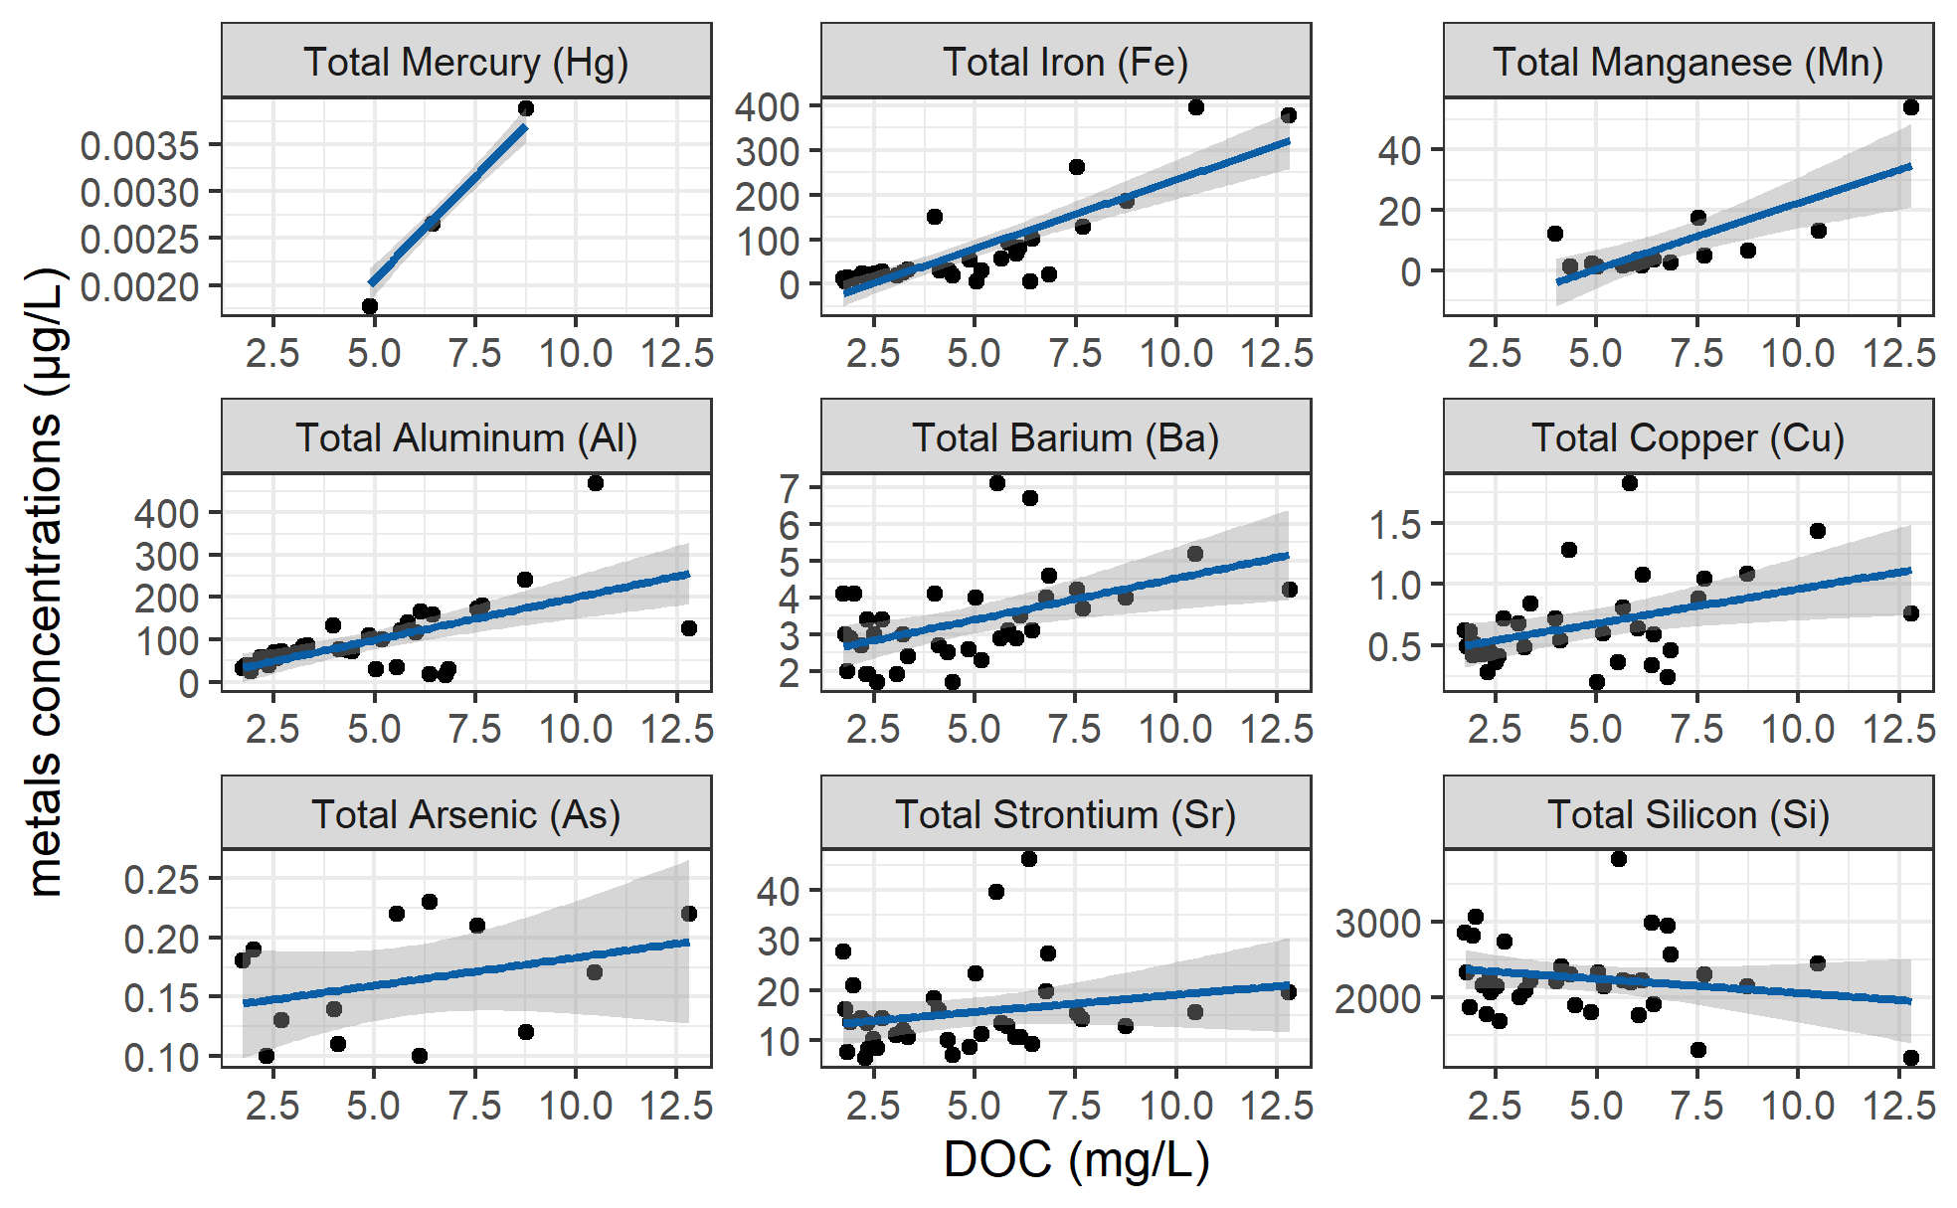

Figure 29: *Concentrations of total metals (in µg/L) and dissolved organic carbon.*

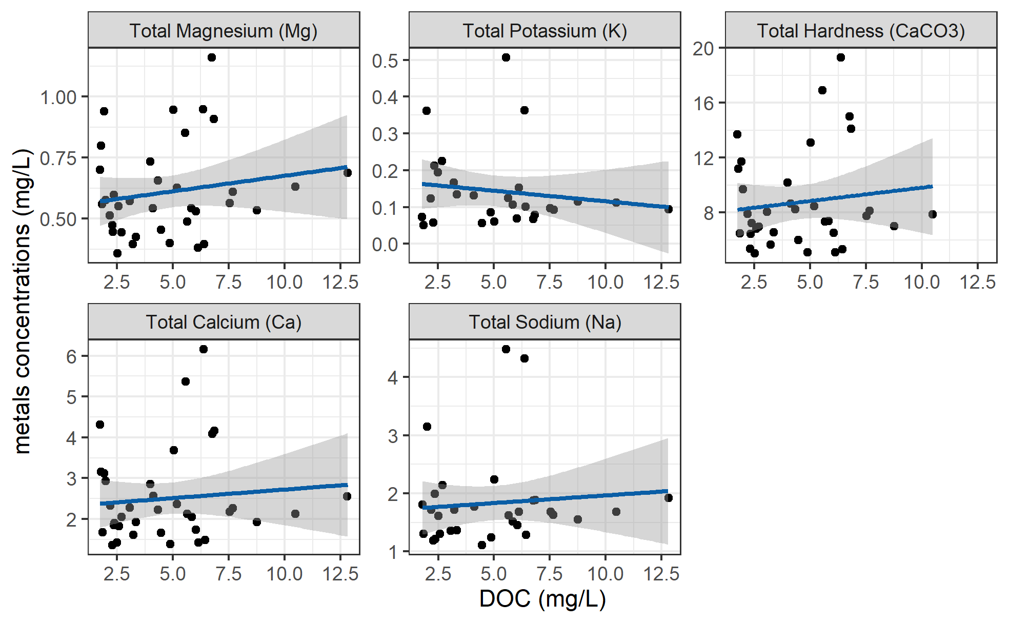

Figure 30: *Concentrations of total metals (in mg/L) and dissolved organic carbon.*

DOC concentrations had strong positive relationships with total mercury, iron, manganese, aluminum. While the relationships were not as strong, DOC was also positively related to concentrations of barium, copper, and arsenic. There was a weak inverse relationship between DOC with silicon and potassium (Table 22). All metals concentrations were below maximum allowable concentrations and aesthetic objectives for drinking source water quality guidelines (British Columbia Ministry of Environment 2017).

Table 22: *Relationships between total metals with dissolved organic carbon*

|  |  |  |  |  |  |
| --- | --- | --- | --- | --- | --- |
| Metal | unit | count | slope | Y intercept | R squared |
| Total Mercury (Hg) | ug/L | 3 | 0.00 | 0.00 | 0.9998 |
| Total Iron (Fe) | ug/L | 40 | 30.86 | -74.47 | 0.6933 |
| Total Manganese (Mn) | ug/L | 18 | 4.38 | -21.41 | 0.5939 |
| Total Aluminum (Al) | ug/L | 42 | 20.13 | -1.21 | 0.3965 |
| Total Barium (Ba) | ug/L | 42 | 0.22 | 2.28 | 0.2251 |
| Total Copper (Cu) | ug/L | 39 | 0.06 | 0.40 | 0.1762 |
| Total Arsenic (As) | ug/L | 14 | 0.00 | 0.14 | 0.1112 |
| Total Strontium (Sr) | ug/L | 42 | 0.69 | 12.21 | 0.0445 |
| Total Silicon (Si) | ug/L | 42 | -37.45 | 2433.98 | 0.0383 |
| Total Magnesium (Mg) | mg/L | 42 | 0.01 | 0.55 | 0.0298 |
| Total Potassium (K) | mg/L | 32 | -0.01 | 0.17 | 0.0216 |
| Total Hardness (CaCO3) | mg/L | 41 | 0.19 | 7.87 | 0.0153 |
| Total Calcium (Ca) | mg/L | 42 | 0.04 | 2.30 | 0.0095 |
| Total Sodium (Na) | mg/L | 37 | 0.03 | 1.70 | 0.0081 |

Ancillary data: climate context

FWx stations in the LWSA

There were two weather stations that operated during the study period: Chris Creek station is located in the headwaters of the LWSA and Martin’s Gulch station is located near the future diversion point (Leech River Tunnel).

The CRD provided weather station data from Chris Creek and Martin’s Gulch weather stations from January 2018 to March 2020. Slightly more precipitation was recorded at Martin’s Gulch than Chris Creek station (Figure 31, Table 23). Data from these two FWx stations were used to calculate arithmetic means of LWSA weather (see Chapter 2).



Figure 31: *Weather from FWx stations in the Leech water supply area. Coloured sections of plots highlight the field study period of this project.*

 Table 23: Annual weather from CRD FWx stations in the Leech water supply area*

|  |  |  |  |  |  |  |  |
| --- | --- | --- | --- | --- | --- | --- | --- |
| Year | station name | annual rain. (mm) | max snow (m) | mean air temp. (°C) | stdev air temp. (± °C) | mean max. temp. (°C) | mean min. temp. (°C) |
| 2018 | FWx Chris Creek | 1967.8 | 0.53 | 8.1 | 7.5 | -11.9 | 34.8 |
| 2018 | FWx Martins Gulch | 2042.3 | 0.24 | 8.9 | 7.3 | -9.5 | 32.9 |
| 2019 | FWx Chris Creek | 1428.4 | 0.48 | 7.5 | 7.2 | -13.7 | 31.9 |
| 2019 | FWx Martins Gulch | 1486.7 | 0.35 | 8.4 | 6.9 | -12.7 | 30.5 |
| Jan-Feb 2020 | FWx Chris Creek | 837.2 | 0.62 | 1.6 | 3.7 | -9.6 | 10.5 |
| Jan-Feb 2020 | FWx Martins Gulch | 930.4 | 0.51 | 2.2 | 3.6 | -9.3 | 11.2 |
|  |  |  |  |  |  |  |  |

Malahat 5 year weather

* NOTE: replace this seciton with data from the PCIC on climate normals and departure from norms during my study period.

The LWSA weather stations were recently installed and therefore data during the study period could not be compared to a record from previous years. A nearby weather station operated by the BC Ministry of Transportation and Infrastructure (Malahat, station ID 62091) had data available from late 2013 which was used to check if weather during the study period departed from previous year trends. Figure 32 shows Malahat weather data, which are summarized in Table 24.

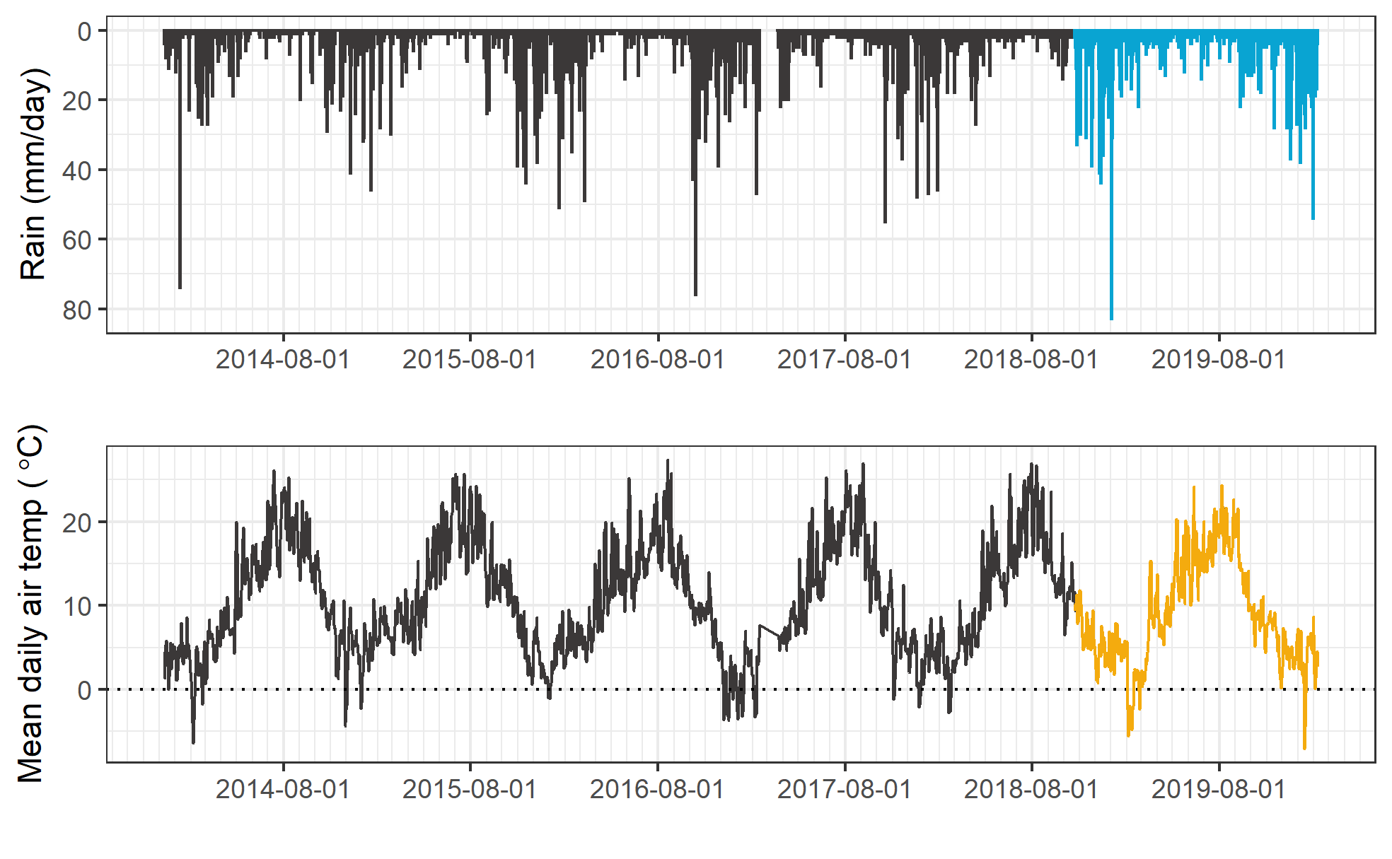

Figure 32: *Five year weather from nearby Malahat station (MoTI ID 62091).*

Table 24: *Annual weather data from Malahat station (MoTI ID 62091)*

|  |  |  |  |
| --- | --- | --- | --- |
| year | annual precip. (mm) | mean air temp. (°C) | std.dev. (± °C) |
| 2014 | 1260 | 10.6 | 6.7 |
| 2015 | 1281 | 11.3 | 6.3 |
| 2016 | 1526 | 10.6 | 6.2 |
| 2017 | 1331 | 10.5 | 7.1 |
| 2018 | 1636 | 10.6 | 6.6 |
| 2019 | 1494 | 10.1 | 6.3 |

Malahat weather station data were grouped by years 2016-2017 and 2018-2019 to check if there was a statistical difference in precipitation and air temperature for the two years prior to this study compared to the two years associated with this study (Figure 33). Table (tab:MalahatTest) summarizes the results Wilcoxon rank sum test comparing these two sets. Based on this two-set, two-year comparison, it was determined that precipitation during the 2018-2019 period was different than the 2016-2017 period.

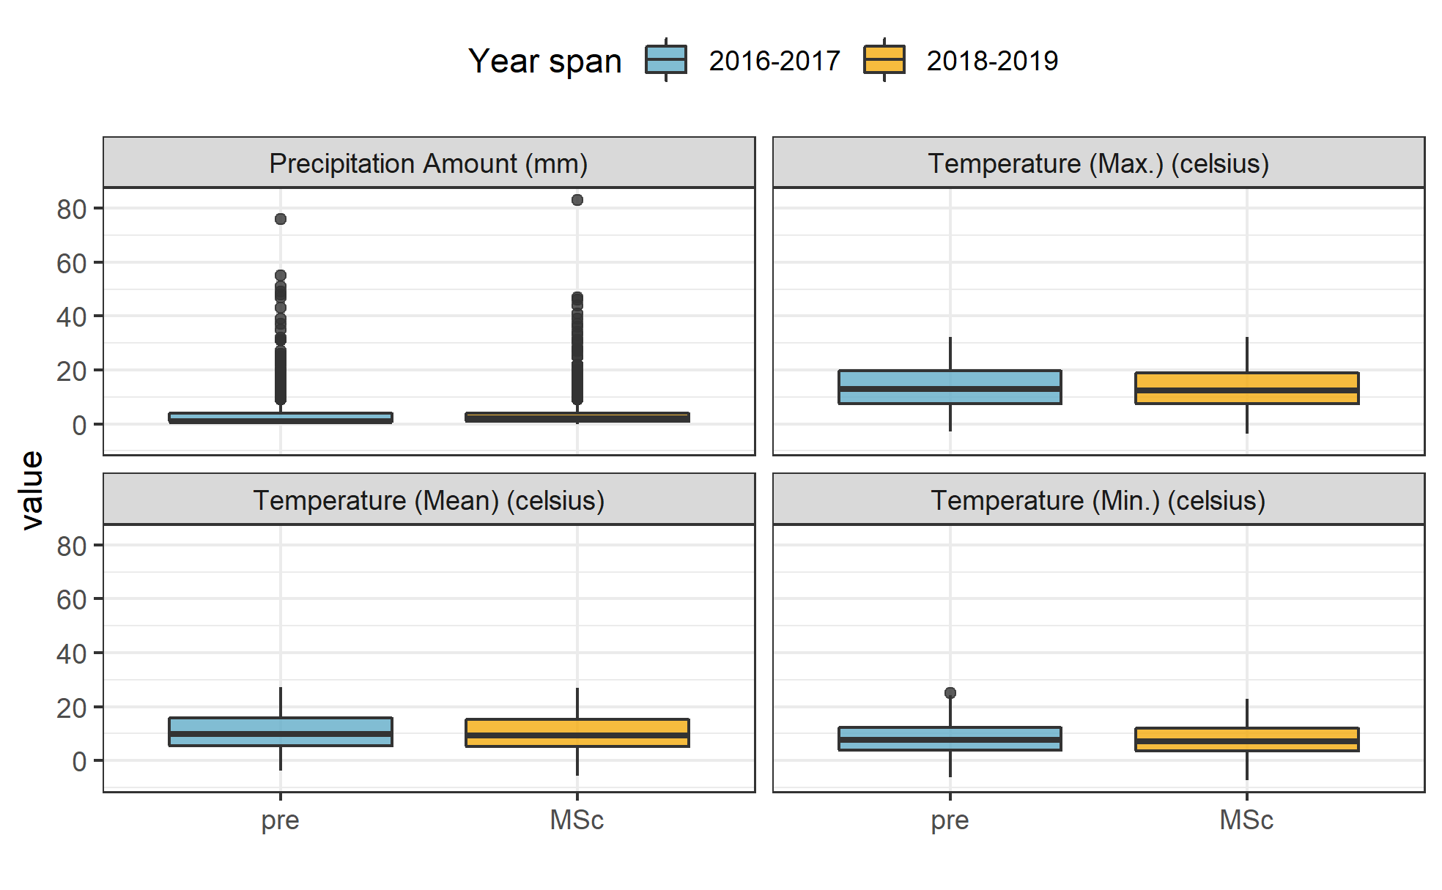

Figure 33: *Weather from the Malahat station for two year periods prior to and during this study (MoTI ID 62091).*

Table 25: *Results of Wilcoxon test for Malahat weather data before and during the study period*

|  |  |  |
| --- | --- | --- |
| Parameter | p.value | signifcance |
| rain | 1.910000e-10 | at 99% |
| temp_mean | 3.904246e-01 |  |
| temp_min | 3.826166e-01 |  |
| temp_max | 4.694509e-01 |  |

Extended: linear regression for air temperatures at vertical racks

TidbiT temperature loggers (HOBO TidbiT v2 Temperature Data Logger, Onset, USA) were attached to the top and bottom of each vertical rack installation to record air and water temperature at 30 minute intervals. Loggers at the top of racks recorded air temperature and those at the bottom recorded water temperature (Figure 34).



Figure 34: *Temperatures recorded in air and water on vertical racks at each research site.*

While loggers were installed in both positions (air and water) on each rack at the same time, it wasn’t until mid-October that all sites’ water temperature loggers were submerged. Figure 35 shows the distributions of air and water temperatures at each site, where water temperature was limited to the period when all sites water temperature loggers were submerged. Median water temperatures increased from the headwaters of Leech River to the point of diversion (Leech-Head < Cragg-Crk < West-Leech < Tunnel).

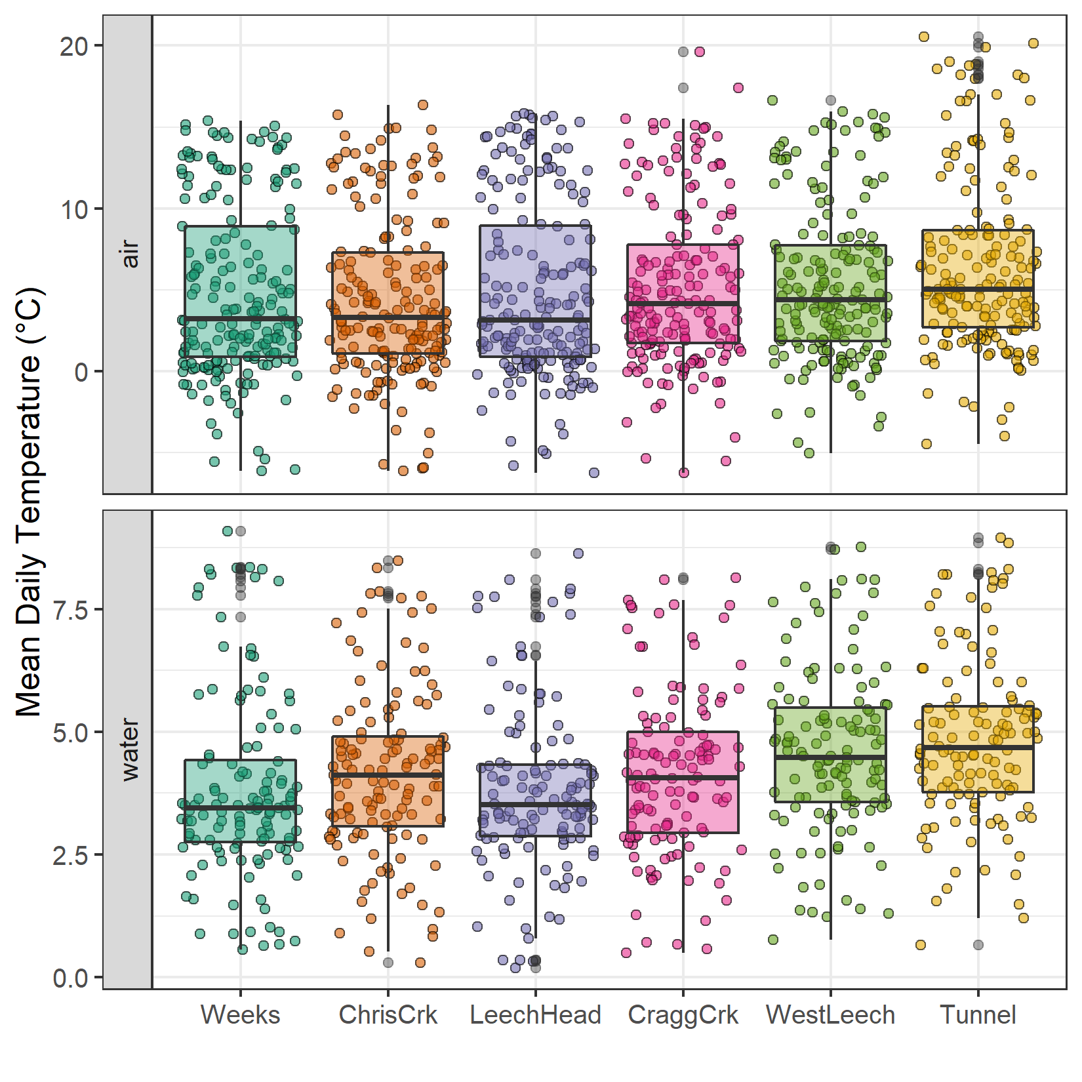

Figure 35: *Temperatures recorded in air and water on vertical racks at each research site.*

Linear regression: air temperature estimation

Air temperatures recorded at each of the six sites were compared to LWSA FWx for the overlapping period (August 24, 2019 to February 20, 2020). Overall, FWx temperatures were slightly higher than those recorded at each site installation. Figure 36 shows the density distribution of air temperature measured at each site compared to the LWSA FWx mean.



Figure 36: *Density distribution of air temperatures recorded at each sub-basin compared to mean LWSA air temperatures from CRD fire weather stations.*

Results of two-sided Wilcoxon rank sum tests revealed that 15-minute air temperatures at West Leech (site-5) were similar to LWSA FWx (p-value 0.02), and the differences between the other five sites and FWx were found to be significantly different (p-values << 0.001). However, when daily mean temperatures were compared (rather than 15 minute data) the differences between sites and FWx temperatures were less dramatic (Table 26) with no statistical difference (at 90% confidence) for Cragg Crk, West Leech and the Tunnel (sites 4, 5, 6).

Table 26: *Relationships between mean daily air temperature recorded at each monitoring site compared to mean LWSA air temperature recorded by Chris Creek and Martin’s Gulch fire weather stations.*

|  |  |
| --- | --- |
| Site | p-value |
| Weeks | 0.0014 |
| ChrisCrk | 0.0065 |
| LeechHead | 0.0009 |
| CraggCrk | 0.0470 |
| WestLeech | 0.5745 |
| Tunnel | 0.2966 |

Despite some differences between FWx and Hobo site data, the overlapping FWx and TidbiT daily mean air temperature data were used to generate linear regression relationships to estimate air temperatures at each site for the time preceding Hobo TidbiT deployment (Figure 37). Table 27 summarizes the average percent error of estimated air temperatures based on a test period of overlapping data. Estimated mean daily air temperatures at each site were used in flagging Rack sample data for quality control with respect to days samples remained on vertical racks (hold-times).

Table 27: *Summary of predicted air temperature at each site compared to mean LWSA temperature from CRD FWx stations for the same time period*

|  |  |  |  |  |  |  |  |
| --- | --- | --- | --- | --- | --- | --- | --- |
| Site | Error (%) | Median Temp. (°C) | Estimated Median (°C) | Min. Temp (°C) | Estimated Min. (°C) | Max. Temp (°C) | Estimated Max. (°C) |
| Weeks | 19.4 | 2.9 | 3.9 | -6.1 | -7.6 | 15.4 | 17.7 |
| ChrisCrk | -35.1 | 3.3 | 4.0 | -6.1 | -7.5 | 15.7 | 18.0 |
| LeechHead | -39.9 | 2.7 | 3.8 | -6.2 | -7.3 | 15.8 | 17.2 |
| CraggCrk | 83.2 | 3.7 | 4.7 | -6.2 | -7.0 | 17.4 | 18.9 |
| WestLeech | -60.9 | 4.4 | 5.0 | -5.0 | -6.0 | 16.6 | 18.4 |
| Tunnel | -7.2 | 5.1 | 5.8 | -4.5 | -5.5 | 20.6 | 19.5 |



Figure 37: *Linear regression relationships between mean daily air temperature recorded at each monitoring site compared to mean LWSA air temperature recorded by Chris Creek and Martin’s Gulch fire weather stations*

Results extended

NOM sampling in nested catchments (from Ch.2)

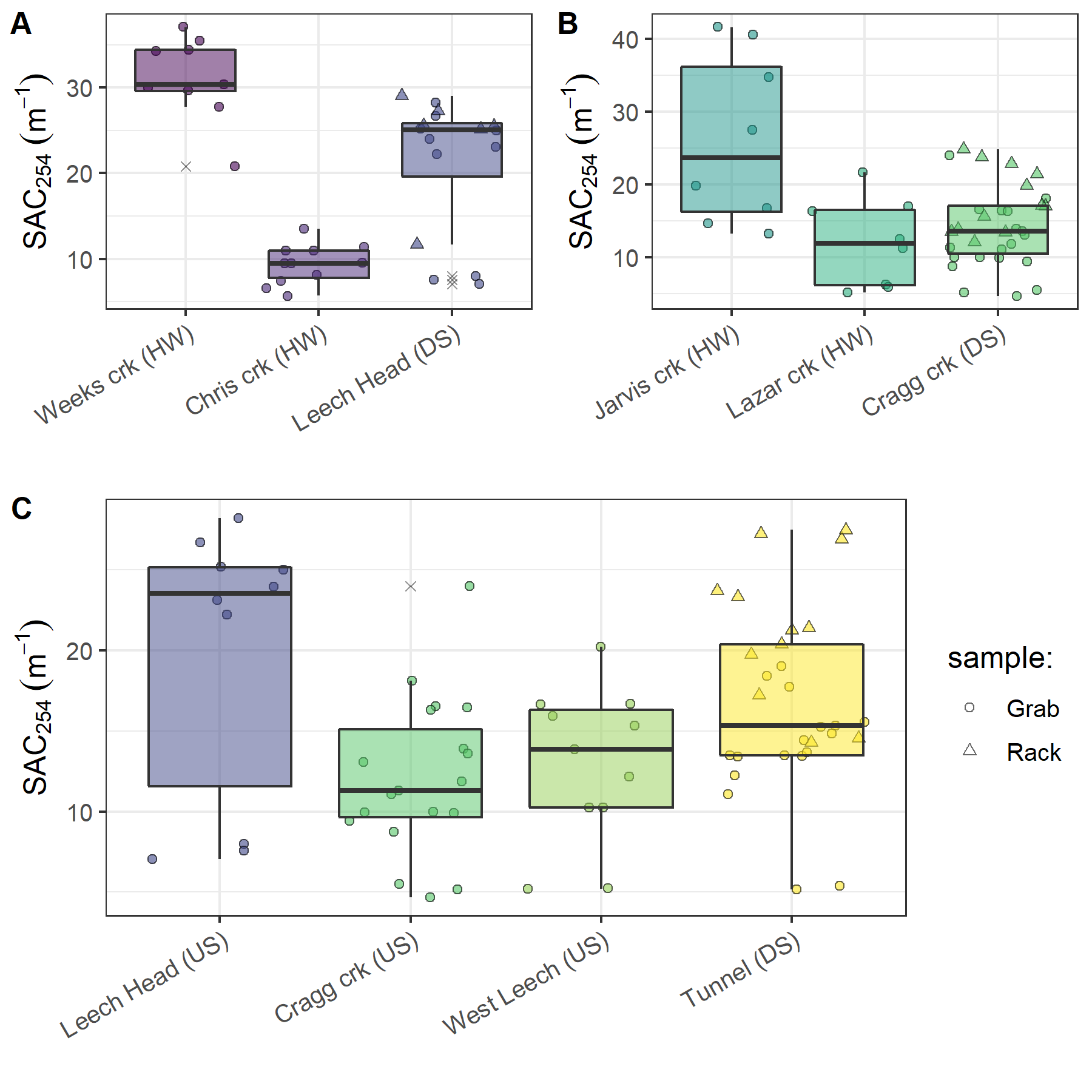

Figure 38: *Grab sample SAC254 at upstream locations compared to Rack and Grab sample SAC254 below their confluence(s). A and B show grab samples from headwaters (HW) compared to downstream (DS) monitoring sites; C shows upstream river sites (US) compared to mainstem monitoring.*

Below the confluences of headwaters sites (Figure 38, plots A & B), the combination of Rack and Grab sampling did not capture the ranges of SAC254 observed in upstream Grab samples alone. At both sets of headwater sites, the variance obtained by combining Rack and Grab samples downstream was not the same as upstream Grab sampling variance (Levene’s test for homoscedasticity p-value = 0.0174). At higher order rivers, the combination of Rack and Grab samples at the Leech Tunnel site did capture the SAC254 ranges observed in Grab samples at three upstream river sites (Figure 38, plot C). Levene’s test for homogeneity of variance (homoscedasticity) confirmed that there was no difference in SAC254 variance in the downstream Rack/Grab combination results compared to Grab-only from upstream (p-value 0.105).

No apparent trend was seen in the E2:E3 characteristic for aromaticity/molecular size (Figure 39). There were similar variances in E2:E3 values across all groupings (Levene’s p-values 0.1225, 0.09551, 0.09298 for sets A, B, C).

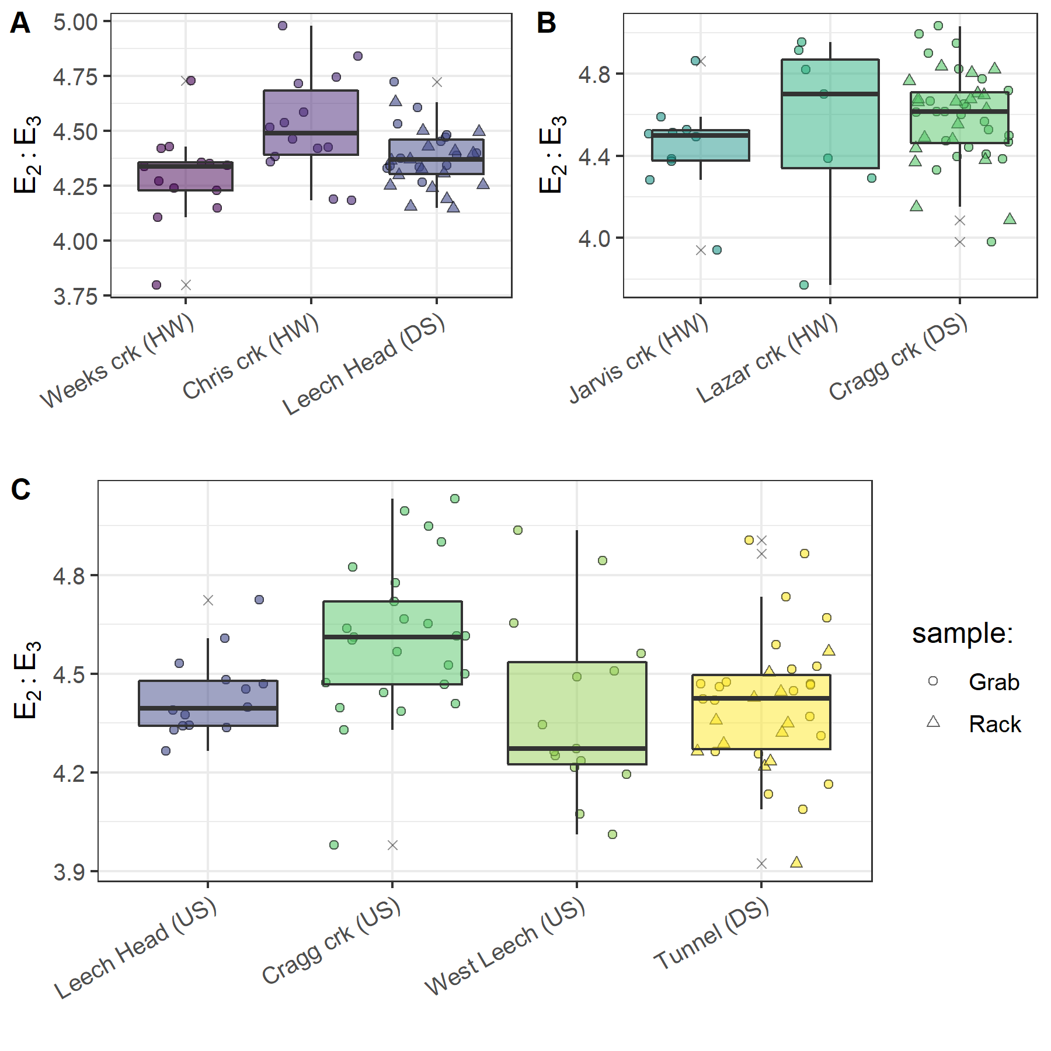

Figure 39: *Grab sample E2:E3 at upstream locations compared to Rack and Grab sample E2:E3 below their confluence(s). A and B show grab samples from headwaters (HW) compared to downstream (DS) monitoring sites; C shows upstream river sites (US) compared to mainstem monitoring.*

possible trash

Spatial variance in DOC concentrations

As the Leech River Tunnel will be the point of diversion for future inter-basin transfers from Leech water supply area (LWSA) to the Sooke Reservoir basin, the Tunnel (site 6) is the effective outlet of the LWSA where runoff from each nested catchment is integrated. Similarly, Weeks and ChrisCrk (sites 1 & 2) are integrated at LeechHead (site 3), which is just below the headwaters’ confluence. Sites were categorized based on their relative position in the Leech river system and evaluated for DOC range and variability (Table 28).

Table 28: *Summary of DOC across the six LWSA research sites with each nested catchment classified by basin type.*

|  |  |  |  |  |  |  |  |  |
| --- | --- | --- | --- | --- | --- | --- | --- | --- |
| Site | Basin type | Sample count | Mean DOC (mg/L) | Stdev (± mg/L DOC) | RSD (± %) | Min. (mg/L) | Median (mg/L) | Max. (mg/L) |
| Weeks | headwater | 49 | 9.9 | 3.4 | 34 | 3.78 | 9.69 | 19.07 |
| ChrisCrk | headwater | 42 | 4.9 | 2.1 | 42 | 1.84 | 4.65 | 9.16 |
| LeechHead | mainstem | 44 | 7.2 | 1.7 | 24 | 3.95 | 6.92 | 11.64 |
| CraggCrk | mainstem | 62 | 4.7 | 1.5 | 33 | 1.79 | 4.45 | 8.22 |
| WestLeech | mainstem | 57 | 5.8 | 2.4 | 41 | 2.00 | 5.55 | 10.95 |
| Tunnel | outlet | 64 | 4.8 | 1.8 | 39 | 1.65 | 4.98 | 9.02 |
| summary | headwater | 91 | 7.6 | 3.8 | 50 | 1.84 | 6.95 | 19.07 |
| summary | mainstem | 163 | 5.8 | 2.1 | 37 | 1.79 | 5.55 | 11.64 |
| summary | all nested catchments (sites 1-5) | 254 | 6.4 | 3.0 | 46 | 1.79 | 6.09 | 19.07 |

The relative standard deviation (RSD) in DOC observed at LeechHead was lower than that of the two headwater sites upstream, and median DOC observed at LeechHead was very near to the median for the headwaters sites. Overall, there was greater variance among headwater sites than there was within each headwater site. For the higher order rivers, the variance observed at each mainstem was comparable to the variance among the three mainstems. Results of Levene’s test confirmed that variance in DOC concentrations was not homogeneous across the six sites of the LWSA (p-value = 8.2-10).[1]

To identify which pairs of sites had equal DOC variance Levene’s test was applied to sample DOC results. Table 29 classifies each site comparison by basin-type and summarizes resulting Levene’s test p-values for each pair. Of the nine comparisons made among the six sites, all pairs with WestLeech (site 5) and/or Weeks (site 1) did not have homogeneous variance with any other sites, while all other combinations of sites showed homoscedasticity in DOC. Both heteroscedastic sub-basins drain the west side of LWSA.

Table 29: *Results of Levene’s test comparing DOC variance between pairs of sites. Significance stars indicate confidence levels:* ** 99% (alpha = 0.01); ** 95% (alpha = 0.05); * 90% (alpha = 0.1), 90% confidence was the threshold for supporting the null hypothesis of homoscedasticity.*

|  |  |  |  |
| --- | --- | --- | --- |
| Comparison Group | Site Comparison | p.value | Significance |
| headwaters | Weeks & ChrisCrk | 0.01047 | ** |
| headwaters | LeechHead & Weeks | 0.00051 | *** |
| headwaters | LeechHead & ChrisCrk | 0.15472 | homoscedastic |
| mainstems | LeechHead & CraggCrk | 0.47012 | homoscedastic |
| mainstems | LeechHead & WestLeech | 0.01858 | ** |
| mainstems | CraggCrk & WestLeech | 0.00051 | *** |
| mainstem to outlet | LeechHead & Tunnel | 0.50170 | homoscedastic |
| mainstem to outlet | CraggCrk & Tunnel | 0.10260 | homoscedastic |
| mainstem to outlet | WestLeech & Tunnel | 0.03433 | ** |
|  |  |  |  |

E2E3 over time

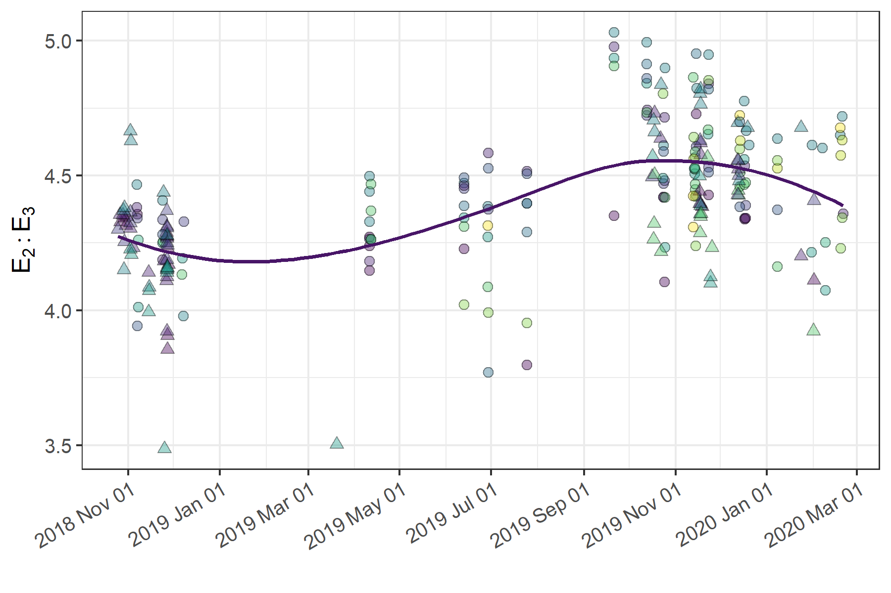

Figure 40: *Trends in E2:E3 (spectral NOM indicator), where E2:E3 values are inversely related to NOM aromaticity and molecular weightaromaticity and molecular weight indicator) over sixteen months at twelve sites across the Greater Victoria Water Supply Area. Trend line shows locally weighted smoothing (loess, local polynomial regression).*

***?***

* Gauging Streamflow (?)

# References

Abbott, Benjamin W., Gérard Gruau, Jay P. Zarnetske, Florentina Moatar, Lou Barbe, Zahra Thomas, Ophélie Fovet, et al. 2018. “Unexpected spatial stability of water chemistry in headwater stream networks.” *Ecology Letters* 21 (2): 296–308. <https://doi.org/10.1111/ele.12897>.

Aiken, George, and Evangelo Cotsaris. 1995. “Soil and hydrology: Their effect on NOM.” *American Water Works Association* 87 (1): 36–45. <https://doi.org/10.1002/j.1551-8833.1995.tb06299.x>.

Aiken, George R., Heileen Hsu-Kim, and Joseph N. Ryan. 2011. “Influence of dissolved organic matter on the environmental fate of metals, nanoparticles, and colloids.” *Environmental Science and Technology* 45 (8): 3196–3201. <https://doi.org/10.1021/es103992s>.

Avagyan, Armine, Benjamin R. K. Runkle, and Lars Kutzbach. 2014. “Application of high-resolution spectral absorbance measurements to determine dissolved organic carbon concentration in remote areas.” *Journal of Hydrology* 517: 435–46. <https://doi.org/10.1016/j.jhydrol.2014.05.060>.

Ågren, Anneli, Ishi Buffam, Martin Berggren, Kevin Bishop, Mats Jansson, and Hjalmar Laudon. 2008. “Dissolved organic carbon characteristics in boreal streams in a forest-wetland gradient during the transition between winter and summer.” *Journal of Geophysical Research: Biogeosciences* 113 (3): 1–11. <https://doi.org/10.1029/2007JG000674>.

Baird, Rodger, Andrew D. Eaton, and Eugene W. Rice, eds. 2017a. “5310 Total Organic Carbon (TOC) - 5310 A.” In *Standard Methods for the Examination of Water and Wastewater*, 23rd ed. Washington, DC: American Public Health Association. <http://www.standardmethods.org/>.

———, eds. 2017b. “UV-Absorbing Organic Constituents: Ultraviolet Absorption Method - 5910 B.” In *Standard Methods for the Examination of Water and Wastewater*, 23rd ed. Washington, D.C: American Public Health Association. <https://doi.org/10.2105/SMWW.2882.113>.

Biau, Gérard, and Erwan Scornet. 2016. “A random forest guided tour.” *Test* 25 (2): 197–227. <https://doi.org/10.1007/s11749-016-0481-7>.

Breiman, Leo. 2001. “Random forests.” *Machine Learning* 45: 5–32. <https://doi.org/10.1201/9780367816377-11>.

British Columbia Ministry of Environment. 2017. “BC Source Drinking Water Quality Guidelines: Guideline Summary.” Victoria, B.C.: Prov. B.C. <https://www2.gov.bc.ca/gov/content/governments/organizational-structure/ministries-organizations/ministries/environment-climate-change>.

Canadian Council of Ministers of the Environment. 2004. “From source to tap : guidance on the multi-barrier approach to safe drinking water.”

CCME. 2011. *Protocols Manual for Water Quality Sampling in Canada*. Canadian Council of Ministers of the Environment.

Chow, Alex T., Randy A. Dahlgren, Qian Zhang, and P. K. Wong. 2008. “Relationships between specific ultraviolet absorbance and trihalomethane precursors of different carbon sources.” *Journal of Water Supply: Research and Technology - AQUA* 57 (7): 471–80. <https://doi.org/10.2166/aqua.2008.064>.

Cory, Rose M., Elizabeth W. Boyer, and Diane M. McKnight. 2011. “Spectral Methods to Advance Understanding of Dissolved Organic Carbon Dynamics in Forested Catchments.” In *Forest Hydrology and Biogeochemistry, Synthesis of Past Research and Future Directions*, 216:xxii, 740. Biswas 1970. Springer Netherlands. <https://doi.org/10.1007/978-94-007-1363-5>.

CRD. 2017. “Regional Water Supply 2017 Strategic Plan.” Victoria, B.C.: Capital Region District, Integrated Water Services. <https://www.crd.bc.ca/project/past-capital-projects-and-initiatives/water-supply-plan>.

———. 2019. “Leech Water Supply Area Restoration Update: Report to Regional Water Supply Commission (Wednesday, June 19, 2019).” Victoria, B.C.: Capital Regional District. <https://doi.org/IWSS-297445977-5079>.

———. 2020. “Unpublished weather station data, Greater Victoria Water Supply Area.” Victoria, B.C.: Capital Regional District, Watershed Protection Division, Integrated Water Services.

Creed, IF Irena F, DM Diane M Mcknight, Brian A Pellerin, Mark B Green, Brian A Bergamaschi, George R Aiken, Douglas A Burns, et al. 2015. “The river as a chemostat : fresh perspectives on dissolved organic matter flowing down the river continuum.” *Canadian Journal of Fisheries and Aquatic Sciences* 14 (April): 1–14. <https://doi.org/10.1139/cjfas-2014-0400>.

Critten, John C. Trussell, Rhodes. Hand, David. Howe, Kerry. Tchobanoglous, George. 2014. *MWH Water Treatment Principles and Design*. <https://doi.org/10.1016/B978-0-12-382092-1.00019-1>.

Delpla, Ianis, and Manuel J. Rodriguez. 2016. “Experimental disinfection by-product formation potential following rainfall events.” *Water Research* 104: 340–48. <https://doi.org/10.1016/j.watres.2016.08.031>.

Diehl, Timothy H. 2007. “A Modified Siphon Sampler for Shallow Water.” U.S. Department of the Interior, U.S. Geological Survey. <https://pubs.er.usgs.gov/publication/sir20075282>.

Dudley, N, and S Stolton. 2003. “Running Pure: The importance of forest protected areas to drinking water.” World Bank / WWF Alliance for Forest Conservation; Sustainable Use. [http://scholar.google.com/scholar?hl=en{\&}btnG=Search{\&}q=intitle:Running+Pure{\#}1](http://scholar.google.com/scholar?hl=en%7B\&%7DbtnG=Search%7B\&%7Dq=intitle:Running+Pure%7B\#%7D1).

Emelko, Monica B., Uldis Silins, Kevin D. Bladon, and Micheal Stone. 2011. “Implications of land disturbance on drinking water treatability in a changing climate: Demonstrating the need for " source water supply and protection" strategies.” *Water Research* 45 (2): 461–72. <https://doi.org/10.1016/j.watres.2010.08.051>.

Epps, Deborah Norine. 1994. “Factors Affecting Disinfection By-Products from Surface Source Waters on Vancouver Island.” Master of Science, University of Victoria.

Fichot, Cédric G., and Ronald Benner. 2012. “The spectral slope coefficient of chromophoric dissolved organic matter ( S 275-295 ) as a tracer of terrigenous dissolved organic carbon in river-influenced ocean margins.” *Limnology and Oceanography* 57 (5): 1453–66. <https://doi.org/10.4319/lo.2012.57.5.1453>.

Graczyk, David J., Dale M. Robertson, William J. Rose, and Jeffrey J. Steur. 2000. “Comparison of water-quality samples collected by siphon samplers and automatic samplers in Wisconsin.” Middleton, Dane County, Wisconsin: U.S. Department of the Interior U.S. Geological Survey. <https://doi.org/10.3133/fs06700>.

Harmel, R. D., K. W. King, and R. M. Slade. 2003. “Automated storm water sampling on small watersheds.” *Applied Engineering in Agriculture* 19 (6): 667–74. <https://doi.org/10.13031/2013.15662>.

Health Canada. 2019a. “Guidance on Natural Organic Matter in Drinking Water.” <https://www.canada.ca/content/dam/hc-sc/documents/programs/consultation-organic-matter-drinking-water/NOM20190129-eng.pdf>.

———. 2019b. “Guidelines for Canadian Drinking Water Quality – Summary Table.” Ottawa, Ontario: Water; Air Quality Bureau, Healthy Environments; Consumer Safety Branch. [https://www.canada.ca/content/dam/hc-sc/migration/hc-sc/ewh-semt/alt{\_}formats/pdf/pubs/water-eau/sum{\_}guide-res{\_}recom/summary-table-August-15-2019-eng.pdf](https://www.canada.ca/content/dam/hc-sc/migration/hc-sc/ewh-semt/alt%7B_%7Dformats/pdf/pubs/water-eau/sum%7B_%7Dguide-res%7B_%7Drecom/summary-table-August-15-2019-eng.pdf).

HealthCanada. 2006. “Drinking Water Chlorination.” <https://www.canada.ca/en/health-canada/services/healthy-living/your-health/environment/drinking-water-chlorination.html>.

HealthLinkBC. 2018. “Drinking Water Chlorination Facts.” <https://www.healthlinkbc.ca/healthlinkbc-files/drinking-water-chlorination>.

Helms, John R, Avon Stubbins, Jason D Ritchie, Elizabeth C Minor, and Kenneth Mopper. 2008. “Absorption Spectral Slopes and Slope Ratios as Indicators of Molecular Weight, Source, and Photobleaching of Chromophoric Dissolved Organic Matter.” *Limnology and Oceanography* 53 (3): 955–69. <https://www.jstor.org/stable/40058211>.

Hua, Guanghui, David A. Reckhow, and Ibrahim Abusallout. 2015. “Correlation between SUVA and DBP formation during chlorination and chloramination of NOM fractions from different sources.” *Chemosphere* 130: 82–89. <https://doi.org/10.1016/j.chemosphere.2015.03.039>.

Jacangelo, Joseph G., Jack DeMarco, Douglas M. Owen, and Stephen J. Randtke. 1995. “Selected processes for removing NOM: An overview.” *Journal / American Water Works Association* 87 (1): 64–77. <https://doi.org/10.1002/j.1551-8833.1995.tb06302.x>.

Johnson, Lucinda, Carl Richards, George Host, and John Arthur. 1997. “Landscape influences on water chemistry in Midwestern stream ecosystems.” *Freshwater Biology* 37: 193–208. <https://doi.org/doi:10.1046/j.1365-2427.1997.d01-539.x>.

Karanfil, Tanju, Ilke Erdogan, and Mark A. Schlautman. 2003. “Selecting filter membranes for measuring DOC and UV₂₅₄.” *American Water Works Association* 95 (3): 86–100. <https://www.jstor.org/stable/41311011>.

Karanfil, Tanju, Mark A. Schlautman, and Ilke Erdogan. 2002. “Survey of DOC and UV measurement practices with implications for SUVA determination.” *Journal / American Water Works Association* 94 (12): 68–80. <https://doi.org/10.1002/j.1551-8833.2002.tb10250.x>.

Kirchner, James W. 2006. “Getting the right answers for the right reasons: Linking measurements, analyses, and models to advance the science of hydrology.” *Water Resources Research* 42 (3): 1–5. <https://doi.org/10.1029/2005WR004362>.

LaZerte, Bruce. 1991. “Metal transport and retention: the role of dissolved organic carbon.” December. Ontario: Dorset Research Centre, for Ontario Ministry of the Environment. <https://archive.org/details/metaltransportre00lazeuoft/mode/2up>.

Li, Angzhen, Xu Zhao, Ran Mao, Huijuan Liu, and Jiuhui Qu. 2014. “Characterization of dissolved organic matter from surface waters with low to high dissolved organic carbon and the related disinfection byproduct formation potential.” *Journal of Hazardous Materials* 271: 228–35. <https://doi.org/10.1016/j.jhazmat.2014.02.009>.

Mackay, A. K., and M. P. Taylor. 2012. “Event-based water quality sampling method for application in remote rivers.” *River Research and Applications* 28 (8): 1105–12. <https://doi.org/10.1002/rra.1504>.

Matilainen, Anu, Egil T. Gjessing, Tanja Lahtinen, Leif Hed, Amit Bhatnagar, and Mika Sillanpää. 2011. “An overview of the methods used in the characterisation of natural organic matter (NOM) in relation to drinking water treatment.” *Chemosphere* 83 (11): 1431–42. <https://doi.org/10.1016/j.chemosphere.2011.01.018>.

Matilainen, Anu, Mikko Vepsäläinen, and Mika Sillanpää. 2010. “Natural organic matter removal by coagulation during drinking water treatment: A review.” *Advances in Colloid and Interface Science* 159 (2): 189–97. <https://doi.org/10.1016/j.cis.2010.06.007>.

Meyer, Judy L., and Cathy M . Tate. 1983. “The Effects of Watershed Disturbance on Dissolved Organic Carbon Dynamics of a Stream.” *Ecology* 64 (1): 33–44. <https://www.jstor.org/stable/1937326>.

Mistick, Emily. 2019. “Forest harvest and water treatability: Analysis of dissolved organic carbon in headwater streams of contrasting forest harvest history during base flow and storm flow.” PhD thesis, UNIVERSITY OF BRITISH COLUMBIA.

Mosher, Jennifer J., Louis A. Kaplan, David C. Podgorski, Amy M. McKenna, and Alan G. Marshall. 2015. “Longitudinal shifts in dissolved organic matter chemogeography and chemodiversity within headwater streams: a river continuum reprise.” *Biogeochemistry* 124 (1-3): 371–85. <https://doi.org/10.1007/s10533-015-0103-6>.

Newham, Lachlan T H, Barry F W Croke, and a J Jakeman. 2001. “Design of Water Quality Monitoring Programs and Automatic Sampling Techniques.” In *ANU Research Publications*. 02. <http://hdl.handle.net/1885/40940>.

Oni, S. K., M. N. Futter, K. Bishop, S. J. Köhler, M. Ottosson-Löfvenius, and H. Laudon. 2013. “Long-term patterns in dissolved organic carbon, major elements and trace metals in boreal headwater catchments: Trends, mechanisms and heterogeneity.” *Biogeosciences* 10 (4): 2315–30. <https://doi.org/10.5194/bg-10-2315-2013>.

Owen, Douglas M., Gary L. Amy, Zaid K. Chowdhury, Rajendra Paode, George McCoy, and Kathy Viscosil. 1995. “NOM characterizatoin and treatability.” *American Water Works Association* 87 (1): 46–63. <http://www.jstor.com/stable/41295152>.

Palleiro, L., M. L. Rodríguez-Blanco, M. M. Taboada-Castro, and M. T. Taboada-Castro. 2013. “The influence of discharge, pH, dissolved organic carbon, and suspended solids on the variability of concentration and partitioning of metals in a rural catchment.” *Water, Air, and Soil Pollution* 224 (8). <https://doi.org/10.1007/s11270-013-1651-9>.

Peuravuori, Juhani, and Kalevi Pihlaja. 1997. “Molecular size distribution and spectroscopic properties of aquatic humic substances.” *Analytica Chimica Acta* 337 (2): 133–49. <https://doi.org/10.1016/S0003-2670(96)00412-6>.

Pike, R., M. Feller, J. Stednick, K Rieberger, and M Carver. 2010. “Water Quality and Forest Management.” In *Compendium of Forest Hydrology and Geomorphology in British Columbia: Volume 2 of 2*, 400–439. [https://www.for.gov.bc.ca/hfd/pubs/docs/lmh/Lmh66/LMH66{\_}volume2of2.pdf](https://www.for.gov.bc.ca/hfd/pubs/docs/lmh/Lmh66/LMH66%7B_%7Dvolume2of2.pdf).

Rautu, Roxana. 2019. “Linking Seasonal and Spatial Stream Carbon Dynamics to Landscape Characteristics in Selected Watersheds on the Olympic Peninsula.” PhD thesis, University of Washington.

Raymond, Peter A, James E Saiers, Source Biogeochemistry, No September, Peter A Raymond, and James E Saiers. 2010. “Event controlled DOC export from forested watersheds.” *Biogeochemistry* 100 (1): 197–209. <https://doi.org/10.1007/sl0533-010-9416-7>.

Raymond, Peter A, James E Saiers, William V Sobczak, and E James. 2016. “Hydrological and biogeochemical controls on watershed dissolved organic matter transport: pulse-shunt concept.” *Ecology* 97 (1): 5–16. <https://www.jstor.org/stable/24702986>.

Richardson, Susan D., Michael J. Plewa, Elizabeth D. Wagner, Rita Schoeny, and David M. DeMarini. 2007. “Occurrence, genotoxicity, and carcinogenicity of regulated and emerging disinfection by-products in drinking water: A review and roadmap for research.” *Mutation Research - Reviews in Mutation Research* 636 (1-3): 178–242. <https://doi.org/10.1016/j.mrrev.2007.09.001>.

Ruhala, Sydney S., and Jay P. Zarnetske. 2017. “Using in-situ optical sensors to study dissolved organic carbon dynamics of streams and watersheds: A review.” *Science of the Total Environment* 575: 713–23. <https://doi.org/10.1016/j.scitotenv.2016.09.113>.

Stanley, Emily H., Stephen M. Powers, Noah R. Lottig, Ishi Buffam, and John T. Crawford. 2012. “Contemporary changes in dissolved organic carbon (DOC) in human-dominated rivers: Is there a role for DOC management?” *Freshwater Biology* 57 (SUPPL. 1): 26–42. <https://doi.org/10.1111/j.1365-2427.2011.02613.x>.

Strobl, Carolin, Anne Laure Boulesteix, Thomas Kneib, Thomas Augustin, and Achim Zeileis. 2008. “Conditional variable importance for random forests.” *BMC Bioinformatics* 9: 1–11. <https://doi.org/10.1186/1471-2105-9-307>.

Strobl, Carolin, James Malley, and Gerhard Tutz. 2009. “An Introduction to Recursive Partitioning: Rationale, Application, and Characteristics of Classification and Regression Trees, Bagging, and Random Forests.” *Psychological Methods* 14 (4): 323–48. <https://doi.org/10.1037/a0016973>.

Strobl, Robert O., and Paul D. Robillard. 2008. “Network design for water quality monitoring of surface freshwaters: A review.” *Journal of Environmental Management* 87 (4): 639–48. <https://doi.org/10.1016/j.jenvman.2007.03.001>.

Tyralis, Hristos, Georgia Papacharalampous, and Andreas Langousis. 2019. “A Brief Review of Random Forests for Water Scientists and Practitioners and Their Recent History in Water Resources.” *Water*.

Ussery, Joel, and AECOM. 2015. “Leech Water Supply Area: An Assessment for Source Water Protection and Land Management.” April. Victoria, B.C.: Capital Regional District, Watershed Protection Division, Integrated Water Services.

Vannote, Robin L., G. Wayne Minshall, Kenneth W. Cummins, James R. Sedell, and Colbert E. Cushing. 1980. “The River Continuum Concept.” *Canadian Journal of Fisheries and Aquatic Sciences* 30 (1): 130–37.

Vidon, Philippe, Laura E. Wagner, and Emmanuel Soyeux. 2008. “Changes in the character of DOC in streams during storms in two Midwestern watersheds with contrasting land uses.” *Biogeochemistry* 88 (3): 257–70. <https://doi.org/10.1007/s10533-008-9207-6>.

Weishaar, James L., George R. Aiken, Brian A. Bergamaschi, Miranda S. Fram, Roger Fujii, and Kenneth Mopper. 2003. “Evaluation of specific ultraviolet absorbance as an indicator of the chemical composition and reactivity of dissolved organic carbon.” *Environmental Science and Technology* 37 (20): 4702–8. <https://doi.org/10.1021/es030360x>.

Yang, Liyang, Jin Hur, Sonmin Lee, Soon Woong Chang, and Hyun Sang Shin. 2015. “Dynamics of dissolved organic matter during four storm events in two forest streams: source, export, and implications for harmful disinfection byproduct formation.” *Environmental Science and Pollution Research* 22 (12): 9173–83. <https://doi.org/10.1007/s11356-015-4078-6>.

Zarnetske, Jay P., Martin Bouda, Benjamin W. Abbott, James Saiers, and Peter A. Raymond. 2018. “Generality of Hydrologic Transport Limitation of Watershed Organic Carbon Flux Across Ecoregions of the United States.” *Geophysical Research Letters* 45 (21): 11, 702–11, 711. <https://doi.org/10.1029/2018GL080005>.

1. Levene’s test is used to check for homogeneity of variance (homoscedasticity), it’s an alternative to the Bartlett’s test that’s less sensitive to departures from normality in the data.